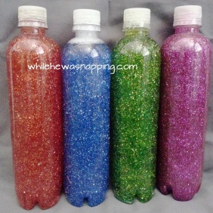
Step 1: Remove label from bottle.
Step 2: Fill bottle with luke warm water {helps the glue to mix better}
Step 3: Squeeze glue into bottle. Remember for the large bottle I used two glues. You will only need one for the small bottle unless you want to add two!
Step 4: Use each coloured glitter to represent a different emotion and shake, shake, shake it! It will take a little time for the glue to complete mix into the water. Use the pva glue to seal the lid.
Step 5. Discuss how our body feels inside when we experience different emotions, use the sensory bottle as a visual. Think of ways to self regulate and begin to feel calm again.
Step 6: Link the activity with calm boxes, Emotions scrap book and scaling.
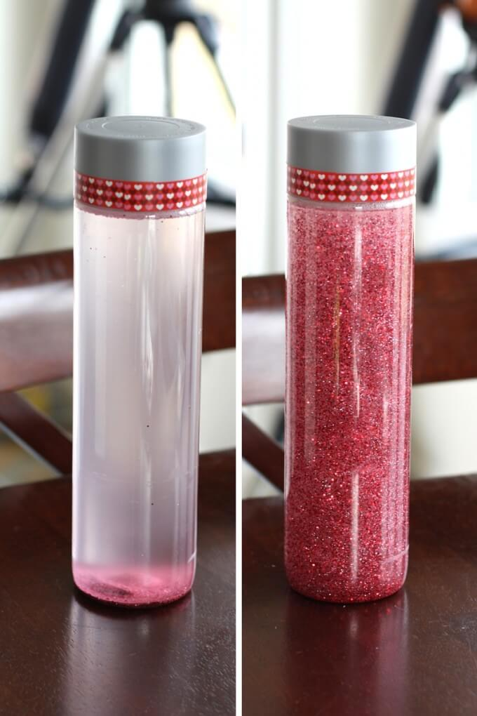
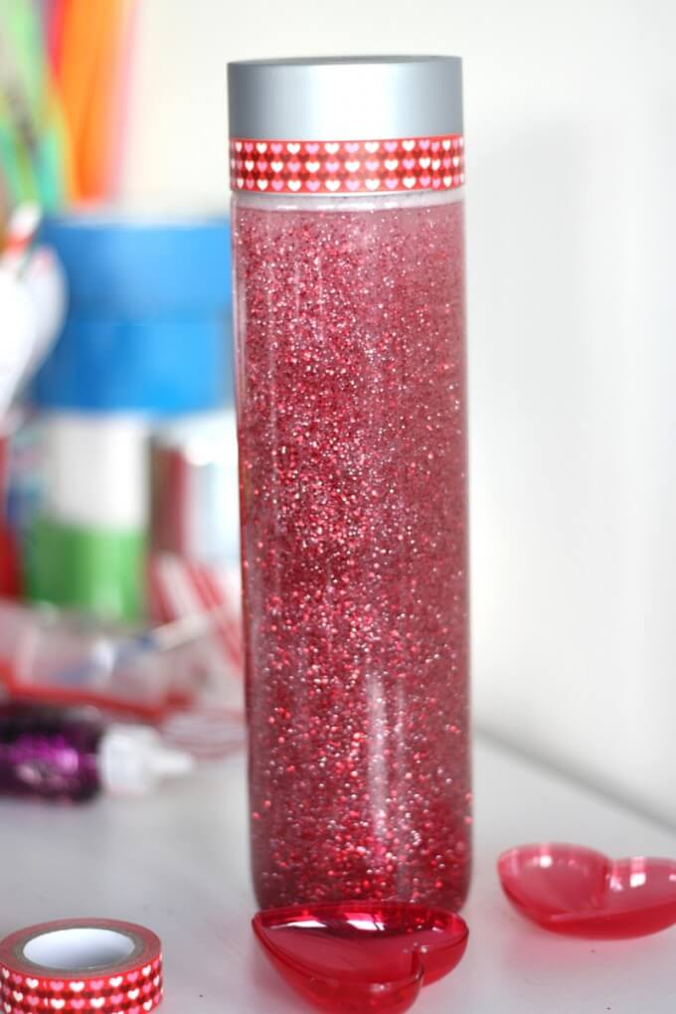
Sensory bottles are often referred to as calm down bottles. Why you ask? The time it takes you to watch the glitter glue to settle can be calming or relaxing for both kids and adults. Leave one in a handy location. It makes a nice alternative to a time out and can really turn a negative

