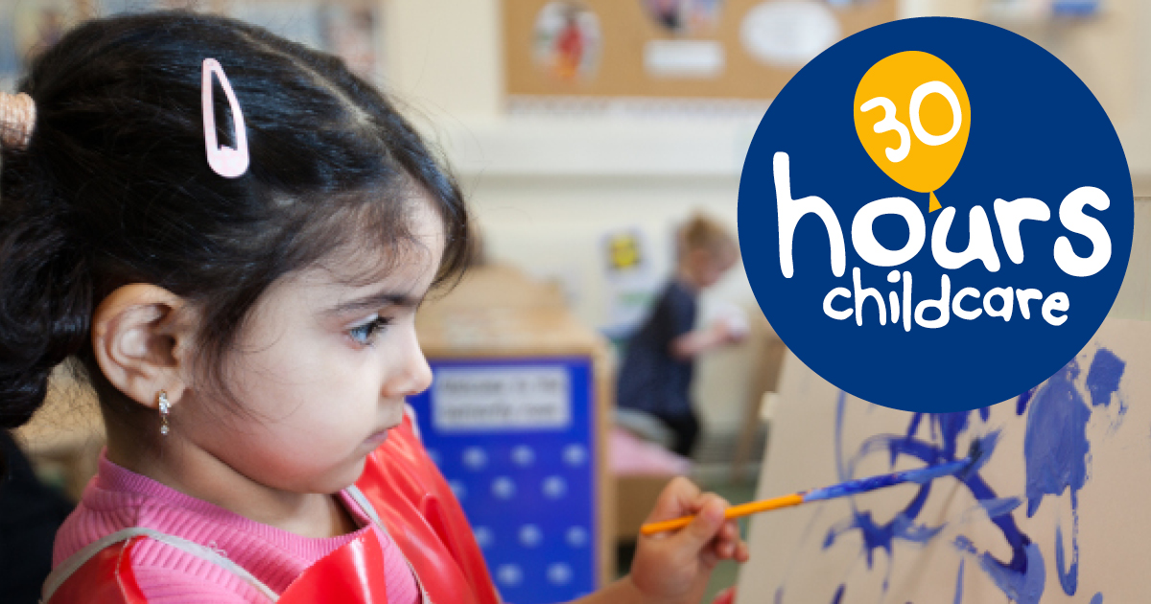
Is your child eligible for a 30 hour place in January 2018?
If so you must apply now for your code.
We strongly advise you to apply before 30 November 2017 to make sure you get your code in good time for the start of the term.
For more information www.bradford.gov.uk/childcare
Or ask your childcare provider for more details.

