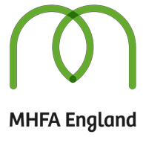
About Mental Health First Aid
Mental Health First Aid (MHFA) courses, first developed in Australia in 2001, provide robust evidence-based training that increase mental health literacy and help turn awareness into action by teaching skills to help someone experiencing a mental health issue.

MHFA has a proven international track record and has consistently demonstrated its effectiveness through evaluation. Every MHFA course in England is delivered by a quality assured instructor who has attended the MHFA England seven day Instructor Training Programme, accredited by the Royal Society for Public Health. To date, these instructors have delivered courses to over 235,000 people in England, 42,000 of those in Youth MHFA. Globally, over two million people have been trained in MHFA skills across 24 countries.

MHFA England is a community interest company (CIC) with the objective of raising mental health literacy and reducing stigma and discrimination in mental health across the whole community. In England it the sole licensed provider of MHFA Instructor Training and you can find out more about the company, MHFA courses and the evidence base by visiting mhfaengland.org.
Why Youth Mental Health First Aid?

Mental health and emotional issues often develop during adolescence, with half of young adults with mental health issues displaying symptoms by the age of 14, and nearly 75% before the age of 24. To promote the recovery of good mental health, it is important to identify the signs of a potential mental health issue at the earliest possible stage. Educating adults to spot when a young person might be struggling, and increase their confidence to offer initial support, is an important step in preventing a mental health issue from reaching crisis point.

Youth MHFA instructors have been recruited due to their diverse backgrounds in education and youth work, experience in mental health, and their ability to engage and motivate participants. Our robust quality assurance processes ensure that our instructors are consistently delivering to an agreed high standard which is continually monitored.

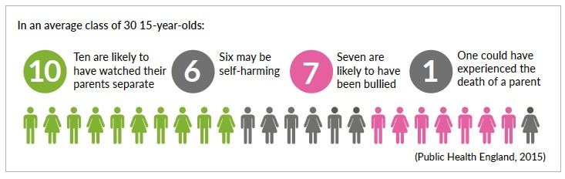

Youth Mental Health First Aid (MHFA) is the initial help given to a young person experiencing a mental health issue. The aims of Youth MHFA are to:

- Preserve life where a young person may be a danger to themselves or others
- Intervene to prevent the emotional or mental health issue developing into a more serious state
- Provide comfort to a young person experiencing a mental health issue
- Empower a young person to access further support, be that self-help, pastoral care within their school, or professional services
- Promote the recovery of good mental health
- Raise awareness of mental health issues in the community
- Reduce stigma and discrimination

With access to an adult with MHFA skills we can provide early intervention in guiding a young person to the support they may need, and empower school staff to better understand, identify and respond to young people experiencing a mental health issues.

What do you learn on a Youth MHFA course?

Youth MHFA provides school staff and frontline professionals working with young people the skills and confidence to spot common signs and triggers of mental health issues, as well as the knowledge and confidence to help. Through a mix of presentations, discussions and activities, the course covers these key topics:

- What is mental health?
- Depression and anxiety
- Suicide and psychosis
- Self harm and eating disorders

Within each section there is clear focus on the issues faced by young people today, including bullying/cyber bullying and substance misuse.

The Youth MHFA One Day course has been designed specifically with schools and colleges in mind and fits perfectly into inset days and busy timetables. Over 42,000 people have already taken a Youth MHFA course in England, including staff in over 1,000 schools and colleges.

Completing the Youth MHFA One Day course designates you as a Youth MHFA Champion. A Youth MHFA Champion is skilled in understanding how to spot the signs and symptoms of mental health issues in young people and will have the confidence to guide the young person to a place of support.

Feedback on Youth MHFA courses delivered in 2017

“To ensure that students do not have any barriers to their learning we need to support them holistically
in providing top-quality pastoral care and this excellent course effectively raises awareness and
understanding of mental health issues.”
“I believe Youth MHFA has provided me with extra tools to be able to better understand and support
young people - something so valuable in my line of work.”
“Straight after the first session I was able to use the techniques with a student (who) had anxiety and panic attacks for a number of years. By listening, reassuring her and helping her to recognise her mental health she became more confident in discussing her concerns and we were able to give her the appropriate help during her examinations.”
“I developed observational and listening skills to pick up signs of difficulties at an early stage (and) further developed close links with external agencies.”
“It is the structured approach of the course and the supporting materials that makes it so practical and
a fantastic tool to have at our fingertips.”

Programme delivery plan

The government-funded Youth MHFA in Schools programme was launched in April 2017 with the aim of training one member of staff in every state secondary school in England in Youth MHFA skills by 2020. In the first year of the programme more than 100 Youth MHFA One Day courses were delivered, training over 1,200 school staff as Youth MHFA Champions. A similar number of courses will be delivered in years two and three of the programme, at the end of which all state secondary schools in England will have been given the chance to ensure their school has at least one member of staff trained in Youth MHFA.
Now in year two of the programme, state secondary schools are again being invited to apply to take part. One representative from each invited school may attend a course, with the exception of host schools who are offered four additional places.
Access your school's free place on a Youth MHFA One Day course by contacting our schools team at schools@mhfaengland.org.

To find more information and resources on the Youth MHFA in Schools programme, please visit mhfaengland.org/mhfa-centre/schools-programme.

Expert reference group

To meet the needs of schools and the teaching community, the programme is guided by an expert reference group (ERG) led by:
- Chair: Caroline Hounsell, MHFA England Director, Youth Lead and psychotherapist
- Co-chair: James Brown, former head of year at Brentwood School and a non-executive director of MHFA England
- Jessica Agudelo, Regional Lead at MHFA England and Youth MHFA instructor
The ERG includes representation from young people with lived experience, parents and expert advisors from the fields of Clinical Psychiatry, education and Public Health. With a wide range of experience, the ERG will continue to inform and advise on the programme, as it progresses over the remaining two years.

UCL Evaluation
As part of the Youth MHFA in Schools programme, a team of academics from University College London (UCL) are conducting research on its impact, involving pre- and post-training questionnaires. Your school may also be selected to be interviewed as part of this research.

This research aims to evaluate teacher’s responses to the MFHA training by exploring and listening to teachers’ experiences, viewpoints and understandings of their training and the impact it has made upon them and their school.

The research is being conducted within the ethical guidelines provided by the British Education Research Association and the UCL Institute of Education. Care is being taken to ensure anonymity of all respondents and the security of data. All interview respondents will be provided with an Information Leaflet and a Consent Form to sign, and a summary sheet of the findings of the study will be reported back to any case study schools, as well as a copy of the final report.

