Websites to use with young children

Language development:
I CAN:www.ican.org.uk  https://ican.org.uk/ | 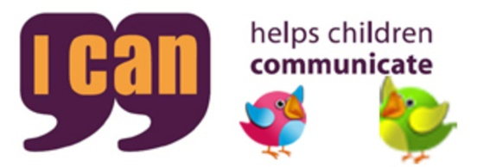
The Communication Trust:  www.thecommunicationtrust.org.uk | 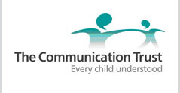
www.downs-syndrome.org.uk  https://www.downs-syndrome.org.uk/ | 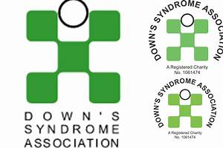
hungrylittleminds.campaign.gov.uk  https://hungrylittleminds.campaign.gov.uk/ | 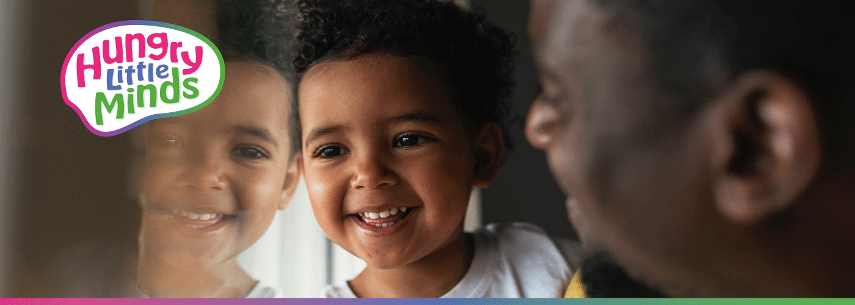
Lovemybooks.co.uk  http://www.lovemybooks.co.uk/ | 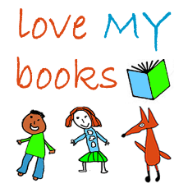
Scottish Book Trust Bookbug Song and Rhyme Library  https://www.scottishbooktrust.com/songs-and-rhymes | 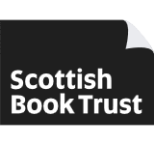

Activities and games:
helpkidzlearn.com  https://www.helpkidzlearn.com/ | 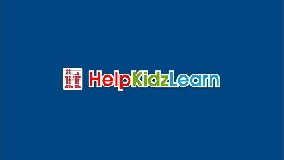
CBEEBIES: https://www.bbc.co.uk/tv/cbeebies  https://www.bbc.co.uk/cbeebies/shows?fairy | 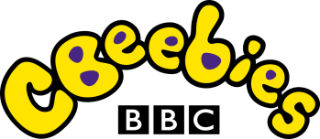
Singing Hands  https://singinghands.co.uk/ | 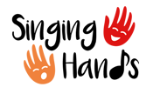
National Portage Association: https://www.portage.org.uk/ | 