WAITING FOR ANYA SCHOOL SCREENING FOR HOLOCAUST MEMORIAL DAY

Description of the Film and Event
This is an opportunity for school children to take part in a private screening event of the upcoming film, Waiting for Anya in commemoration of Holocaust Memorial Day on Monday 27th January 2020. The film is based on a novel by Michael Morpurgo (author of War Horse) and stars Noah Schnapp of Stranger Things, Anjelica Huston and Jean Reno.

During the harrows of WWII, Jo, a young shepherd along with the help of the widow Horcada, helps to smuggle Jewish children across the border from southern France into Spain.

Our target audience is children and families and this event would be a great experience for school children in Years 6, 7, 8 and 9 to view the film before it is set for release sometime in February.

We would love to give children the opportunity to hear Michael Morpurgo’s story behind the book and ask him questions in person at the Science + Media Museum, Bradford. We would also like to film some of the children’s reactions and what they thought of the film after the screening, for a short documentary that will go alongside the film when released to the general public.

Our Aim
Our main aim is to encourage children to start reading from an early age by telling the amazing story behind the young writer, Toby Torlesse, who wrote the screen play for the film after reading Michael Morpurgo’s books when he was a young boy.

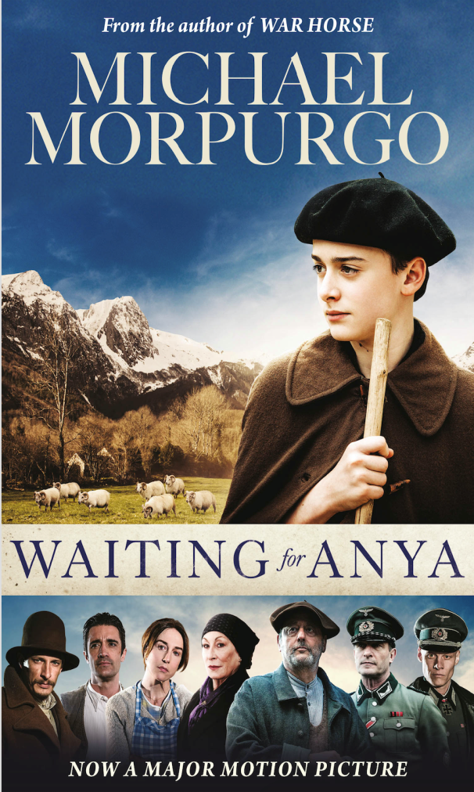
Date and Time
Monday 27th January at 9.30am at the National Science + Media Museum

Coaches and buses can be arranged to pick up/drop off children from school and take them to the Science + Media Museum for arrival at 9.30am.

For further information please contact Arran MacLennan: Highfield Grange Studios on 01757 289333 or Catherine Halliwell/David Maw: Bradford Council on 01274 439600

Timings of the Day (subject to change)
9.30am Arrival
10am Talk by Sir Michael Morpurgo
10.30-12 Waiting for Anya Film showing
12-1pm Filming children’s reactions/views
1pm Lunch
1.45pm Departure

