Ilkley Library
Station Road
Ilkey
LS29 8HA

30th September 2014

Dear Literacy Coordinator

Poppies for Remembrance Workshop with Bradford Libraries and The Peace Museum

Bradford Libraries and The Peace Museum are offering schools two WW1 Commemoration workshops.

The Poppies for Remembrance workshop looks at the significance of the poppy (red, white and purple) with a chance for the children to make their own. The questions: What is remembrance? and Why it is important? will be discussed. The children will have an opportunity to look at the displays in the Peace Museum which will complement the discussion.

The workshop will also include an opportunity for every child to have a “hands on” rag rug making session with West Yorkshire Ruggers. The library reading rug has been designed by Bradford school children via our Poppies Competition and demonstrates traditional skills from the time of WW1 while creating a legacy from the children of Bradford to commemorate the start of WW1. To date hundreds of school children have contributed and the finished rug will be a lasting remembrance to those who gave their lives during WW1.

The session will conclude with the story “Where the Poppies Now Grow” by Hilary Robinson and a minute’s silence.

The details of the workshops are:

Date: Wednesday 12th November 2014

Time: 9.30am – 11.30am & 1.15pm – 2.45pm

Location: The Peace Museum UK, 10 Piece Hall Yard, Bradford BD1 1PJ
(Please bear in mind that there are 60 steps up to the museum and no lift in the building.)

For each session there are places for 30 children from two schools. We will offer one place (15 children max) per school. The sessions are suitable for Y3 & Y4 and are free of charge.
If you are interested in booking one of the workshops above please fill in the form overleaf. The deadline for applications is Monday 20th October. Your school will be sent a letter of confirmation if you have been successful in securing a place. If you require further information please contact Christinea Donnelly Development Officer for Young People christinea.donnelly@bradford.gov.uk
T: 01274 433915.

Yours Faithfully

Christinea Donnelly
Development Officer for Young People: Bradford Libraries
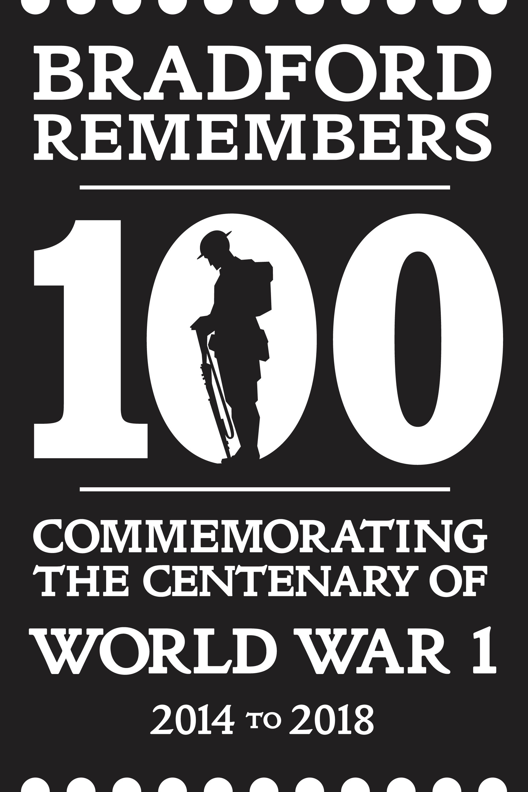

Poppies for Remembrance Workshop Booking Form @ The Peace Museum on Wednesday 12th November.
Return Form to: Christinea Donnelly, Development Officer for Young People, Ilkley Library, Station Rd, Ilkley, LS29 8HA by Monday 20th October 2014

Name of School:
______________________________________________________________________

Contact:
__________________________________________ Tel: ________________________

Email: ______________________________________________________________________

Date | Where | Time | Tick Preference & indicate  Class Year & Nos.
Wednesday 12th Nov 2014  Poppies Workshop  (15 children max) | The Peace Museum | 9.30am – 11.30am
Wednesday 12th Nov 2014  Poppies Workshop  (15 children max) | The Peace Museum | 1.15pm – 2.45pm

