Personal Education Plans (PEPs)
A Guide for Social Workers

Virtual School Bradford
Unique School, Unique Pupils

Important Messages
- The key mechanism for addressing the educational needs of the child or young person is the PEP.
- The PEP should set high expectations of rapid progress and put in place the additional, personalised support the child or young person needs in order to succeed academically and fulfil their potential
- The quality of the PEP is the joint responsibility of the local authority that looks after the child and the school. Social workers, carers, VSH’s, designated teachers and, as appropriate, other relevant professionals will need to work closely together.
Promoting the Education of Looked After Children and previously looked after children - Statutory guidance for Local Authorities and Schools.
This is statutory guidance from the Department for Education and is issued under section 7 of the Local Authority Social Services Act 1970. This means it must be followed unless there are exceptional circumstances that justify departing from it. The guidance sets out the framework through which local authorities have to discharge their statutory duty under 22(3A) of the Children’s Act 1989 to promote the educational achievement of looked-after children.

What is a PEP?
The Person Education Plan (PEP) is the statutory tool to ensure that everyone is actively prioritising the education of the Young Person, carefully tracking their progress and supporting them to achieve and to be aspirational.
All Looked After Children (LAC) have a statutory Care Plan, which is drawn up and reviewed by the Local Authority that looks after them. The Personal Education Plan (PEP) is a legal part of the Care Plan; which is a statutory requirement for LAC from from a child of 3 years if in education provision up to the age of 18.

The key personnel who should be involved in every PEP meeting are:
• The Young Person
• The Social Worker
• The Carer
• The Designated Teacher for LAC
The PEP meeting should ensure that the young person is receiving all of the appropriate support, advice and experiences to enable them to overcome any barriers to learning, to achieve their full potential and to plan for their future. Everyone at the PEP meetings should share an aspirational mind-set for the young person. There should be a shared commitment to encouraging them from an early age to do well and to aim high for their future.
We know that at times, some young people experience very significant difficulties in attending school and participating in learning. These difficulties can be very complex and can present great challenges. It is critical that all of the professionals involved in the care and education of the young person remain resilient in striving to continue to work with them, reviewing and amending the plan as often as is necessary in order to find the appropriate approach or intervention which will enable them to achieve. Everyone involved in the care and education of a young person holds a Corporate Parenting responsibility and in this capacity we must not give up.
Why do we needs PEP’s?
The Person Education Plan (PEP) is the statutory tool to ensure that everyone is actively prioritising the education of the Young Person, carefully tracking their progress and supporting them to achieve and to be aspirational.
All Children Looked After (CLA) have a statutory Care Plan, which is drawn up and reviewed by the Local Authority that looks after them. The Personal Education Plan (PEP) is a legal part of the Care Plan; which is a statutory requirement for CLA from a child of 3 years if in education provision up to the age of 18.
PEPs, statutory guidance
The PEP (pre-school to age 18) is an evolving record of what needs to happen for looked after children to enable them to make expected progress and fulfil their potential. The PEP should reflect the importance of a personalised approach to learning that meets the identified educational needs of the child, raises aspirations and builds life chances.

The statutory duty for ensuring that a good quality PEP is in place is shared between the local authority that looks after the child and the school. Social workers, carers, Virtual School Heads (VSHs), designated teachers (DT) and, as appropriate, other relevant professionals will need to work closely together.

All of those involved in the PEP process should always ensure the child’s involvement in the development and review of the PEP and also, where appropriate, the child’s parent and/or relevant family member.

All of those involved in the process of developing the PEP should use it to support the personalised learning of the child.

Who should have a PEP
All Looked After Children who are of statutory school age are required to have PEP (ages 4-18).
For younger children who are attending an early years setting, it is also good practice to complete Early Years PEP.
Content of the PEP
The PEP should cover the full range of education and developmental needs (as specified in Care planning, placement and case review (England) regulations 2010) including:
- access to a nursery or other high quality early years provision that is appropriate to the child’s age (e.g. pre-school playgroups) and meets their identified developmental needs;
- on-going catch-up support for those who have fallen behind with school work
(including use of effective intervention strategies);
- provision of immediate suitable education where a child is not in school (e.g. because of temporary or permanent exclusion);
- transition support where needed, such as when a child starts attending a new school or returns to school (e.g. moving from pre-school/ early years to primary school, primary to secondary school, from secondary school to further education, or following illness or exclusion) or when a child has a plan for permanence (e.g. placed for adoption) and may change schools as part of that plan;
- school attendance and, where appropriate, behaviour support; and
- support needed to help the child realise their short and long-term academic
achievements and aspirations.

Who should initiate the PEP?
The social worker has the duty to initiate the PEP and take the lead in the process, supported by the VS even where a looked-after child is without a school place.
Children who are new into care
The social worker should ensure that where a child is placed in an emergency, the PEP is initiated within 10 working days of their becoming looked-after; wherever they are placed as it needs to be in place before the first care review meeting. Therefore must be completed within 10 working days after the PEP meeting.
How often should the PEP be written?
A new plan should be produced following any major change, such as when a child or young person moves school or further education provider or placement or moves to another authority.
Who needs to be present at PEP meetings?
- Nursery or school setting then generally it is the carer, the Designated Teacher and the social worker as well as the child/young person (where appropriate); others can be invited if necessary.
- If a child has SEN then the SENCo might be invited or if a child has health needs then the relevant health professional could be invited.
- For a Post 16 Education Plan generally it is the young person, carer or parent, the most appropriate person from the education or training placement and social worker. Others may be invited if necessary, for example Student Welfare/Safeguarding Officer, Support Worker.
Who does what – Virtual School
The VSH will work to ensure that:
- social workers, social work managers, designated teachers and schools, carers and IROs understand their role and responsibilities in initiating, developing, reviewing and updating the child’s PEP and how they help meet the needs identified in that PEP
- all PEPs are up-to-date, effective and of a high quality and that all looked after children, wherever they are placed, have such a PEP
- there are arrangements for PEPs to be reviewed at least twice a year and for the up to date PEP to be available to feed into the next statutory review of the care plan
- Pupil Premium is released for each child in education from the Early Years –Year 11 on receipt of a good quality PEP.

Who does what – IRO
The IRO will ensure that:
- An up to date PEP is available to be discussed at each CLA Review meeting by prompting the social worker to ensure this is the case prior to the day of the meeting,
- the progress with the implementation of the current PEP and the impact being achieved is discussed in sufficient detail as part of the statutory review and at other times if necessary. Where a child has special educational needs, the IRO should ensure that the PEP review is linked with any review of those needs, and
- the IRO should raise any unresolved concerns about a child’s PEP or education provision with social workers and the VSH. The Virtual School recognises that the IRO is not an educationalist and is available to provide them with advice and support about any unresolved educational issues which might arise during the CLA review

Who does what – Designated Teacher
- The DT or another school representative should attend the PEP meeting
- The DT & CT lead on how the PEP impacts on the child’s progress including strengths, weaknesses and barriers to learning
- Leads on implementing the PEP within the school and completes the review with the Social Worker
- Updates Termly Attainment on BSO

Who does what - Social Worker
- Arranges PEP meeting.
- First PEP/Transition PEP, must happen with 10 days of child coming into care.
- PREPARE
  - Gets child’s views prior to PEP meeting.
  - Take a blank PEP copy to meeting,
  - Take the last PEP form to meeting and review this with the school
  - Draw up list of questions

Who does what – Team Managers
The SWTM will regularly monitor the PEP practice of the social workers within their
team and ensure through their management role, team meetings and supervision
conversations that each social worker understands and is fulfilling their duties as
outlined above.
Initiating the PEP
- The social worker has the duty to initiate the PEP and take the lead in the process, supported by the VS even where a looked-after child is without a school place.
- At least 2 weeks prior to the meeting the social worker should email the previous PEP to the school and a copy of the blank PEP to be completed
- The social worker should ensure that where a child is placed in an emergency, the PEP is initiated within 10 working days of their becoming looked-after, wherever they are placed.
- The social worker should (with the support of others) ensure the PEP contains a summary of the child’s current attainment and progress (including any additional needs such as SEND and mental health needs)
How often should the PEP be written?
Initiate the PEP within 10 working days of becoming looked-after and completed no more than 10 days after that as it needs to be in place before the first care review meeting
The minimum requirement for the PEP to be reviewed is once every six months. It is useful to do it before the child or young person’s Statutory (CLA) Review. However, good practice would suggest that where there are concerns regarding learning or progress they should be reviewed more regularly such as each term.
A new plan should be produced following any major change, such as when a child or young person moves school or further education provider or placement or moves to another authority.
PEP Meetings – basic agenda
- Introductions
- Review previous PEP
- SMART targets
- Actions
- Success Criteria
- Pupil Premium Plus Costs
- Share child’s views if already gathered or invite the child to share their views (if appropriate)

Don’t forget:
- To remind Carer/Foster Carer that the meeting is taking place
- Set the date of next PEP meeting at the end of the meeting

Remember - effective PEPs lead to accelerated progress for Children Looked After

What does an effective PEP meeting and a good PEP look like?
The PEP Meeting
All PEPs need to be reviewed each school term. The PEP meeting needs to be arranged to ensure that all key people can attend and that sufficient time is allocated to allow for a quality conversation. This is to ensure that the plans to support the child’s educational progress are based on current information and that they continue to fully meet the child’s educational needs. It is also to ensure that information from the PEP is available to feed into the next statutory review of the wider Care plan. For this reason PEP meetings need to be scheduled to take place on a date which is prior to the 6 monthly statutory LAC Review to ensure a high quality and up to date PEP is in place for discussion for this at the LAC Review meeting. It should not therefore be scheduled to take place immediately before or just after a LAC Review meeting.

Giving the young person a voice
Everyone should ensure that at every stage the young person is fully involved in the meetings, discussions and decision making processes in relation to their care and education. The young person should be fully supported to attend their PEP meetings and to ensure that their wishes and feelings about their education are taken into account in the development, implementation and review of their PEP. It should be noted that each young person will be expressing these views on a daily basis and not just in preparation for their PEP meeting.
If the child is either too young or feels unable to attend the meeting their views must be brought by the most appropriate person and the key discussion points should be shared in an appropriate way with the child after the meeting.
The approach to involving the young person in their review needs to be very personalised. All young people should have quality time, with the most appropriate person, prior to the meeting, to prepare for what they would like to say in the meeting. They should be supported to discuss how they feel about their education, the progress they are making, what is going well, which aspects of their care plan support them to do well at school, where they would welcome some additional
support and to consider what they may want to do in the future.
These conversations will take very different forms depending upon the young person’s age abilities, specific learning or language needs and/or frame of mind at the time. Everything should be done to support them to feel comfortable to voice their views, wishes and feelings. Some young people have said that in these situations they are expected to give “the right answers”. This will be best avoided by ensuring that the person that they talk to is someone that they know and trust.
Some young people will feel comfortable to attend their full review meeting and to actively participate in all of the discussions. For other young people attending the full meeting may be far too overwhelming. Where this is the case the young person should be supported, if possible to attend part of the meeting and where this is not possible it is important that they know that their views will be shared and discussed at the meeting.
Where a young person is to attend their review meeting, it is important that they are involved with identifying the venue for the meeting to ensure that it is suitably comfortable and private. Some young people have told us they have felt too uncomfortable to attend their review meetings because the room being used in school has had a large glass door and internal windows which has meant they would be on full view to any of their teachers or peers who might walk past during the meeting. Some have said that they have felt uncomfortable when the meeting has been held in a very formal room, such as a board room which they have never been in before and which they negatively associate with disciplinary type meetings.
It is also important that after the meeting each young person is clear about how their views have been responded to. Where their wishes, feelings or preferences can not be fully met, for example if a specific decision it is felt not to be in the young person’s best interest, then it is important that someone explains carefully to them why this is the case. It is good practice to log these conversations within the PEP.
When you have completed the PEP think, “Would this PEP be good enough for my own child?” Remember in years to come the young person may look back at this PEP. If they do will they feel that it captured their views, aspirations, talents and achievements? Will they feel reassured that they were supported to achieve well in their education through the PEP process?

A good quality PEP
To be an effective and high quality PEP it should:
- be a ‘living’, evolving, comprehensive and enduring record of the child’s experience, progress and achievement (academic and otherwise) and inform any discussion about education during the statutory review of the child’s wider care plan;
- be linked to, but not duplicate or conflict with, information in any other plans held by the child’s education setting;
- include and respond to the views, wishes and feelings of the young person;
- identify developmental (including any related to attachment) and educational needs (short and longer term) in relation to skills, knowledge, subject areas and experiences;
- include SMART short-term targets, including progress monitoring of each of the areas identified against development and educational needs;
- include SMART longer-term plans for educational targets and aspirations. These should, according to age and understanding, typically focus on public examinations, further and higher education, managing money and savings, work experience and career plans and aspirations;
- identify actions, with time scales, for specific individuals intended to support the achievement of agreed targets and use of any additional resources (e.g. the pupil premium) specifically designated to support the attainment of looked after children;
- highlight access to effective intervention strategies and how this will make/has made a difference to achievement levels;
- assimilate information from other relevant plans (e.g. Individual Education Plans (IEPs) and Pastoral Support Plans (PSPs) and EHCP’s, Health and Care Plan and include early plans to support transition to a new year group,
school or college.
When thinking about what should be discussed at a PEP meeting and recorded in a PEP document it is perhaps helpful to consider the following scenario.
If you were receiving this young person into your school, setting or college tomorrow would the PEP you have just written provide you with a good understanding of their needs, their aspirations, likes and dislikes, and of the strategies and approaches which help them to learn?
A parent is generally aware of the progress their child is making in their education and is actively involved in supporting them in their learning and the choices they are making about their future. It is through the collection of a child’s PEP documents that we ensure that as Corporate Parents, a responsibility that we all share, we have a good understanding and recall of a Young Person’s educational progress, needs, strengths, views and aspirations during their time in care.
After the PEP Meeting
- All PEPs must be put onto LCS by the social worker as soon as possible after the PEP meeting has taken place and certainly within the 10 day time limit as drift and delay is unacceptable.
- Quality of PEPs – must be at least ‘good’
The SW’s role in supporting the PEP
- Not to take significant decisions about education without reviewing the PEP in consultation with the child, the child’s school, carer, VSH, IRO and, where appropriate, their parents.
- Alert the IRO to any significant changes to the child’s PEP such as the breakdown or change of an education placement so that the IRO can decide whether a review of the care plan is required.
- Work with the child’s school or other education setting between statutory reviews of their care plan (involving the VS if necessary) to ensure up-to-date PEPs are is fed into those reviews, which are chaired by the IRO.
- Ensure that all relevant information about the child’s educational progress and support needs is up-to-date and evidenced before the statutory review meeting
- Act on any changes required to meet the child’s education needs identified by the IRO.

Pupil Premium Plus
- Total PPP grant £2300. From April 2019 50% retained centrally; schools get £1150 per year in 3 termly payments
- PPP is allocated if the child is at the school on census date
- PPP is ring-fenced for Children Looked After
- To impact on the targets with additional and different support

Getting the most from PPP
- Raising aspirations through access to high-quality educational experiences
- Building self-esteem
- Individually tailored to the needs and strengths of pupils
- Focussed on clear short-term goals which give opportunities for pupils to experience success
- Supporting pupil transition e.g. primary to secondary
Post 16 Education – Specific key points to be aware of.
Raising the Participation Age (RPA)
It is important to mention again the introduction of the raising of the participation age. The Education and Skills Act 2008 set out the legal framework for Raising the Participation Age (RPA) in England. From summer 2013, all young people have been required to participate in education or training up until the end of the academic year in which they turn 17. From 2015, this requirement was extended to apply until their 18th birthday.

Participation means one of the following:
- Full-time education, such as school or college;
- An Apprenticeship, or other work based learning;
- Part-time education or training if they are employed, self employed or volunteering for more than 20 hours a week.

Vulnerable Bursary for Post 16
- CLA Post 16 and Care Leavers up to the end of Year 13
- £1200 across the academic year
- Usually paid termly or weekly
- SW to provide a letter confirming the CLA status
- School/College can then process the claim
- YP will need to have a bank account

Where can I get further information about PEPs?
- Bradford Schools Online (BSO) - (BSO.bradford.gov.uk) In the site contents menu on the left hand side of the page there you will find the Virtual School with a drop down menu full of information.
- From any member of the Virtual School Team, we are located on floor 4 at Sir Henry Mitchell House.
- Email enquiries - VirtualSchoolEnquiries@bradford.gov.uk
- From your team manager or PEP champion if you have one

Age Related Expectations (ARE/EXS) – where should children be – at what age
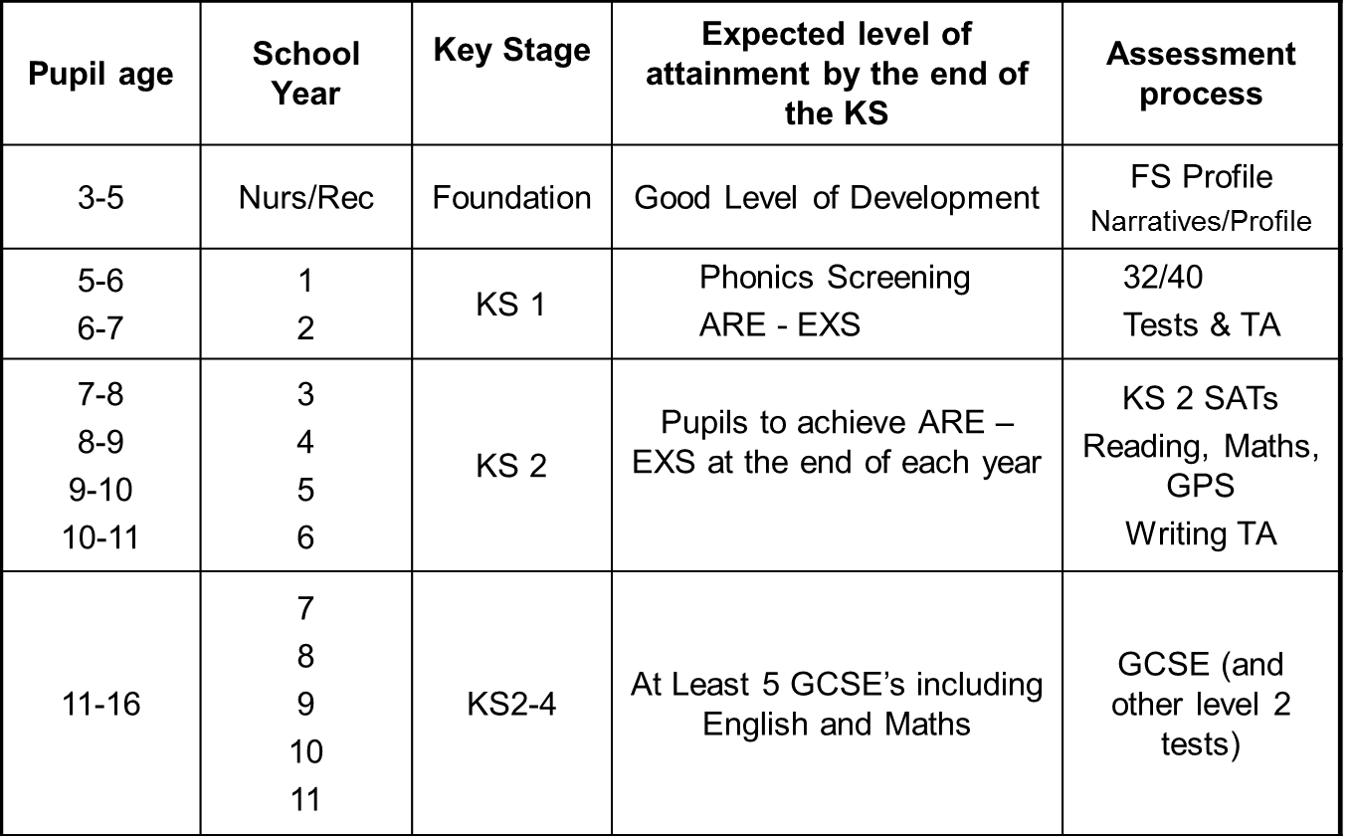

The Early Years Foundation Stage

The seven areas of learning and development | 17 Aspects
Three Prime areas
- Personal, social and emotional development | Making relationships
 | Self-confidence and self-awareness
 | Managing feelings and behaviour
- Physical Development | Moving and handling
 | Health and self care
- Communication and language | Listening and attention
 | Understanding
 | Speaking
Four Specific areas
- Literacy | Reading
 | Writing
- Mathematics | Numbers
 | Shape, space & measures
- Understanding the world | People and communities
 | The world
 | Technology
- Expressive arts and design | Exploring and using media and materials
 | Being imaginative

- Each of the seventeen aspects above has an Early Learning Goal (ELG) which teachers support children to achieve by the end of the reception year.
- Teachers assess their children and gathering information against the development matters points in the EYFS curriculum which works towards the ELGs.
- By June each year, teachers will be ready to make a final assessment to decide whether children have achieved the Early Learning Goals for the seventeen aspects or not. This is a ‘best fit’ judgment of each ELG separately.
- For each ELG, the teacher has to decide which of the following three judgement is most accurate:
- Emerging. The child has not yet achieved the ELG but is working somewhere within the six developmental bands of the EYFS curriculum e.g. 30-50 months.
- Expected . The child has achieved the ELG as a best fit judgement
- Exceeding. The child has gone beyond the ELG and is working within the KS1 National Curriculum

Good Level of Development (GLD)
- A child has reached expected (goal) level in all Prime Areas and both literacy and maths (12 areas in total).

Key Stage 1
- Phonics Screening in Y1 – young people take this test in the summer term and need to get at least 32/40 to pass. There is an opportunity to retake in Y2 if unsuccessful.
- Children get awarded a ‘standard’ – WTS, EXS or GDS. Children not achieving WTS can get PKG – not to be confused with ‘P’ scales.
- Throughout KS1&2 Children need to be working at Age Related Expectations in Reading, Writing &, Mathematics at least.
Key Stage 2
- At the end of the Key Stage – in Y6 children take SAT’s in Reading, GPS and Maths. Writing is by teacher assessment.
- Children need to be working at EXS at least in Reading, Writing &, Mathematics at least.
Key Stage 4
As you are probably aware the government has introduced radical new changes to the structure and assessment of GCSEs. This is to align the UK with the best education systems in the world.
They have moved away from the familiar system of A*-G grades to a system of grading with number, 1-9. In addition to the changes to the structure of GCSEs, the DfE until 2019, has also redefied a ‘standard pass’ to be a grade 4 (the equivalent to a C in the old GCSE grading system) and a ‘strong pass’ to be a grade 5 (the equivalent to a high C or low B).
Grade 9 is the highest grade and will be awarded to fewer students than the old A*.
The old and new GCSE grading scales do not directly compare but there are three points where they align, as the table below shows:
- The bottom of grade 7 is aligned with the bottom of grade A;
- The bottom of grade 4 is aligned with the bottom of grade C; and
- The bottom of grade 1 is aligned with the bottom of grade G. 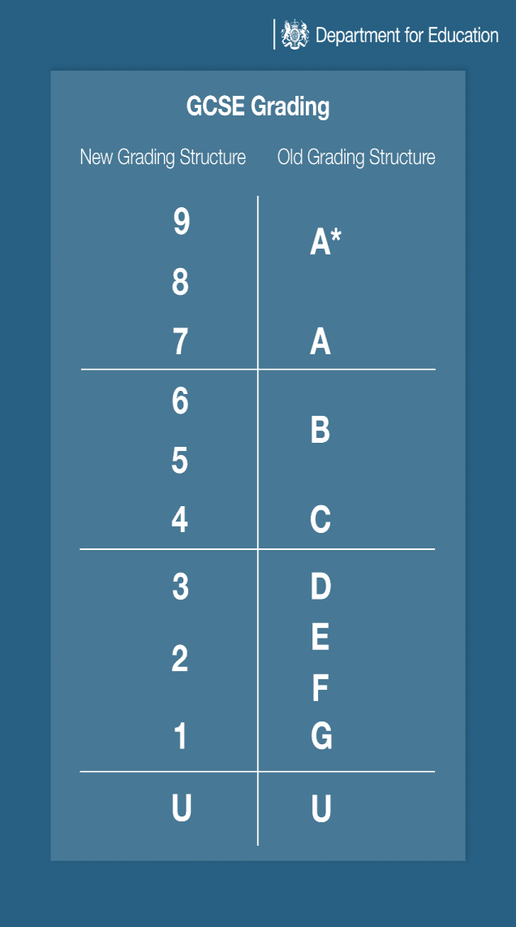
Personal Education Plans
Personal Education Plans – Checklist for auditing:
Outstanding
- PEP gives a wide range of parent/carer and professionals clear insight into the child’s developmental and educational needs.
- There is evidence that future transitions are planned and documented to support the child’s developmental needs as appropriate (e.g. placement, school, year group, key stage)
- If the child’s development raises concerns there is clear evidence that the provision is implementing actions, including timescales, specific individuals and effective intervention strategies and working in partnership with carers and co-ordinating with other services.
- The provision’s practice consistently reflects the highest expectations and the highest aspirations.
- Children’s educational progress is in line with their end of year target and their current progress (data uploaded to BSO)
- Identified actions will match learning needs.
- The child’s voice is recorded and there is evidence that it is fully acted upon through next steps and adult actions.
- Includes SMART short term targets, including progress monitoring of each of the areas identified against developmental and educational needs.
- All aspects of the PEP are completed in detail and is used/ viewed as a working/ evolving document.
- The success criteria shows measurable impact on development.
- Pupil Premium Plus (where eligible) is costed and evidenced towards the target.
- PEP review document completed in detail.
Good
- PEP gives a range of parent/carer and professionals some insight into the child’s developmental and educational needs.
- There is some evidence that future transitions are planned.
- If the child’s development raises concerns there is evidence that the provision is implementing actions and working in partnership with carers and other services including some timescales, specific individuals and effective intervention strategies and working in partnership with carers and co-ordinating with other services.
- Provision is in place to meet identified learning needs.
- The child’s voice is recorded and is considered alongside next steps and adult actions.
- All aspects of the PEP are completed.
- Next steps are appropriate and in line with the summary of learning, development and additional needs.
- Pupil Premium (where eligible) is evidenced and outcomes improved.
- Children’s educational progress is in line with their end of year target and their current progress (data uploaded to BSO)
- Includes SMART short term targets, including some monitoring of progress of each of the areas identified against developmental and educational needs
- All aspects of the PEP are completed in detail and is used/ viewed as a working/ evolving document.
- Success criteria shows some measurable impact on development.
- Pupil Premium Plus (where eligible) is costed and evidenced towards the target.
- PEP review document completed in detail.
Requires improvement
- PEP gives parent/carers and professionals some insight into the child’s educational development and needs.
- There is some evidence that future transitions are planned.
- If the child’s development raises concerns there is some evidence that the setting is implementing actions and working in partnership with carers.
- Includes short term targets, but some monitoring of progress of each of the areas identified against developmental and educational needs
- Identified provision does not adequately match learning needs.
- Individual target setting is not aspirational.
- Child’s voice is not reflected in the actions.
- There are gaps in recording on the PEP.
- Pupil Premium (where eligible) is recorded but no recording of outcomes or expected outcomes.
Inadequate
- PEP gives parent/carers and professionals no insight into the child’s educational development and needs. There is no evidence that future transitions are planned.
- If the child’s development raises concerns there is no evidence that the setting is implementing actions and working in partnership with carers.
- Includes vague short term targets, with no monitoring of progress of each of the areas identified against any needs
- There is no evidence of provision to match learning needs.
- Learning needs have not been clearly identified.
- Next steps are not recorded.
- There are many gaps in recording on the PEP.
- Child’s voice is not adequately represented.
- The actions will not address the needs raised in the PEP.
- The Next Steps do not reflect appropriate development.
- Pupil Premium (where eligible) is not completed with impact and used for its intended use

Contacting the Virtual School
Virtual School for Looked After Children Team
Ken Poucher | Head of the Virtual School for CLA | 01274 439623
Rita Kumar | Deputy Head Teacher | 01274 439639
Harbinder Bola | Specialist Teacher - Children on the Edge of Care | 01274 434607
Ann Shepherd | Specialist Teacher - Post Looked After and Secondary Looked After | 01274 435860
Louise Coates-Black | Specialist Teacher and Attachment Lead | 01274 434599
Caroline Dolan | Specialist Teacher and Attachment Lead | 01274 434612
Joy Robson | Post 16 Specialist | 01274 437123/432250
Fiona Wood | Data Collection & Analyst Officer | 01274 435280
Joanne Henry | Data Collection & Analyst Officer | 01274 435860
Yvett Green | Attendance & Admin Officer | 01274 438771
John Whittock | Out of Hours Support Teacher
Enquiries | VirtualSchoolEnquiries@bradford.gov.uk

