Guidance for inputting the termly attainment of children looked after into
Bradford Schools Online

- Select Utilities and then Termly Attainment. A list of the Children at your school who are Looked After by Bradford Council will appear. There will be the options to select the Childs Personal Education Plan and Manage Termly Attainment. Select ‘Manage Termly Attainment’ and then the appropriate Key Stage, year group and term. Remember to click on the green update box to save.

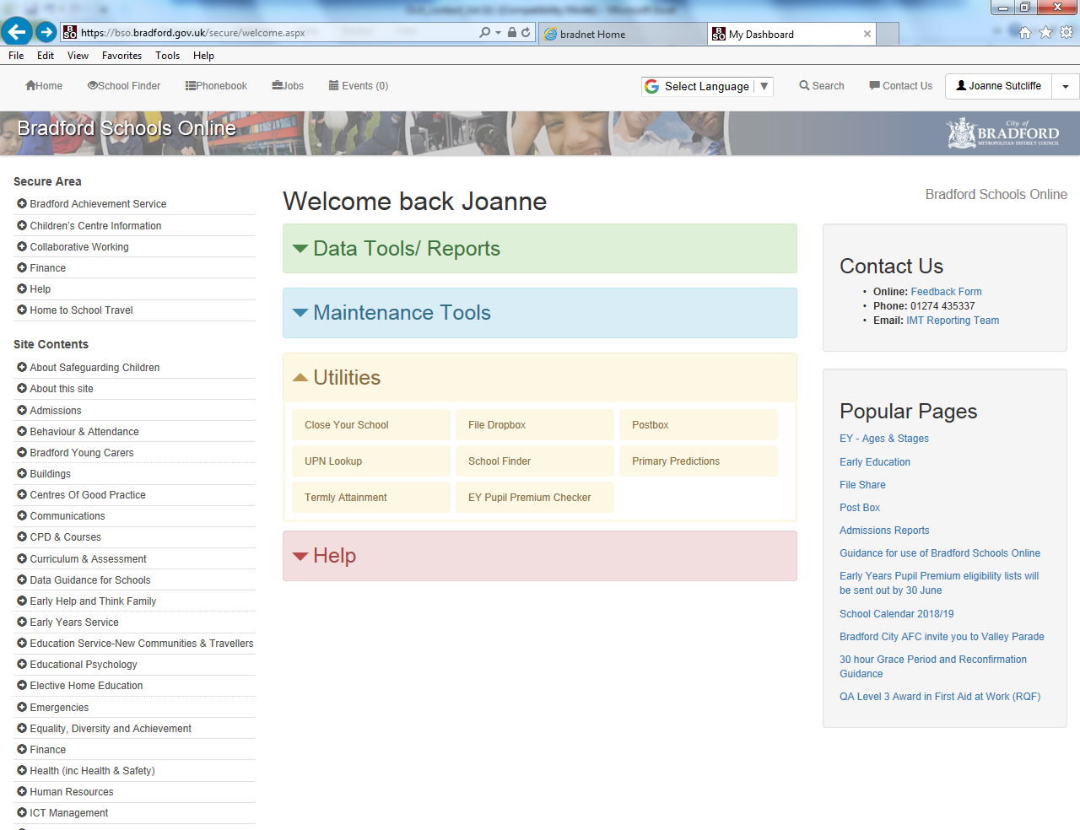
Bradford Schools Online
Primary Schools - Early Years Foundation Stage
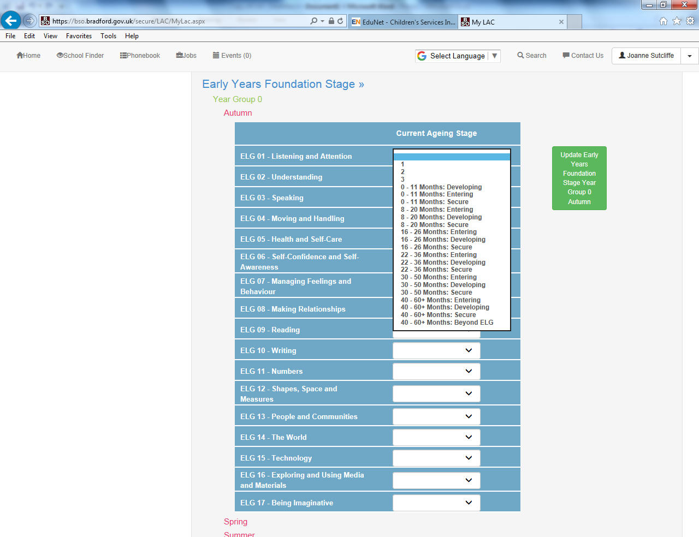
Click on the appropriate term to enter the current stage for each Early Learning Goal
Primary Schools – Key Stage 1
This shows an example of a child who was on track to achieve the ‘Expected level’ in Maths in the Autumn term of Year 2. By the Spring term the child was no longer on track. The child was Working Towards the expected level for their Year at the end of Year 2.
English is being removed for KS1.
GPS is being removed for KS1.
The end of year targets need inputting each term for Maths, Science, Reading and Writing. The target should stay the same throughout the year.
The predicted box needs completing each term for Maths, Science, Reading and Writing. This will indicate based on how the child is currently performing, what they are likely to achieve at the end of the year.
The achieved box needs completing each term for Maths, Science, Reading and Writing. to show how the child is currently performing.
The achieved box needs completing for Phonics once the child has taken the Phonics test. The On track box should be completed each term to show if the child is expected to achieve the benchmark in Phonics.
Yes or No should be selected in the on track box to show if the child is on track to meet the expected target by the end of the year
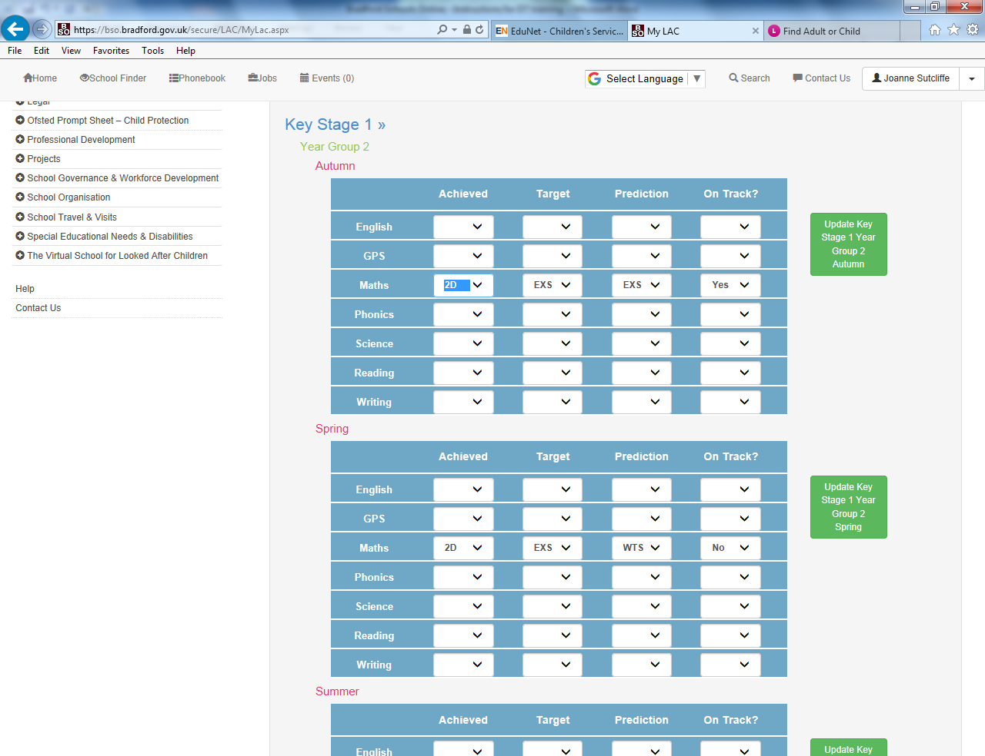
Key Stage 1 Continued..
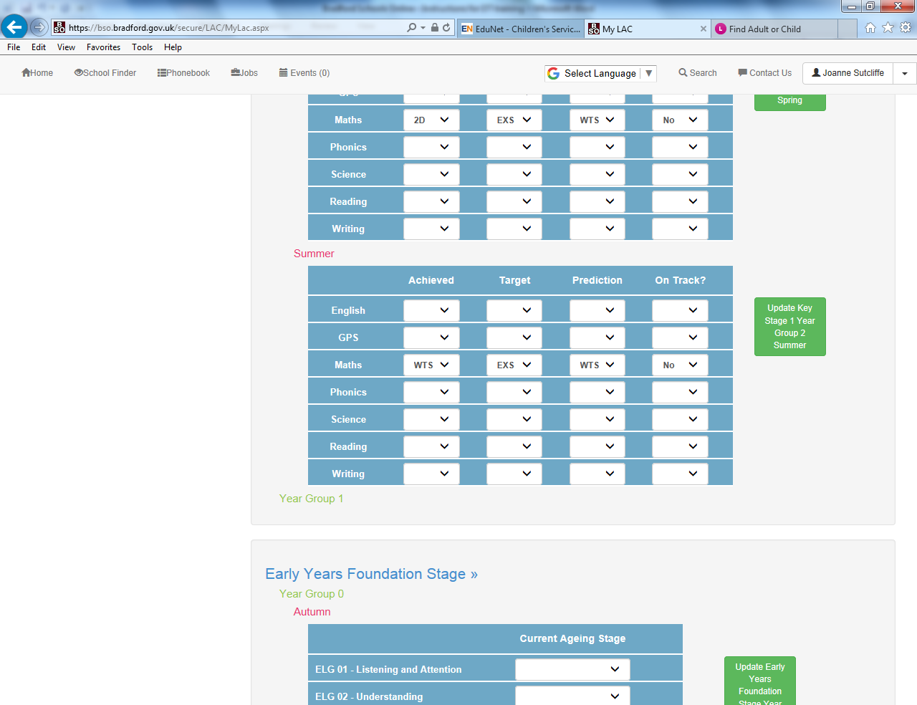

Primary Schools – Key Stage 2
This shows an example of a child who achieved Greater Depth at the end of Year 6. In the Autumn term the child was predicted to achieve the Expected level. However the child achieved Greater Depth at the end of KS2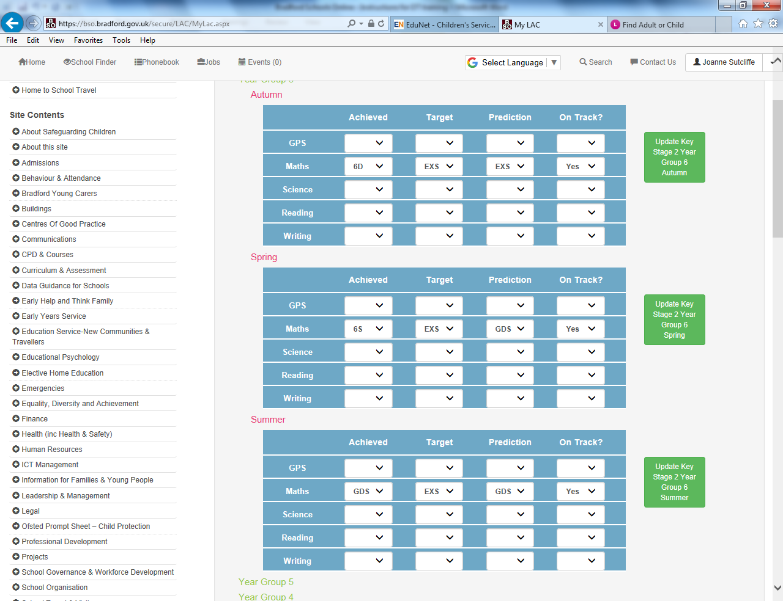
The end of year targets need inputting each term for GPS, Maths, Science, Reading and Writing. The target should stay the same throughout the year.
The predicted box needs completing each term for GPS, Maths, Science, Reading and Writing. This will indicate based on how the child is currently performing, what they are likely to achieve at the end of the year.
The achieved box needs completing each term for GPS, Maths, Science, Reading and Writing, to show how the child is currently performing.
Yes or No should be selected in the ‘on track’ box to show if the child is on track to meet the expected target by the end of the year

Secondary - Key Stages 3 and 4
This shows an example of a child whose predicted grades for the end of key stage 4 changed from the Autumn term to the Spring term in Year 9 based on how the child had performed.
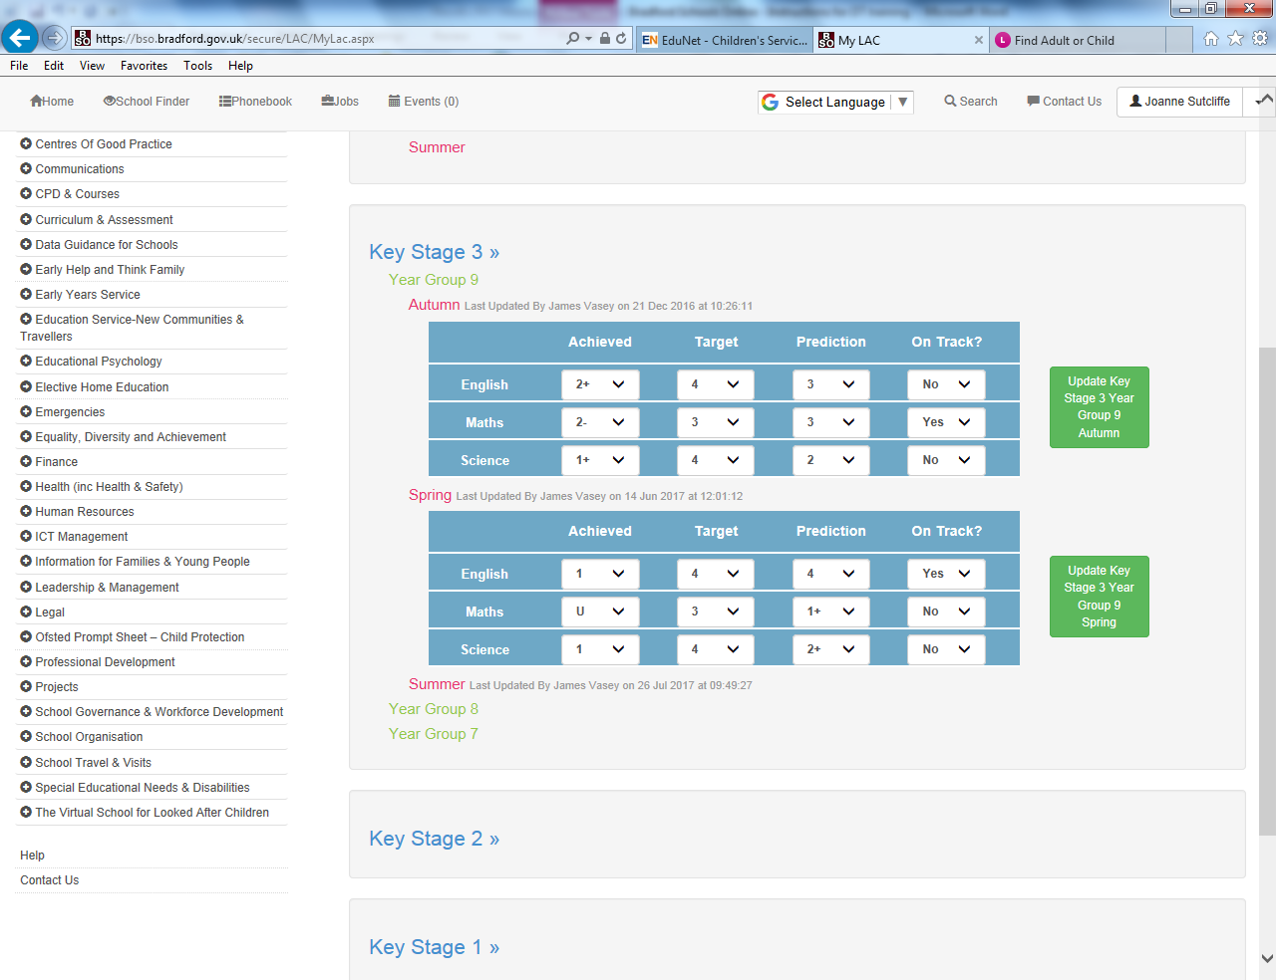
The targets for the KS3 and KS4 data should be the end of Key Stage 4 target which will be based on how the child performed at Key Stage 2. The target should stay the same until the end of key stage 4.

The predicted grades should show what the child is predicted to achieve at the end of Key Stage 4 based on how the child is currently performing.

The achieved grades should show how the child has performed in the end of term assessment.
The On track box should be Yes if the child is on track to meet their end of KS4 target.

