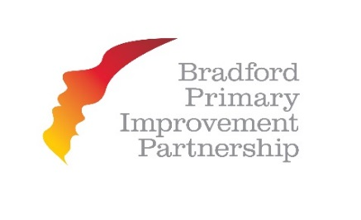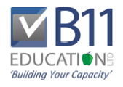
By schools – With schools – For schools

Training in inspection skills
How to become your School’s ‘Resident Inspector’
for
Bradford Primary Improvement Partnership
Primary Schools & Academies
1st & 2nd December 2014 9.30a.m. – 4.00p.m. at Future House, Bolling Road (4 places available)
19th & 20th January 2015 9.30a.m. – 4.00p.m. at Future House, Bolling Road
12th & 13th March 2015 9.30a.m. – 4.00p.m. at Green Lane School, Green Lane
Developed by highly experienced senior inspectors, this two-day training course closely mirrors key aspects of the training normally undertaken by trainee school inspectors.
The course is designed to equip participants with similar skills used by newly trained school inspectors, each area is covered in an imaginative and realisting setting. Using examples from inspection, the whole revised 2014 inspection process is covered to ensure that all delegates gain the same skills as a school inspector.
Outcomes:
- A skilled ‘Resident Inspector’ who heads up the quality assurance aspects of your school’s future work
- A thorough understanding of how school inspectors apply the revised September 2014 framework for inspection and what they look for during inspections
- Knowledge of how the right evidence is collected and recorded to secure judgements
- Increased confidence in making judgements about the quality of teaching and pupil achievement
- More rigiourous evaluation of pupil progress through work scrutiny, discussion and performance data
- A strong evidence base to support self-evaluation and build your capacity for sustained improvement
Suitable for:
Headteachers/Principals and Deputy or Assistant headtecahers who have not previously attended the course or those who wish to refresh their understanding of the new framework
For more information and in order to reserve your place on this 2 day course, contact:
Yasmin Umarji, Senior Primary Partnership Officer:Email: yasmin.umarji@bradford.gov.uk
Mobile: 07582109272

