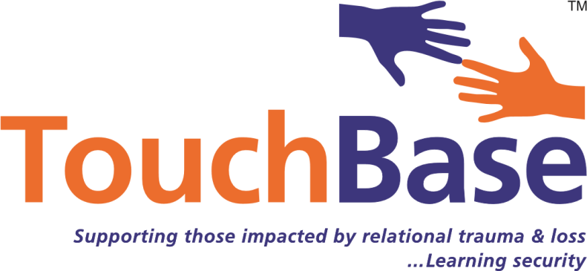

Attachment Lead in Schools training
Accredited by

Understanding how to support adopted, fostered and troubled pupils to settle and learn
Presented by
TouchBase Strategic Attachment Lead Teachers
This 7 day modular training course has been developed to enable school staff themselves to become Attachment Leads in their schools and local authorities. The course is for those determined to provide alternative practices to enable all pupils to be fully included in school making the most of all the educative opportunities on offer. The course is rooted in attachment awareness and trauma informed practices. By attending to the attachment systems of individual pupils, these pupils can settle to learn. This course will be based on the latest findings around interventions to support those affected by developmental trauma, loss and insecurity of attachment. The course will complement the book ‘Settling troubled pupils to learn: Why relationships matter in school’ co-authored by Louise Michelle Bomber and Dan Hughes. The course will enable staff to identify and assess the need for alternative, additional support in school and to set up integrative support plans for individual pupils over 2-3 years.

Aimed primarily at both education support staff (TAs/Mentors) and their Senior Managers (INCOs, SENCOs, Assistant Heads) who are determined include pupils in their schools who are vulnerable, a cause for concern, in need, at risk, in care, on special guardianships or adopted. However Virtual School Head teachers, the Virtual School team and various behaviour outreach services have also attended. Educational Psychologists have also participated as part of their doctorates at Queens University in Belfast. Those who have recently gained Attachment Lead status are listed on the following website: www.attachmentleadnetwork.net

Entry requirements
- Ideally two members of staff chosen from the same school if possible – a senior manager/leader and member of support staff
- A commitment of 7 days release from usual school duties to attend between 9.30am and 3.30pm over the duration of a year
- Completion of an application form for registration with the university
- A live case from each school to be reflected upon throughout the duration of the course
- A commitment to undertake background reading and to carry out follow up work in between sessions that includes assessed course work
- A commitment to deliver a twilight taste to their own staff after completion of the course
- Participation in a support network with other course members once the training course is completed

With full attendance and successful completion of course work students are awarded higher education credit by the University of Brighton.

University Benefits:
- Full access (including online) to all the University’s library facilities
- For undergraduates - 20 credits at either Level 4 (level of study of first year of honours degree) or Level 6 (level of study of final year of honours degree)
- For postgraduates – 20 credits at Level 6 may be transferred to a postgraduate certificate or Masters.
- A University of Brighton card and eligibility for an NUS card too.

Course Content and Structure
Day 1: Identification of those needing attachment support programs: The impact of developmental trauma and loss, the developmental trauma tree, insecure attachment, intersubjectivity, the brain and vagal tone, developmental vulnerability, behaviour as communication, the attachment support pyramid for schools, preventative work, adaption & recovery

Day 2: Assessments of those needing attachment support programs: Reflective practice, Fact files, observations, checklists, different attachment styles, emotional & social age, the developmental trauma framework for assessment, working together with home and outside agencies, reflecting upon the current systems in place in school, honouring difference and diversity

Day 3: Formulation of attachment support programs: Creating an individual development plan, facilitating a secure base, setting up protected space and time, sensory breaks, differentiating emotional & social tasks & expectations, the allocation of an appropriate key adult, identifying the team around the child, secondary stress management and support, engaging in preventative work

Day 4: The power of relationship and the development of permanency and constancy plus work discussion group: Relational interventions using PACE, practicing relative dependency, reflective function, emotional regulation, holding a pupil in mind, intro to Theraplay, complimentary intention, holding onto success, co-modelling, co-regulation, commentaries, wondering aloud, advocacy

Day 5: Transitions and Home/School Partnership plus work discussion group: Meet and greet, preparation, overwhelm, disappointment rituals, holding on, memory cards, being sensory detectives, tight team work, constancy, creating pauses, memory building

Day 6: Lowering the effects of toxic shame plus work discussion group: The difference between guilt and shame, the build-up of shame, the presentation of toxic shame, enabling clear thinking, use of parts language, safe spaces, exit plans, the mismatch of motives and intentions, reclaiming and rethinking discipline, connection before correction

Day 7: Evaluation and support day: Course participants are encouraged to use this day to refine their knowledge and understanding, consolidating their learning into action within their individual school contexts. Preparation for their taster twilight session. Gathering and creating resources. Whole school policies will be considered. Looking to the future……. Keeping the momentum going!
Dates:
Day 1 – 12/1/18
Day 2 – 2/2/18
Day 3 – 9/3/18
Day 4 - 20/4/18
Day 5 – 11/5/18
Day 6 – 22/6/18
Day 7 – 28/9/18
The cost of the course is £600 per person and this includes 7 days of training, course supervision and monitoring by Louise M Bomber and university accreditation fees paid to Brighton University.

If you would like to book please contact Joanne Henry on
Email joanne.sutcliffe@bradford.gov.uk
Telephone: 01274 435860

