Department of
Children’s Services
– Aiming High for Children

Music & Arts Service
Fairfax Learning & Development Centre, Flockton Road, Bradford, BD4 7RY
Tel: 01274 434970
Fax: 01274 408335
Email: schoolsmusicandarts@bradford.gov.uk
For the attention of
The Headteacher
Music Co-Ordinator and Bursar

Appleton Academy

4 April 2016

Dear Headteacher

ACADEMIC YEAR 2016-17 – MUSIC AND ART PACKAGES

Following the publication of the National Plan for Music Education (which is available to view via BSO) the Government’s expectation is that every child will have the opportunity to learn to play an instrument AND sing regularly. The Music & Arts Service has developed several highly subsidised packages to allow all schools to participate in such schemes – these can be tailored to meet each school’s individual needs – with the packages also comes live music performances for the school, access to Charanga (online music tool) and opportunities to participate in ensembles/large performances.

Over the next academic year the Bradford Music Education Hub hopes to work with you to ensure all children have the opportunity to learn a musical instrument. A member of the team will contact you regarding this.

However, if you want to book a Whole Class Ensemble Teaching Scheme now, please ring Debbie Bellwood on 01274 435014 and we will work with you and assess your requirements.

If you do not wish to participate in any of our schemes please would you complete and return the form attached in order that records may be updated and data collected from you at the appropriate time if applicable.

Full package details can be found at: http://bso.bradford.gov.uk/Schools/CMSPage.aspx?mid=2164

If applicable, a Service Level Agreement for your current music provision is attached if you simply wish to renew this provision please complete, sign and return this form by 29 April 2016. If any instruments are issued to your school a list reflecting this will be attached. Any queries regarding instruments should be directed to Windstruments on 01274 510050.

Please also find attached booking forms for small group instrumental/vocal teaching, curriculum and pianist support, information on Whole Class Ensemble Teaching Schemes together with booking forms for art provision and our academic year schedule.

If we can be of any further assistance then please do not hesitate to contact either Debbie Bellwood – Business Manager or myself.

Yours sincerely

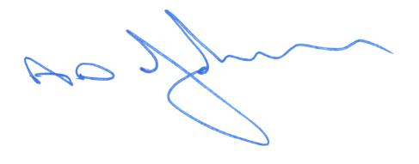

Tony Johnson
Head of Music & Arts Service

Encs

Music & Arts Service Fairfax Learning & Development Centre, Flockton Road, Bradford, BD4 7RYTel: 01274 434970 Fax: 01274 408335

School Name: Appleton Academy

We do not wish to participate in any of the Music & Arts Service Whole Class Ensemble Teaching schemes

We will be providing a _________to Year ____ and details will be provided for the DfE return.
(eg recorder scheme 4)

We will be providing a _________to Year ____ and details will be provided for the DfE return.

We will not be providing any Whole Class Ensemble Teaching schemes in the academic year 2016-17

Is there a Plan for Music in your School /Action Development Plan? Yes/No

Headteacher_________________________Signature______________________Date_____________

Please return to the address/fax above no later than Friday 29 April 2016

