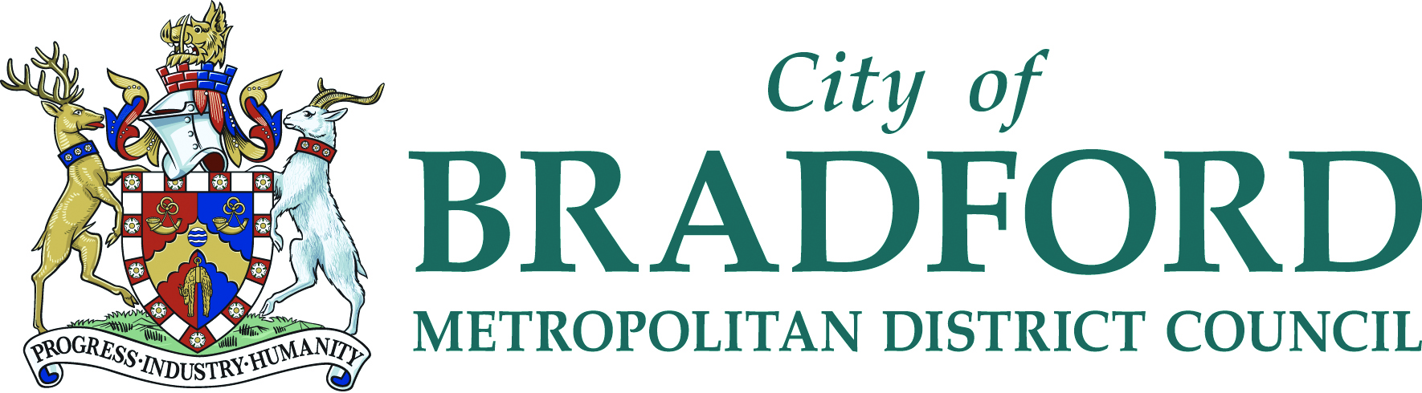

Ilkley Library
Station Road
Ilkley
LS29 8HA

5th September 2018

Dear Literacy Co-ordinator

Thought Bubble Festival at Bradford Libraries –

Comic – Writing Workshops

Bradford Libraries are delighted to have teamed up with Leeds Sequential Art Festival – Thought Bubble to offer:-

Creating Imaginary Friends (And getting into Trouble with Them) Workshop with best selling Marvel & DC novelist and author Greg Rucka.

This is what Greg says about himself: - “Greg Rucka is a novelist and writer of comics and movies with over twenty years of experience, with lots of awards and things, and sometimes gets his books on bestseller lists. In addition to creating his own stories and characters, he’s had the honour of writing adventures for characters like Wonder Woman, Batman, Superman, Spider-Man, and Wolverine, as well as for others who wield lightsabers and live in a galaxy far, far away.”

The workshop is called “Making-up Imaginary Friends (And Getting into Trouble with Them). It is about creating characters and how to let those imagined creations build a story. Every character is different, and working together the children will create a hero (or a villain! or both!) and put them through their paces.

The details are:

Date: Friday 21st September 2018

Time: 10am – 11.30am

Where: City Library, Centenary Square, Bradford BD1 1SD

We have places for two schools each bringing 15 pupils from KS2, with an interest in comic creating and writing/Marvel or sci-fi fantasy comic characters/images.

If you are interested in booking a place please fill in the form below and return to the above address or email below by Monday 10th September. Your school will be emailed a letter of confirmation if you have been successful in securing a place. If you require further information please contact Christinea Donnelly Development Officer for Young People T: 01274 433915. Alternatively email christinea.donnelly@bradford.gov.uk

Yours Faithfully

Christinea Donnelly
Development Officer for Young People

Thought Bubble Festival Comic Writing workshops at Bradford Libraries

Name of School: _____________________________________________________________

Contact: __________________________________________ Tel: ______________________

Email: ______________________________________________________________________

Date | Event | Time | Tick Preference & indicate class year & nos.
Friday 21st September 2018 KS2 (15 children max) | Marvel Characters Workshop with Greg Rucka @ City Library | 10am – 11.30am

