Phonics is fun – Phase 2
How to include young children with special educational needs
in daily phonics in Upper Foundation

Young children require an active approach to learning and phonics is no different! For children who are struggling to remember letter names and sounds, it is important for them to engage as many senses as possible and to enjoy their learning! If a child is unable to hear rhyming words they will find it difficult to hear different sounds in words. The first step is often to recognise and understand what their name begins with orally.

The following ideas are currently being used successfully in Upper Foundation classes with children who have a range of special educational needs including visual impairment and delayed speech and language.

Active phonics

- Each child makes their own telescope to look for letters – when the child finds a letter they can put a coin in a treasure box. The children can make their own rules, for example, 5 coins = 1 sticker.
- Treasure boxes – children to say the initial phoneme of each object or spell out the word. Can use a puppet who makes mistakes for the children to correct!  - What’s in the box? Use a treasure box – find the odd one out by initial phoneme or rhyme. Throw the odd object into a dustbin, saying  “In the bin you go!” | 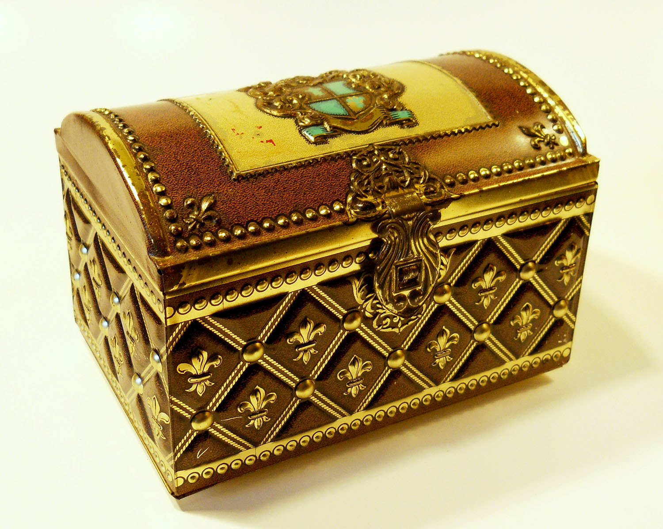  

- Play ‘Pass the Parcel’ – on their turn the child may follow an instruction on a card or pick an object from a basket and say what it begins with or segment.

Forest School phonics

- Find things beginning with…..
- Use the mud kitchen or a muddy area to mix mud and write in it with a stick.
- Write on the back of bark using mud. Mixing the mud with water, children can discuss adding quantities of water – more/less).
- Make treasure hunts to find cvc objects. Follow a map. When the child finds an object it is put in a bag after the child has segmented it – s-t-i-ck.  - Make a hooter from 2 twigs and a blade of grass – make medial vowel sounds through it as they sound louder. | 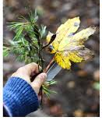

- Make ladybirds with letters on their backs (these can be put in order or used to practise prepositions).
- Make perfume and list the ingredients on blackboards hung outside. The children can read each other’s’ lists.
- Make 4 little bark houses or fairy doors and position north, south, east and west. Give clues for the children to follow, for example, “Take 4 steps to something beginning with ‘f’.” | 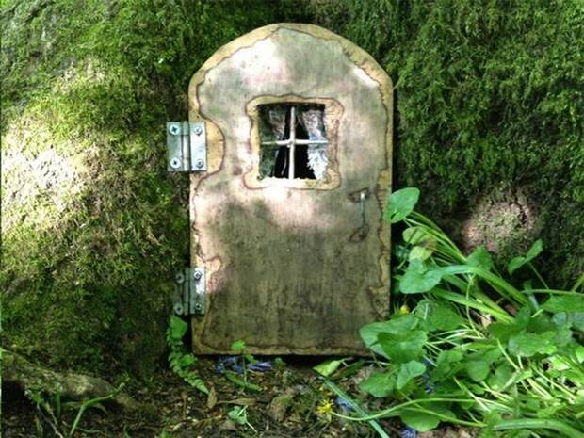

- Feel objects outside such as bark, snow etc. Encourage the children to describe what the objects feel like. These adjectives can be grouped by initial phoneme and used for alliteration.

Fairy tale phonics

- Make magic wands with wool and sticks. Write down spells using cvc words or rhyming words. The adult begins with “Abracadabra – a log”. The child responds with “Abracadabra - a log and a frog”.
- Dragon eggs – adult writes phoneme/digraph on shiny pebbles using IWB pens. Children can look for the dragon nests and find the eggs – dragon fluff can be added using green wool. | 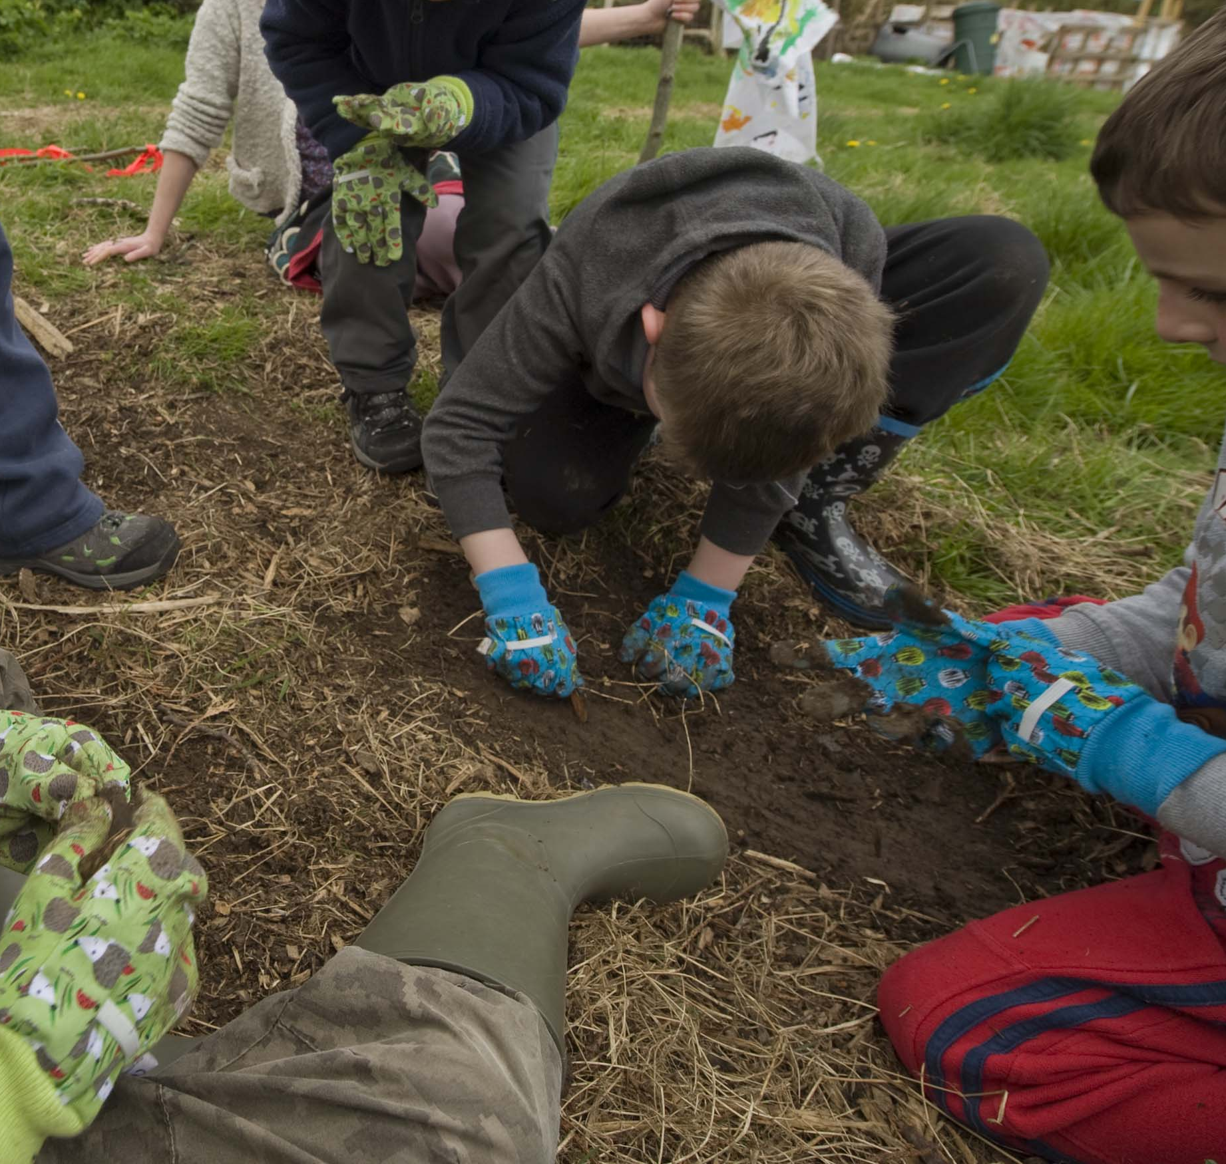

- Make an elf horn to blow vowel sounds.

With thanks to Amanda Worton who is currently co-ordinating early years and forest school provision at Blankenhagen Primary School, having worked for several years at High Fernley, Wyke.

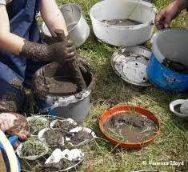 | 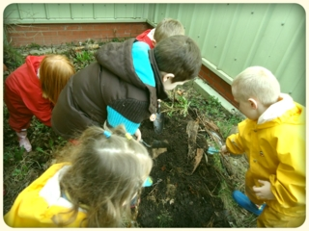

If you have any ideas you would like to add please send them to
sylvia.cramp@bradford.gov.uk – thank you.

SC - SEN EIT – September 2015

