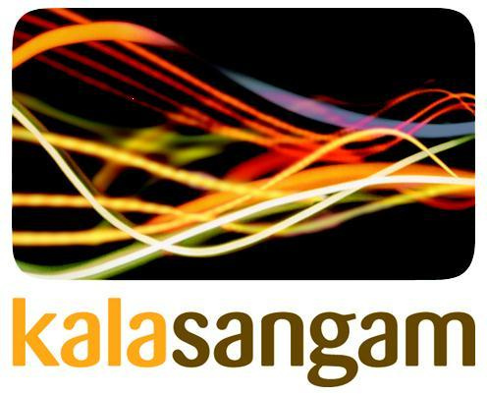

Sounds of South Asia – Performances
Introduction:

Kala Sangam founded in 1993 adopted Bradford as a base and is now a leading South Asian arts company in the north of England working nationally and internationally. It is housed in a grade 2 listed building which is in the process of developing into a beacon centre of excellence dedicated to South Asian arts, culture and heritage.

Kala Sangam a National Portfolio (NPO) client of Arts Council England is constituted as a registered charity (1055488) and a company limited by guarantee (03195878). We work with people of all ages, abilities, races, religion and ethnic backgrounds.

Our Mission is "to deliver outstanding South Asian and intercultural arts in contemporary Britain and beyond be a dynamic intercultural arts organisation valued by communities, artists and audiences everywhere”.

Our Vision is “to be a dynamic intercultural arts organisation valued by communities, artists and audiences everywhere.”

Aim and Objectives:
- Present ‘High quality South Asian music Performance' with a multi-sensory approach.
- Introduce, educate and offer a rich experience for young people to the musical forms from another culture.
- Inspire and encourage young people to learn music.
- Provide the opportunity to listen and watch more than one instrument being performed
- Encourage the young people to experience both melody and rhythm intricate to the Indian Classical music
- Facilitate sharing of a new artist and art form
- Provide opportunities for understanding new music and cultures thereby leading to a harmonious multi-cultural society of Bradford
Content:

Age range of Participants: 5 to 11 years old
Duration: approximately 40 minutes

- Introduction to South Asian Music in a Power Point Presentation
- Violin, Flute with percussion accompaniment
- Percussion solo of various rhythmic patterns
e) Question and answers from students regarding the performance

Artists:

Vijay Venkat a multi-instrumentalist, he is the Musician in Residence at Kala Sangam. Vijay is an internationally reputed musician in both Eastern and Western genres of music and has many years of experience composing, performing, collaborating and leading an orchestra, many world class musicians, dancers as well as with the members of the BBC Philharmonic Orchestra.

Inder Goldfinger is a highly skilled multi-percussionist who has played with many stalwart musicians and has collaborated with many instrumentalists. His varied playing skills make him a favourite with many bands. He has vast experience working with schools conducting workshops in rhythms.

