Sensory Play
Keep safe! Wash your hands before and after play.
Play Dough
Cutting, squishing, rolling, and kneading. Soft Dough is perfect for stimulating sense of touch – toddlers will enjoy hours of soft dough fun!

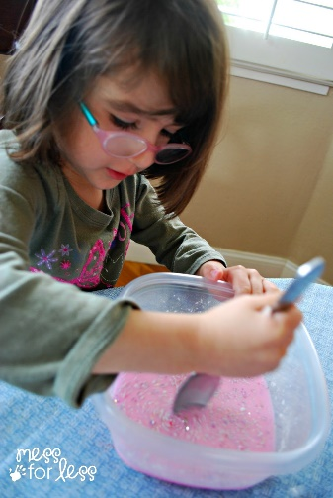 | 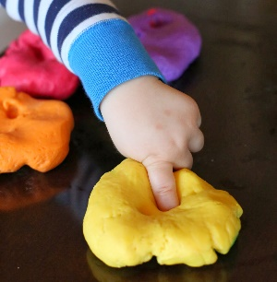 |  | 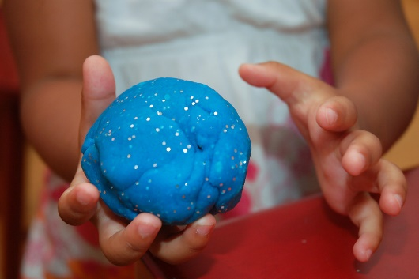
Water Play  Pouring, scooping, splashing and bubbles! Water Play is an exciting sensory play activity, where children become absorbed with the ripples of the water! |  | 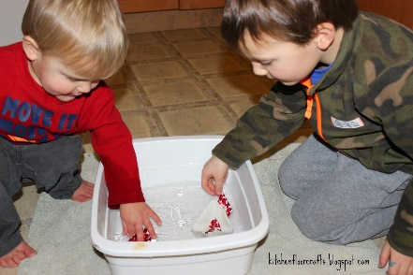
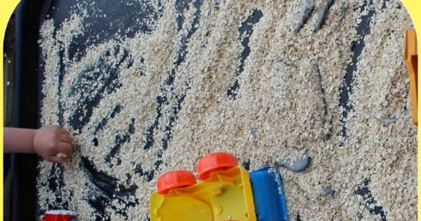 |  | Porridge Oats Construction  Empty a box of porridge oats, or other cereals, into a box or tray. Then add toy diggers & trucks for scooping, driving, digging and burying!  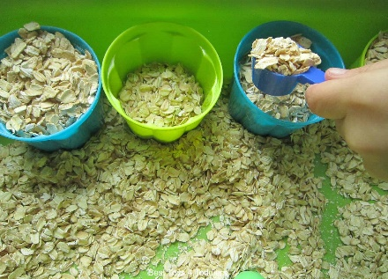
Make Pretend Snow  Feel the snow crunch between your fingers! Fake Snow is really easy to make with flour and oil – simply mix together 8 cups of cornflour and 1 cup of vegetable oil. |  | 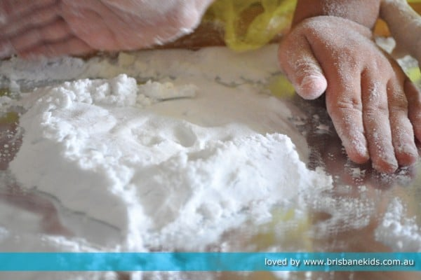
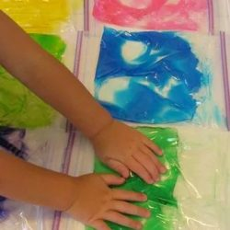 |  | Homemade Paint Bags  Fill zip lock bags with various coloured paints and let the children enjoy squishing them and mixing the colours – without the mess!
Mud Pies  Rustle up some fabulous sludgy treats and enjoy the sensory experience (and mess) of sticky, gloopy and hard mud! |  | 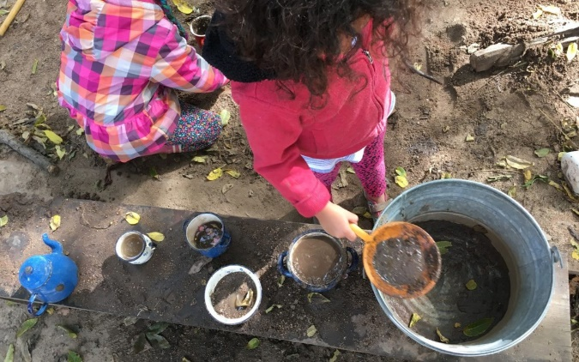

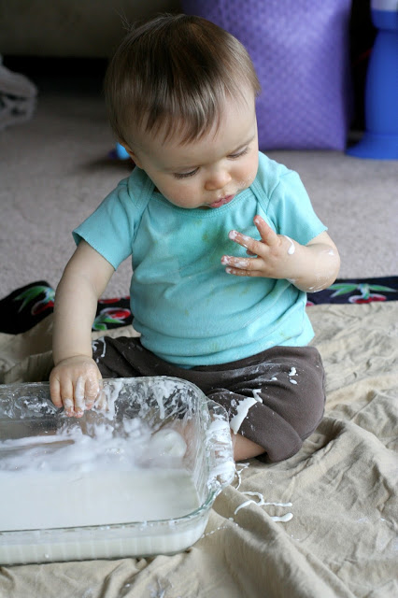 | Have fun playing together  Time to explore  Time to experiment  Time to create

