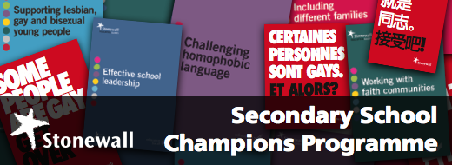

Dear Head Teacher
In June 2015 Westfields PRU was successful in our bid to become a Stonewall training partner and Centre of Excellence. The partnership is financed by the department of Education and government office for Equality.
Assistant Head Teacher James Robinson (Lead for Equality and Diversity PDBW) will be delivering a 1 day “Train the Trainer” course to secondary schools within 27/03/17 at the Cow and Calf Ilkley
The details of the course and benefits to schools are outlined in the documents attached.
In brief the course will equip your staff with the tools to effectively challenge LGBT bullying within your school. It will provide your staff with a range of resources. Your school will achieve Stonewall School Champion status. It will prepare schools with regard to personal development within the OfSTED framework.
The course is currently subsidised at £200 per delegate and requires one member of staff per school to attend.
To book a place on this course please contact James Robinson
James.robinson@pupilreferral.uk
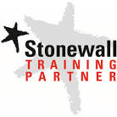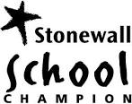

- Resources. You will receive an extensive pack of Stonewall's acclaimed secondary school resources and interactive learning aids - such as the feature film 'FIT' to prompt classroom discussion, a secondary staff training DVD, ideas on how to include sexual orientation across the secondary curriculum, as well as lesson plans, education guides and posters.
- Benchmarking.We will equip you with the tools to compare your school's current policies and practices with legal requirements and national best practice, so that you can create an action plan enabling your school to become a leader in the field.
- Discounted access to training and continuing professional development opportunities. Our training is undertaken by Stonewall's experienced practitioners who have trained thousands of staff in schools. Your staff will also be given discounted access to Stonewall events, conferences and training seminars.
- School Champions logo. Raising awareness of the good work you're undertaking among your parents and community is important so as to increase buy-in and engagement. That's why Stonewall grants its School Champions exclusive use of the School Champions logo for internal and external communications.
- Free Role Model visits. You will have access to exclusive role model visits by prominent members of British society from all walks of life - including members of the armed forces, musicians, actors, writers and lawyers - who share their personal stories, challenge negative stereotypes and show that difference should be celebrated.

Contact: james.robinson@pupilreferral.uk
Mob: 07498717045

