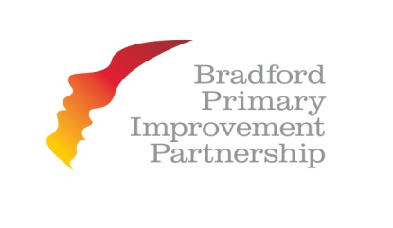

BPIP Teaching and Learning Programme

School Visits – Open Mornings & Open Afternoons

Open Mornings

16th January 2015, 8.00a.m. – 10.30a.m. at Bankfoot Primary School
(juliet.wright@bankfoot.bradford.sch.uk)

21st January 2015, 9.00a.m. – 11.20a.m. at Horton Grange Primary School (humaira.batool@hortongrange.bradford.sch.uk)

13th or 27th January or 11th February 2015, 9.30a.m. – 11.00a.m. at Horton Park Primary School
(saima.bahadur@hortonpark.bradford.sch.uk)

10th February 9.00a.m. – 12.00p.m. at St Francis Primary School
(Annie_rowan1@gmail.com)

Open Afternoons

21st January 2015, 1.15p.m. - .3.30p.m. at Iqra Academy
(J.Shovlin@iqra.bradford.sch.uk)

If you would like more information or if would like to book a place on any of these sessions please contact the relevant school.

