Applying the Apprenticeship Levy in HCSS

As you will be aware, the apprenticeship levy is charged at 0.5% of an annual paybill where it is in excess of £3 million, therefore maintained schools, where the Council is the employer, falls into this category. Each employer will receive an allowance of £15,000 to offset against their levy payment, but this is not available for each school, unless the Governing Body are the actual employers, i.e. Voluntary Aided and Foundation schools.

The facility to calculate the apprenticeship levy charge is a feature in the staffing area of HCSS

When you upgrade HCSS, it says you need to re-add it from the staffing page

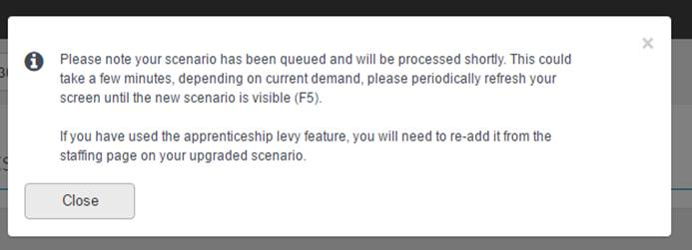

When you click add apprenticeship levy on the Staffing page, it doesn’t work:

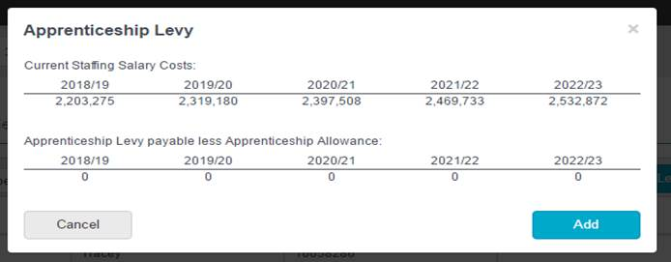

What you **must do first** is go into the School settings -> other settings -> apprenticeship levy settings and zero out the £15,000 pre-set in there.  If you then go to add Apprenticeship Levy, it does work.

