Using FM Successware (The latest software is 4.6.2 Sept 2011)

This programme is solely for programming Phonak radio aids.

Make sure you connect the toaster to your laptop BEFORE opening the programme.

On opening the programme you must choose between dynamic or classic transmitters or receivers. The Inspiro, EasyLink+, ZoomLink+ & MLxi are dynamic – all the others are classic. Click on the tab near the top of the screen to switch between the four options. You must then click in the check box by each transmitter/receiver type to select the one you want.

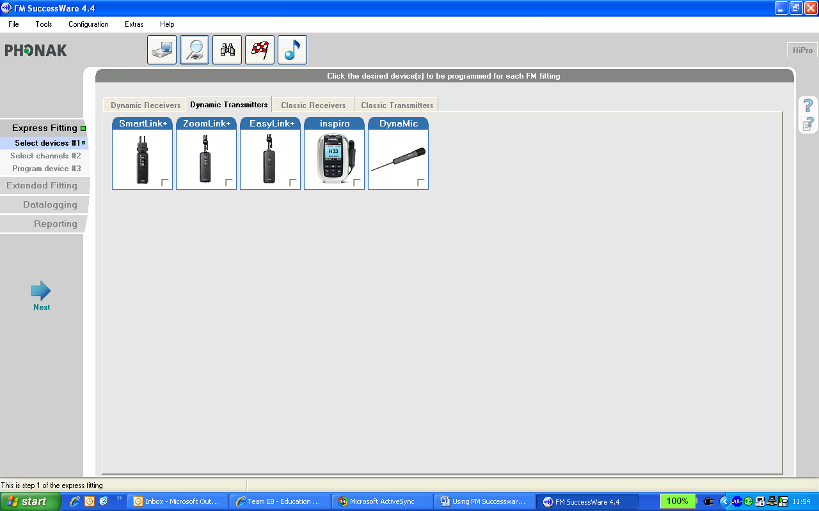

Click on ‘Next’.
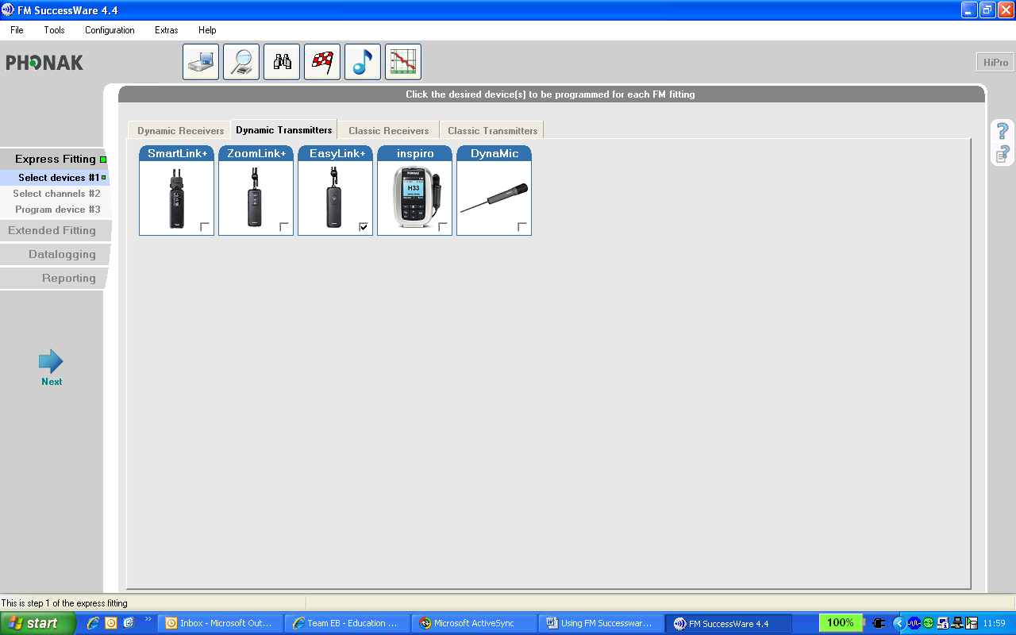
You then need to check one or more of the frequencies you want programmed into the radio aid. Remember to uncheck any frequencies showing which you do not want.

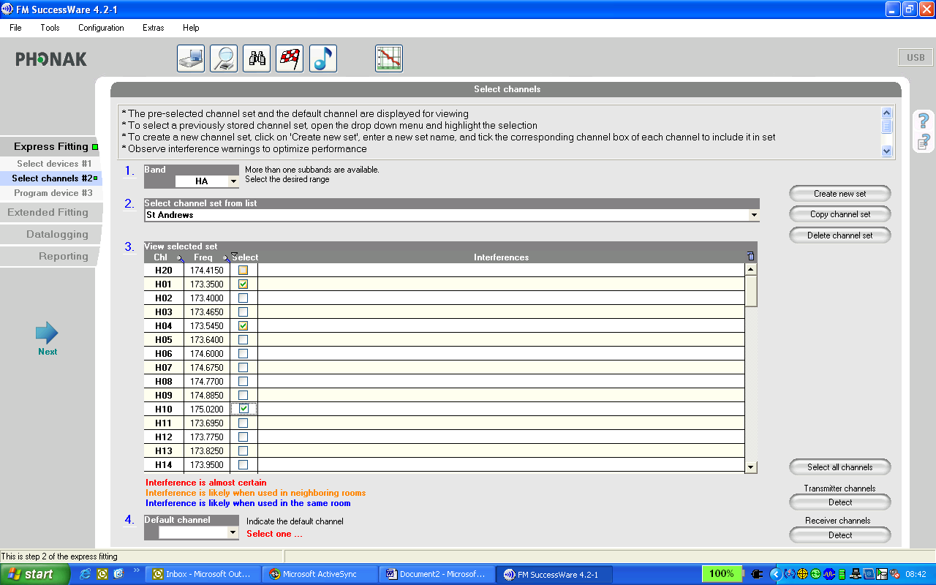

If you have chosen two or more frequencies which might interfere with each other you will see a warning alongside those frequencies. You need to change one of the frequencies until the error message disappears.

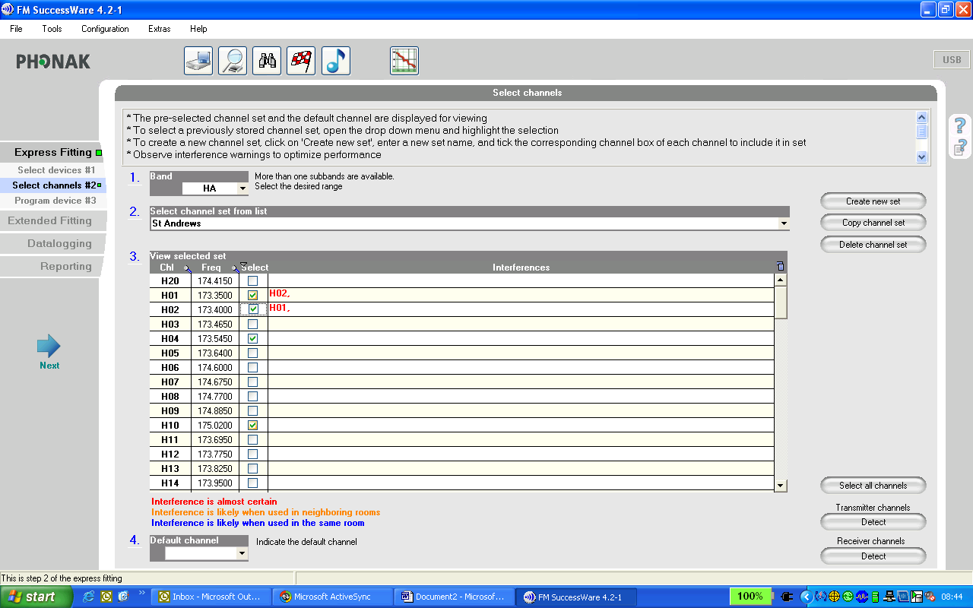

Having selected your frequencies, you need to select the default frequency. You do this via the box at the bottom of the screen. Only the frequencies you have selected will be shown. The default frequency for receivers means that if the child switches their receiver off and then on again, it will go to the default frequency. Transmitters function differently; if switched off and then on again they revert to the last frequency used.

NB. Selecting frequencies for a transmitter means that only those frequencies will be available.
For receivers, in reality, even though you may have only selected one or two frequencies they are all still available. The purpose in selecting a default is that if the pupil switches off then on again it will automatically go to the default frequency.

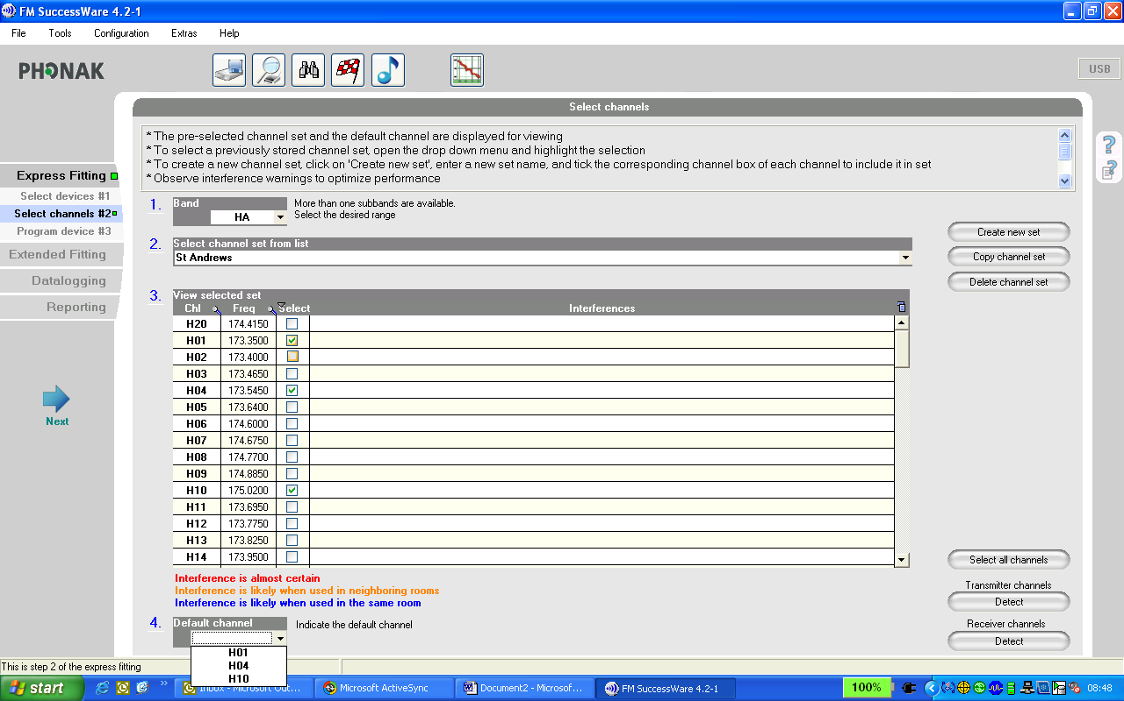

Click ‘Next’.

For receivers you now need to attach the receiver to a hearing aid, make sure both are switched on, and place the receiver and hearing aid in the toaster.

You then click on the button to ‘Save’ to receiver.

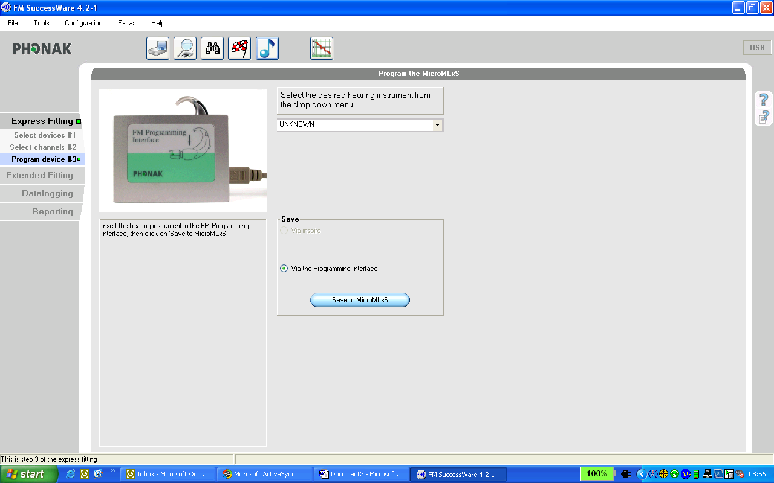

If there is a problem saving the information, try changing the hearing aid battery. Whilst it may be working it may not have enough power remaining to power up the receiver.

For classic transmitters you need to connect the transmitter to your laptop headphone socket using an audio input lead. (Your laptop volume needs to be on - not muted). For dynamic transmitters connect to your laptop using a USB lead.

You then need to press one of the transmitter buttons at the same time as using a pen to press the frequency-change indent to put the transmitter into programming mode.
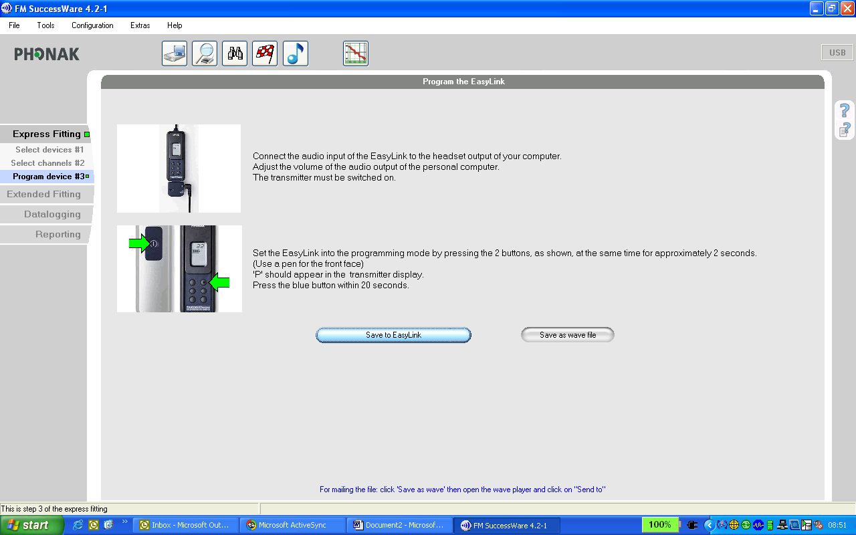

A ‘P’ should appear in the transmitter display. You then have 20 seconds to press the blue ‘Save’ button on screen.

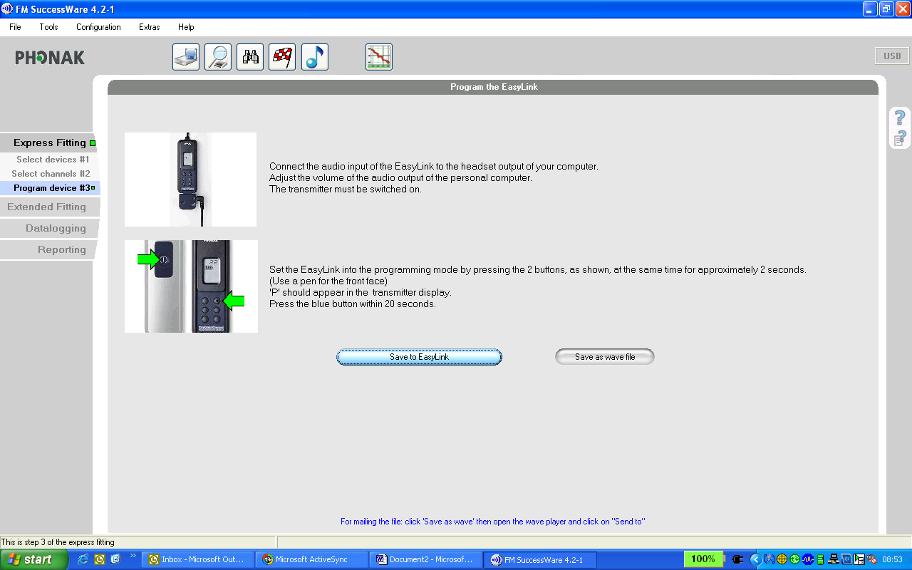
If the programming was successful, ‘P E’ will appear in the transmitter display.

