Nios Hearing Aids

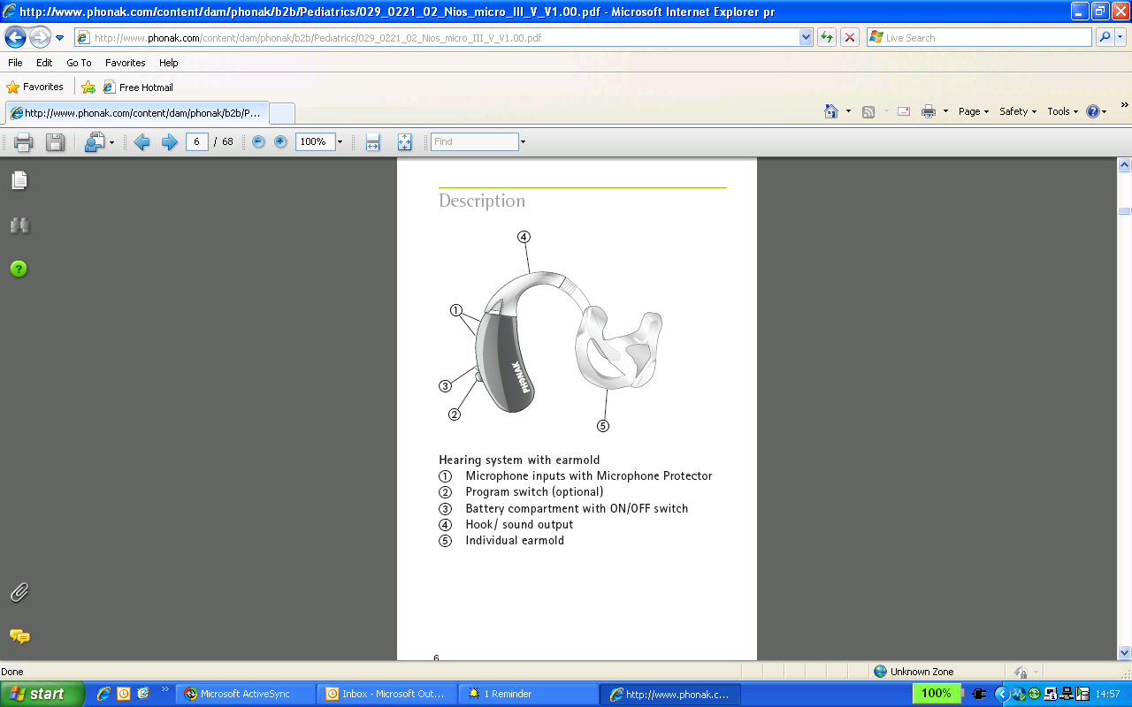
Switching on/off
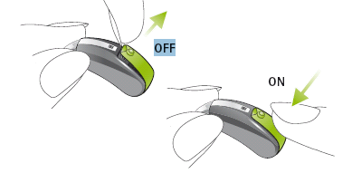
Inserting the battery

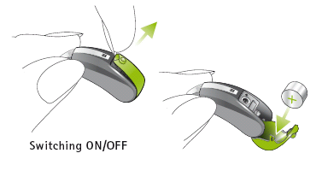
Use battery size 13 for the Nios. Remove the protective foil from the new battery and wait for a short period before inserting it.

Tamper proof battery compartment

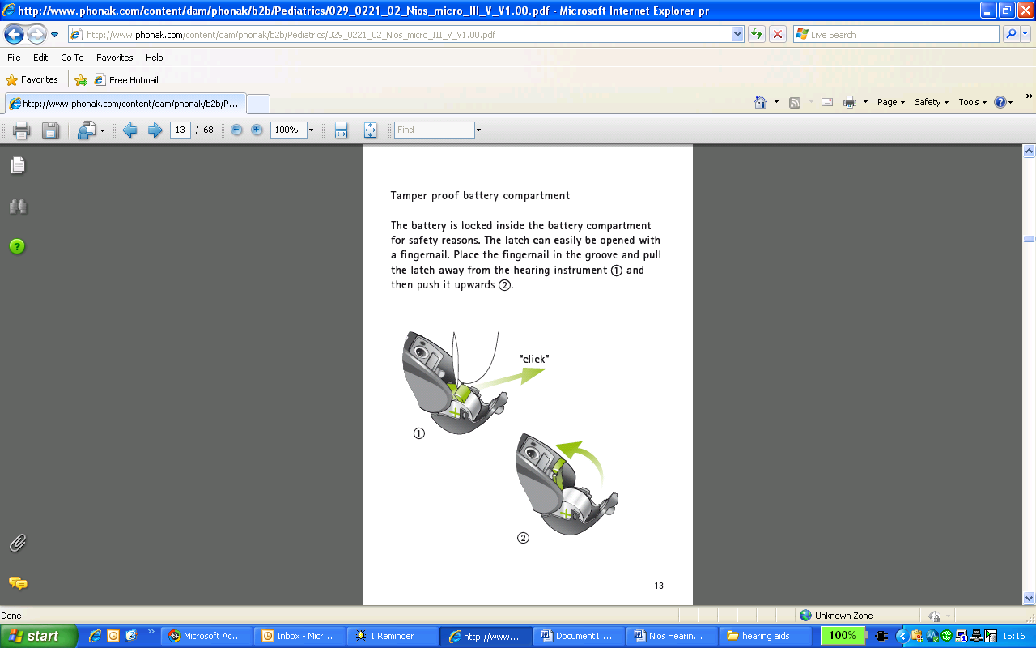
Warning: The battery latch must be placed back over the battery and locked before closing the battery compartment.

Identifying left and right aids Adjust Volume/Select Programme
(Can be set by hospital for either)

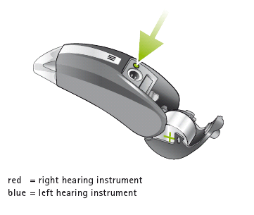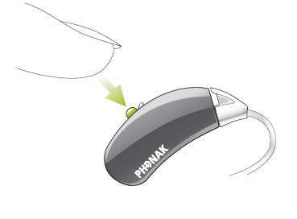
Using with a radio aid

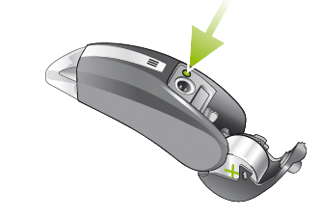
Remove the plastic covering to expose the contacts

Attaching and removing an audio input shoe - AS12



