Celebratory Profile |  | Name: |  | Date of Birth:
Things that people love about  me in my setting. |  | Things that make me happy  in my setting. |  | How I like to be supported  in my setting. | 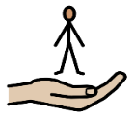
Things that people love about  me at home. |  | Things that make me happy  at home. |  | How I like to be supported  at home.

Celebratory Profile |  | Name: |  | Date of Birth:
Food and drink – likes, dislikes and the help I need. | 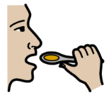 | My medical, physical and sensory needs. |  | Things that help me to communicate. | 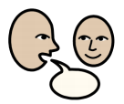
People and pets who are special to me at home. |  | People who make me feel happy in my setting. |  | Professionals who are helping me to thrive.

