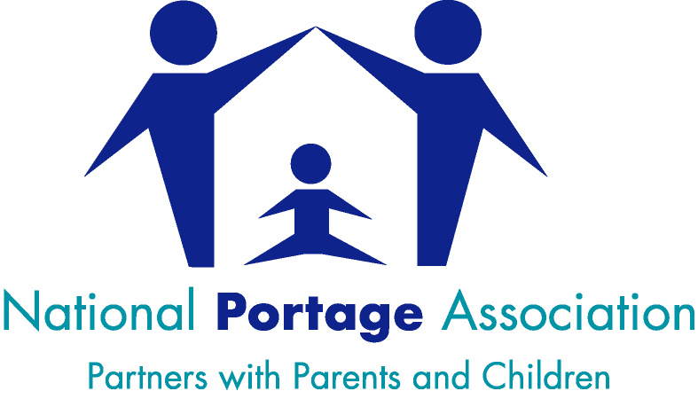
New updated Portage Training from the National Portage Association (NPA) www.portage.org.uk
“Portage Workshop: A Small Steps Approach to Learning for Children with SEND”
2 Days and a 1 day follow up
Wednesday 25th May 2022 9:15am – 3:00pm
Thursday 26th May 2022 9:15am – 3:00pm
Tuesday 14th June 2022 9:15am – 3:00pm – follow up day
Venue: Margaret McMillan Tower, Princes Way, BD1 1NN
Attendance on all 3 days is required for this course
This 3 day workshop is open to anyone working with young children (under 7) with additional needs /disabilities and their families. It covers the core curriculum set out by the National Portage Association. The course is very relevant for parents and all Early Years Practitioners, SENCOs & Teachers particularly those working in nurseries and 2 year provision, Schools, Children’s Centres and other Early years settings.
The course will cover –
- The Portage Model
- Working in Partnership with parents/carers
- Agreeing long term goals and writing clear teaching targets
- Helping children learn by the small step approach (task analysis)
- Specialist teaching techniques
- Play for children with additional needs
- Recording and evaluating children’s developmental progress
COST: For the 3 day course plus materials and certificate - £170
We do not provide refreshments, please bring your own.
For information about the course content contact: Janine Wood: janine.wood3@bradford.gov.uk
For assistance on booking via the below link contact: angela.king@bradford.gov.uk
To book places please click on this link – http://www.skills4bradford.co.uk/Training
Booking tip – please open full screen and click on Training and Events - Type “Portage Workshop” in the “Keywords” box

