Religions in the Bradford District
A seven week course introducing six of the major world faiths represented in the Bradford District


Wednesday 3 May to 21 June 2017

£350

Develop a knowledge and understanding of the beliefs and practices of the Buddhist, Christian, Hindu, Muslim, Jewish and Sikh faiths plus Humanism:

- origins
- beliefs
- founders and leaders
- sacred writing
- symbolism and worship
- how festivals are celebrated
- the significance of rights of passage
- the impact on values and lifestyle

Each session will be led by an experienced Faith Tutor and will include a tour of their place of worship. There will be opportunity for questions and discussion.

Participants will be equipped to:

- help pupils understand a range of faiths,
- promote a shared understanding of universal values,
- teach RE in accordance with local and national guidelines,
- appreciate the cultures and beliefs of their communities.

Course notes will create a detailed handbook for use in school.

Preparing your school to meet the Ofsted challenge:

British values
spiritual, moral, social and cultural development
high quality religious education
community cohesion



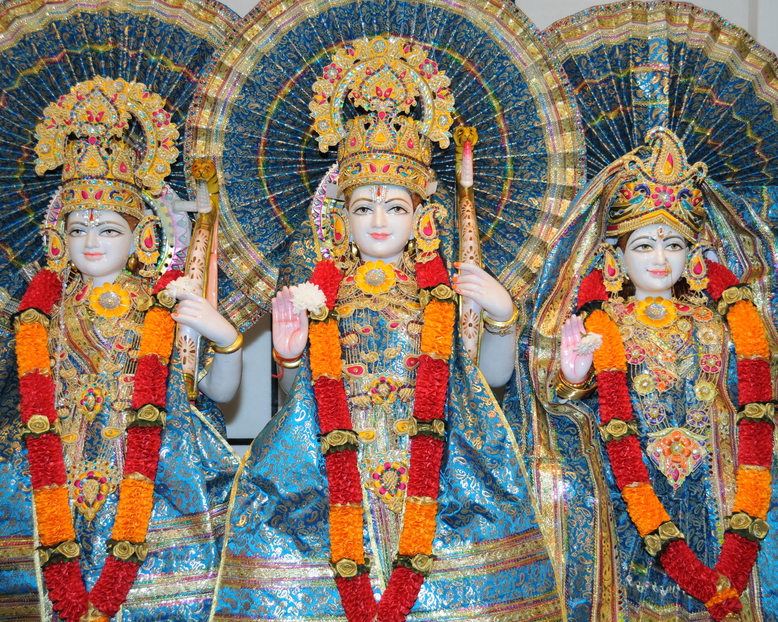
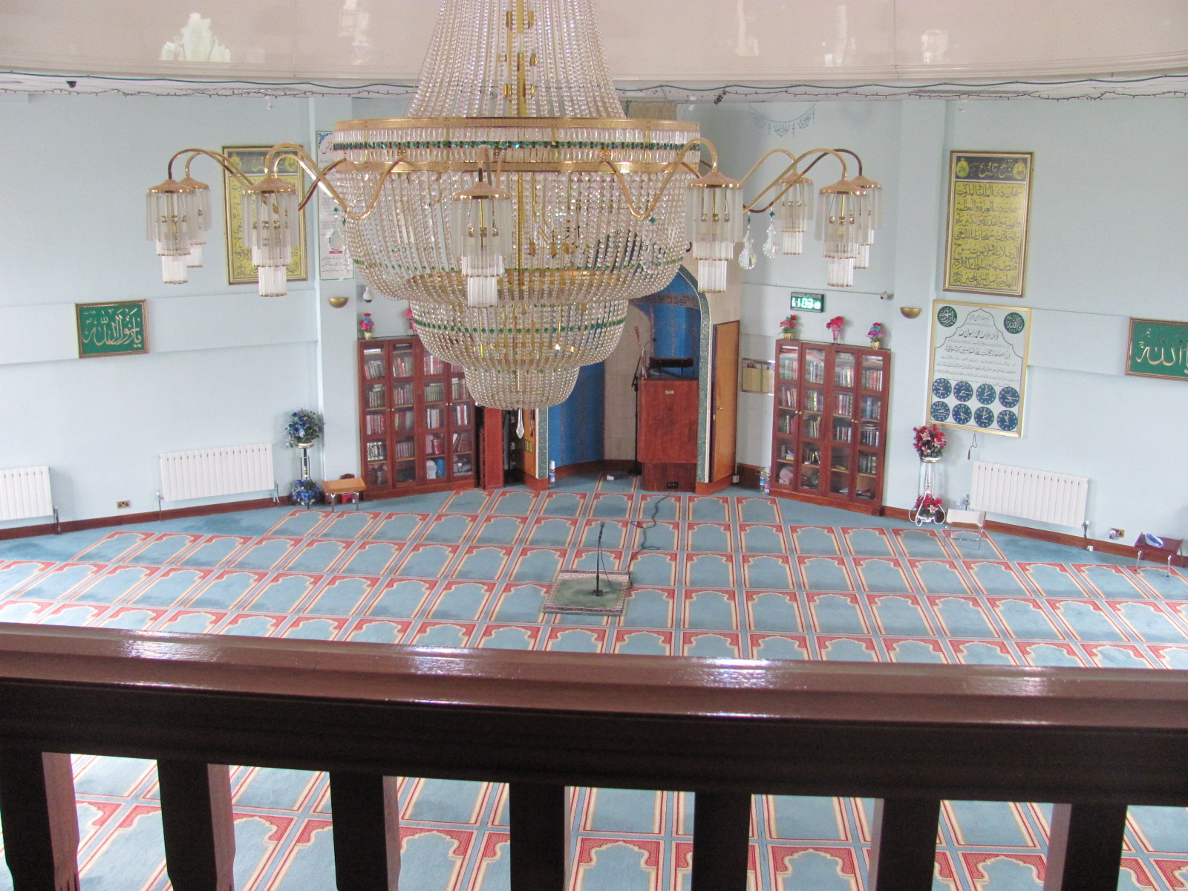
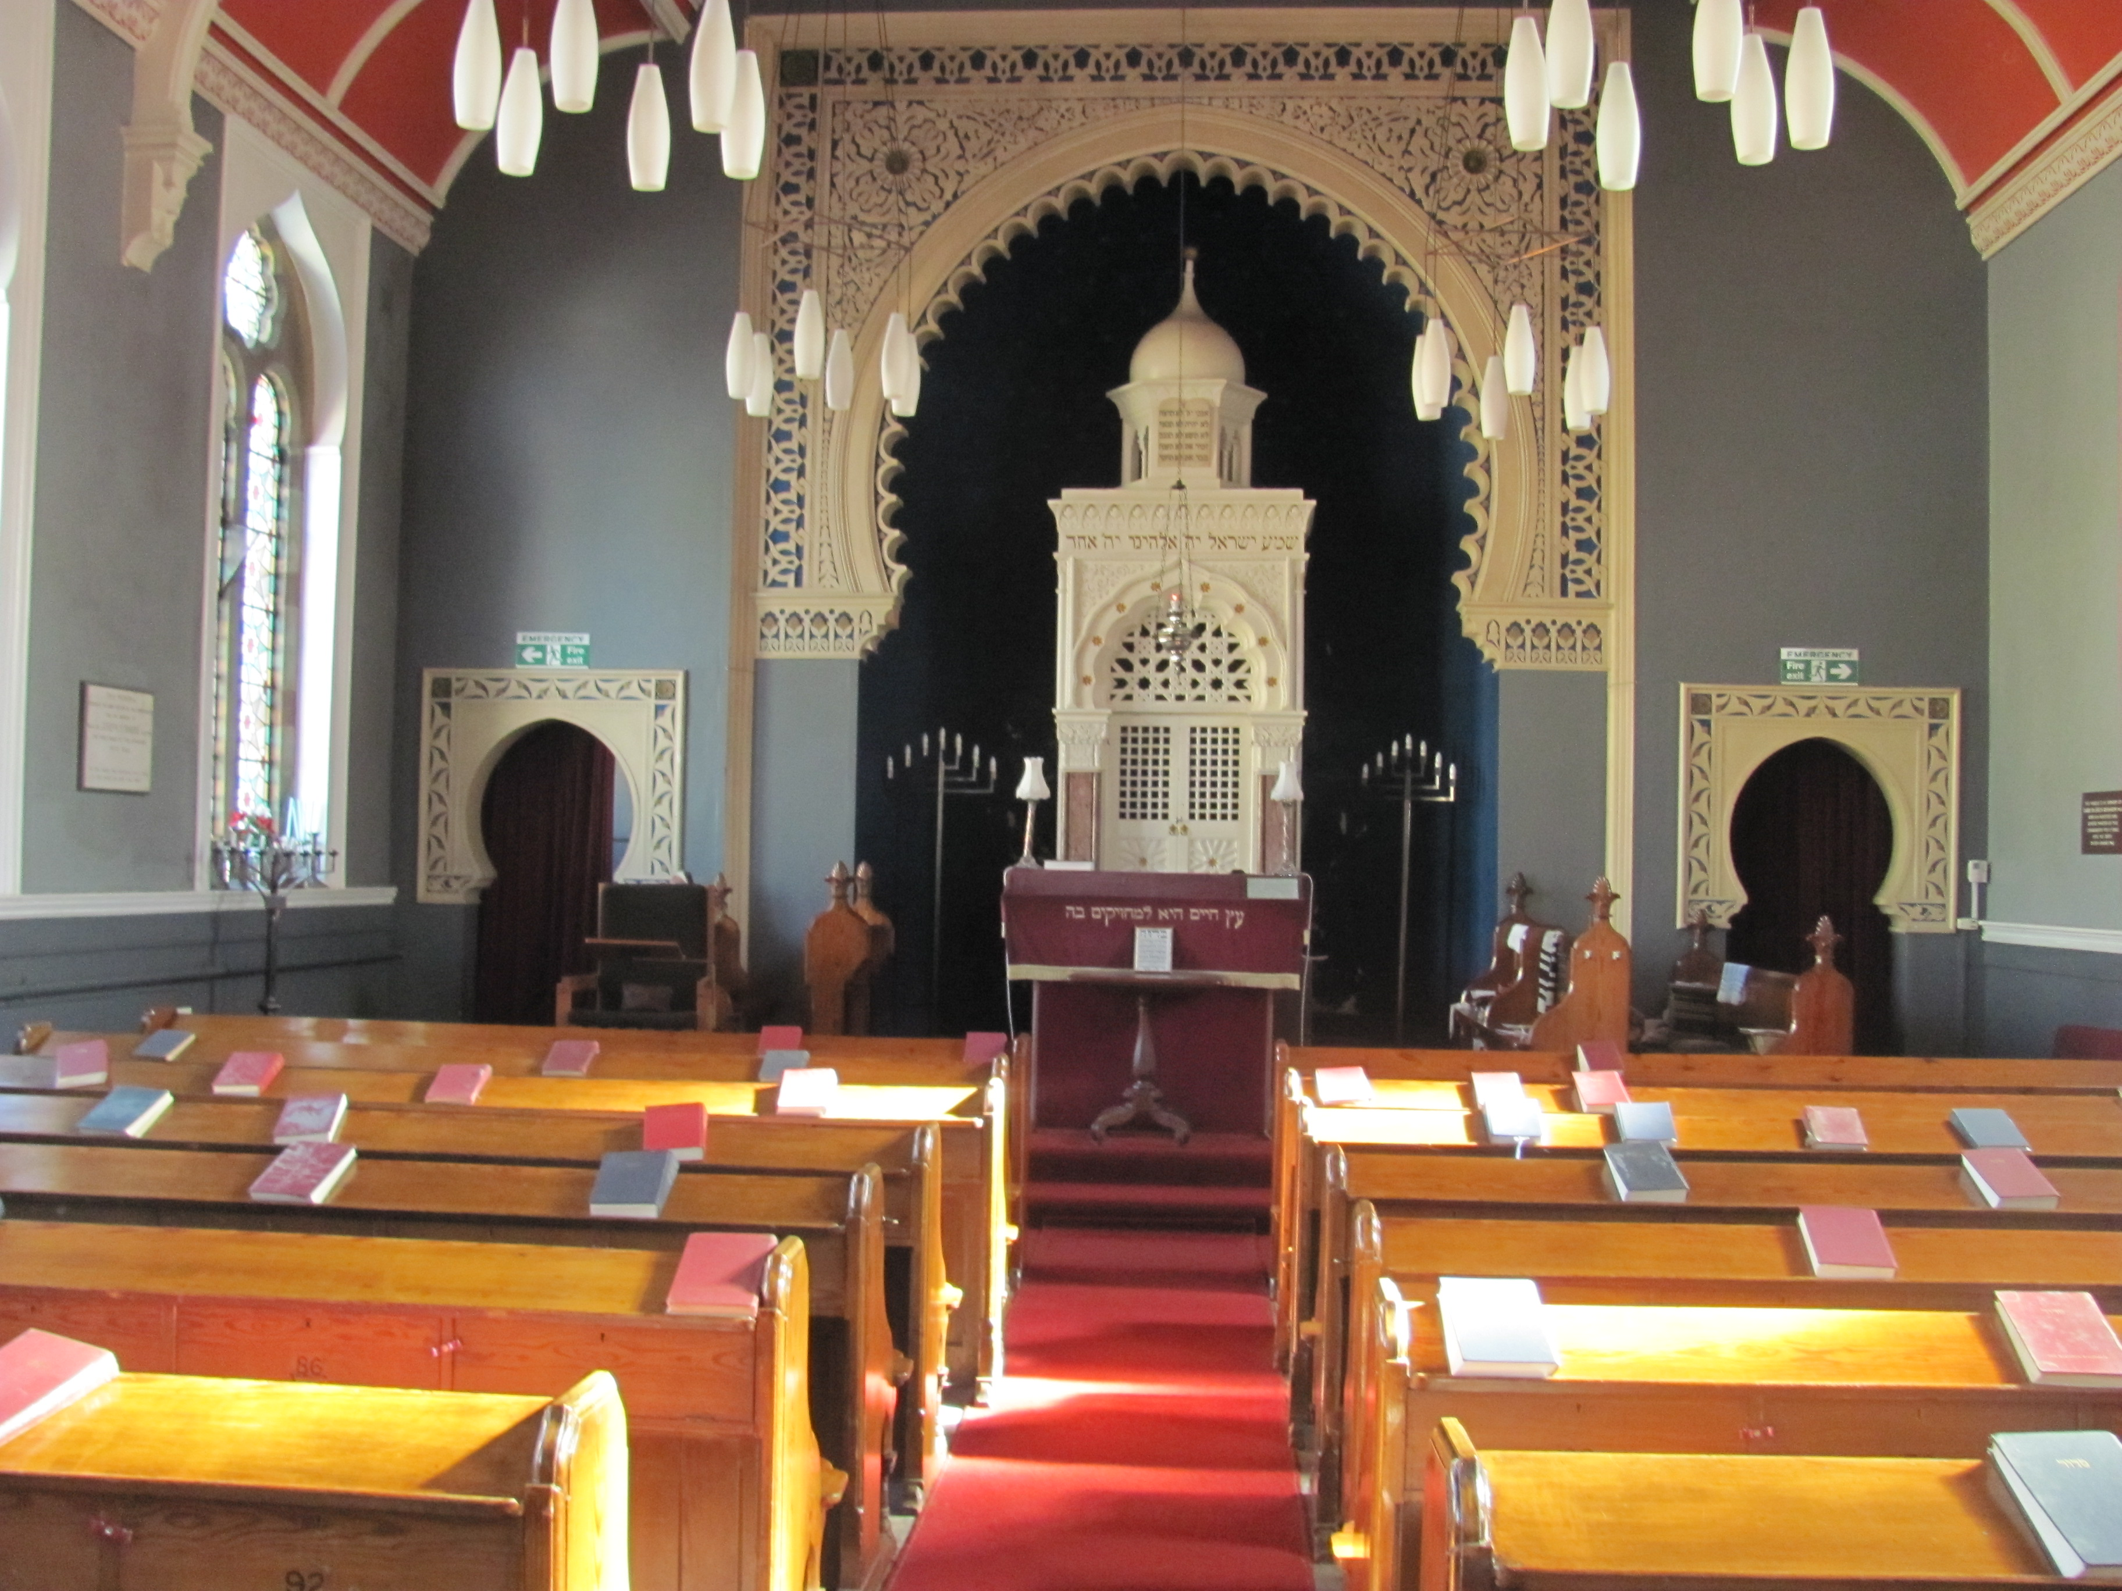

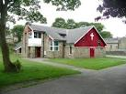

Buddhist Centre Church Mandir Mosque Synagogue Gurdwara

