Recipes for Sensory Play
Keep safe! Wash your hands before making any dough.

Playdough
1 cup plain flour
1 cup salt
2 tsp cream of tartar
1 dessert spoon cooking oil
1 cup of water, just boiled from the kettle
Drop of food colouring-your choice-if you want colour
Drop of vanilla essence/peppermint etc if you want a sensory smell
Add glitter if you wish when the dough is made.

Method:
Put flour, salt, cream of tartar, oil into a saucepan.
Add colour/sensory smell essence, if adding.
Pour in 1 cup of freshly boiled water.
Stir and mix well.
Turn out onto a floured board.
Knead, adding a sprinkle of flour if needed.
Leave to cool - then play!!!

Extend:
Add glitter with your child, use an empty chocolate box to fill with dough, use scissors, cutting tools, forks to make patterns, use twigs to stick in the dough, coloured shells, pebbles.
Use hands to knead, make holes, squeeze, flatten, prod etc.
Make batches of dough in different colours - watch what happens when the different coloured dough balls mould together!!!
No Need to Cook Playdough
When you don’t have time or a cooker for cooked dough, this is a reasonable substitute but don’t keep for very long!
3 cups plain flour
1 cup salt
1tbsp cooking oil
1½ cups of water
Add water very gradually. Knead very well until smooth.

Gloop
Cornflour
Water
Food colouring-if desired
Glitter-if desired

Method:
With your child-
Get a small shallow tray or whatever utensil you wish to use.
Put in 2 dessert spoons of cornflour in the tray to start with.
Have a jug of cold water, and mix a dessert spoonful water into the corn-flour.
Keep adding more cornflour and water slowly until you get to the desired amount or consistency you wish.
See what happens when you add a drop of food colouring.
Watch how it drips from the spoon.
What happens when you touch it?
Can you fill up small containers, milk bottle top lids, ‘feed’ toy animals, dolls, super hero models etc.
Let your child’s imagination unfold and explore. Follow their lead.
Stretchy Dough
You can poke and prod it and it always jumps back into a puffy mass. It will str-e-t-ch until it breaks. Make this when the children think they know everything about dough. It takes quite a lot of kneading on your part to get it right. The children could help. Keeps for a day or two at most.
Half a bowl of self-raising flour
Water to mix
Colouring if wished.

Method:
Mix until firm. Knead for maybe 5 to 10 minutes until smooth. You may need to experiment with adding more water or flour until you get the wonderful, soft but not sticky, smooth and fragrant experience this dough can be!

Cornflour Model Mix
This dough is great for modelling as it holds shapes in fine detail and will go rock hard left to dry in the air for a day or two. Uncoloured, it is the whitest dough you ever saw. great for occupying older children (7+). Too stiff for little fingers as you can’t roll it easily. Can be painted, good for making pretend food for a shop or favourite characters perhaps.
Half a cup cornflour
1 cup salt
Half a cup water

Method:
Blend ingredients. Cook over low heat- stirring. Remove when thickened.

Slime
1 cup soap flakes (Lux)
2 litres warm water
Egg beaters of all sorts
Kitchen gadgets, scoops, sponges, ladles, jugs

Method:
Dissolve soap flakes in water in a large bowl or water tray. Whisk with whisks and beaters until really frothy.

Home-made Paint
1 cup salt
1 cup flour
1 cup water
Food colouring

Method:
Mix the ingredients in a bowl and store in clean squeezy ketchup bottles.

Homemade Bath Paint
Shaving foam (skin sensitive type if needed)
Food colouring (food colouring gels are good)

Method:
Squirt a little shaving foam in each space of a muffin tin and stir in your colour. Can be played with on a wipe-able cloth, indoors/outdoors, in the sink, bathtub and as it’s made of shaving foam cleans up very easily.

Clean Paint
Put an old sheet on the floor and dab some paint onto the canvas. Next wrap some cling film around it, covering the paint dabbed surface and put it down for some painting fun.

Snow Paint
Combine equal parts salt, flour and water.
This paint dries and makes a white snow with a gritty texture that looks like snow. I would recommend using heavy paper if painting or surface scratching. This is good for fine motor fun.

Edible Finger Paint
Mix 2 dollops of Greek yoghurt in washed yoghurt pots with a tiny amount of food colouring - that’s all there is to it!
(Greek yoghurt is thick which makes a better consistency for the finger paints and easier to handle).

Splatter Paints
Washable paint
Cotton rounds (circular make up pads)
Spread out large sheet of paper, put blobs of coloured paints all over it. Cover each one with a cotton pad then smack the pad (a rubber mallet works well or try something with a similar “bash” factor) remove the pads to reveal a great piece of art.

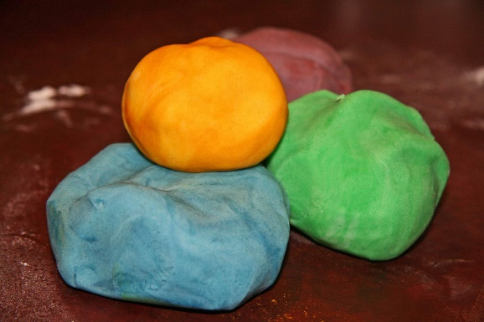 |  | 