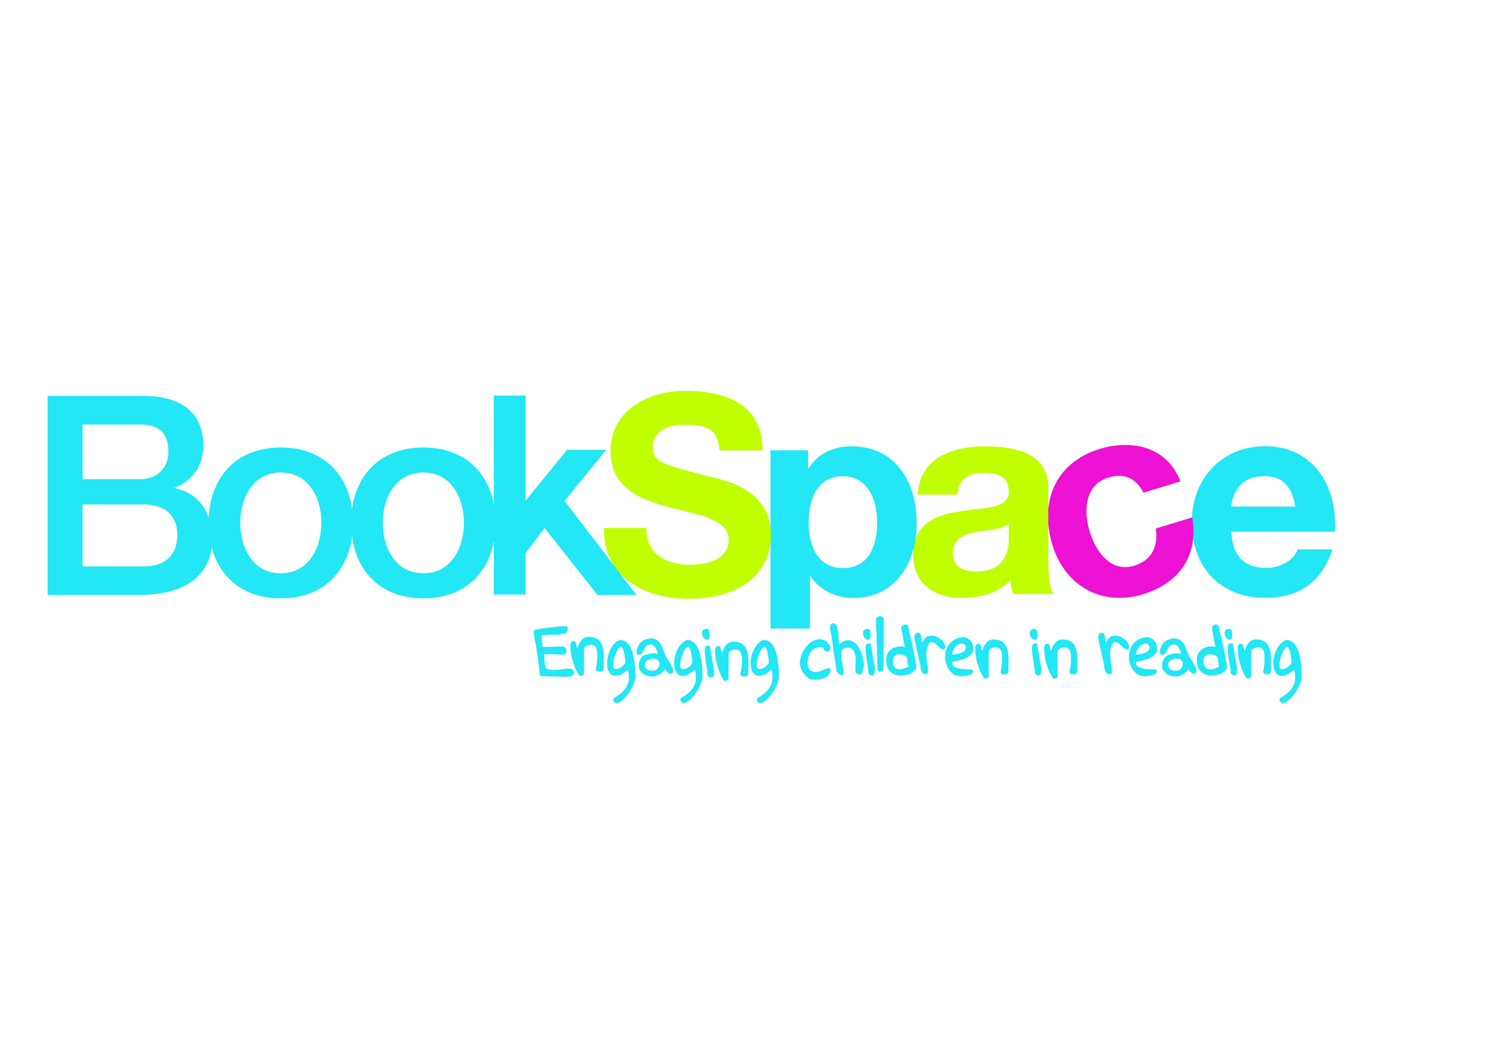
Reading Spaces initiative
Would you like to create a brand new library, refurbish an existing one, upgrade your classroom reading corners or create a community reading space?
We’re looking for one primary school in Bradford to work with us and the School Library Association to design a new Reading Space and test innovative ways of using and managing the space. The aim of the project is to create a centre of excellence within a school where a reading culture can thrive and every child enjoys reading for pleasure. The project will be monitored and evaluated and best practice documented which in turn will form the bases of a blueprint for primary school reading spaces that will be shared with schools across the country.
As part of the project you will receive, completely free of charge, a brand new Reading Space worth up to the value of £15,000, designed and installed by a leading library furniture company bookspaceforschools.co.uk. Additionally you will be able to participate in a range of activities, access advice from the Schools Library Association and your staff can benefit from staff training that will support in running and managing the space on an ongoing basis.
This project is part of the National Literacy Trust’s literacy hub initiative in Bradford which is working in partnership with Bradford Council and a range of other organisations, businesses and services in Bradford to tackle low literacy. To raise awareness of the importance of literacy in each community and inform the public of our activities, we are running a local media campaign called, the Bradford Literacy Campaign. This opportunity is also available to one primary school in Peterborough – another literacy hub area led by the National Literacy Trust.
What we’re looking for…
- A primary school in Bradford which has an area/s within the school that they’d like to turn into a Reading Space. It can be an existing library, a room or space that you’d like to repurpose, or a classroom/s reading corner/s.
- A commitment to the project which will involve staff time, contributing to the monitoring and evaluation process and sharing good practice with other schools in the area.
- A willingness to experiment with new ideas and try different ways of working.
- A commitment to working in partnership with the National Literacy Trust, the School Library Association and BookSpace for Schools.
What you’ll get in return…
- A design consultation session with BookSpace for Schools after which you will receive a series of design proposals and visuals to choose from
- A fully fitted Reading Space with high quality furniture, shelving and seating
- Access to a range of training programmes that help staff in running and managing your Reading Space as well training that supports the promotion of reading for pleasure
- Advice and support from the School Library Association
- Involvement in a high profile initiative
The winning school will demonstrate a need for a new Reading Space and describe clear plans for one which would directly benefit pupils and the wider school community. They will also demonstrate a willingness and ability to undertake innovative approaches to using the space(s) and effectively communicate their work to other schools in Bradford.
Reading Spaces Application form
Deadline: Friday 27 March 2015
In completing and submitting this form you are signing up to the terms and conditions of the competition, also attached.
ON NO MORE THAN THREE SIDES OF A4 please answer the following questions:
Q1. Please provide a brief profile of your school including:
- Number of pupils
- FSM levels
- Current attainment levels
- Current reading space / library offer
- Your school’s vision for your pupils and any other information which will help us to understand your school.
Q2. Describe a typical day in your Reading Space
Q3. How do you envisage being part of this project will contribute to delivering the aims of your School Improvement Plan and in particular your aims for literacy?
Q4. Describe the location and the space/room in your school where you’d site your Reading Space and explain why you have chosen that particular area (please include photographs- maximum of 3)
Q5. In what ways do you envisage your Reading Space will be used by school staff, children, parents and the community?
Q6. Why should your school be chosen - what contribution will your school will make to this project?
Q7. Who in your school will be involved in managing and running this project, how will you ensure that they have sufficient time is made available?
Q8. How will you share what you have learnt with other schools?
Name and position of teacher

Email address
Tel number – direct line
School main telephone number
Teacher’s signature (this should be the main contact for delivering the project)
Head’s signature
Name of School
School address (including postcode)
Date of application

