Rainy Day Play Indoors
Keep safe! Wash your hands before and after play.

Dress-Up Time  Materials needed: Old clothes, costumes  What to do: Haul out a pile of old clothes and let your child play dress-up.  Skills learned: Creativity, imagination, language skills, and social development | 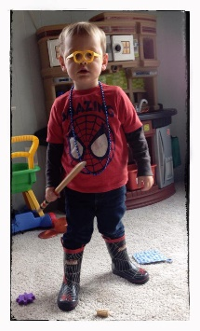
Toy Hide-and-Seek
Materials needed: Toy
What to do: Hide a toy somewhere in the house, and ask your child to find it. Explore with them, using cues like "warmer" and "colder" to guide them.
Variations: Use flashlights for the search, or hide several objects at one time.
Skills learned: Listening, problem-solving, social skills, and memory

Simon Says
What to do: Start out with simple directions—"Simon says, touch your toes"—then graduate to silly, more complex routines ("Simon says, tug on your left ear, then your right ear"). And don't forget to drop "Simon says" every now and then!
Variations: You can also encourage your child to jump, skip, catch something, and more.
Skills learned: Gross motor skills, following directions, and receptive language

You’ve Got Mail  Materials needed: Old shoe box, junk mail  What to do: Make a post box by decorating an old shoe box or cardboard box and cutting a slit in the top. Fill it with your junk mail for your child to open.  Skills learned: Develops an understanding of basic concepts, fine motor skills | 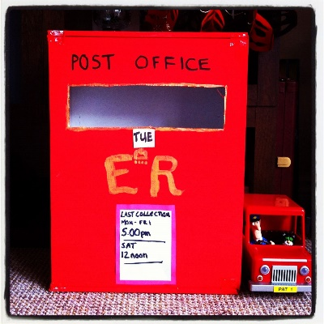

All Aboard  Materials needed: Towel or blanket  What to do: Have your toddler sit on a towel or blanket and gently pull her around the room. Pretend the blanket is a train or a boat and that you are stopping at different places, like the zoo or wherever your imaginations take you.  Skills learned: Balance, pretending |  | 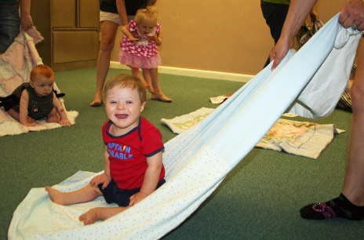
Body Tracing
Materials needed: Large piece of paper, crayons
What to do: Have your child lie down on a large piece of paper and trace the outline of their body. As the child has to lie still to be traced, they learn self-control. You can show your child where the two eyes, nose, and mouth go, but if your child just wants to colour all over it, that's fine. Don't impose anything on them, just let them have fun with it.
Variation: If your child doesn't want to lie still, start with tracing just their hand or foot, or tracing your hand and foot.
Skills learned: Sense of self, self-control, and identifying body parts/language skills

STOP! GO!  What to do: Play games that involve starting and stopping, such as  "Red light, green light."  Skills learned: Self-control |  | 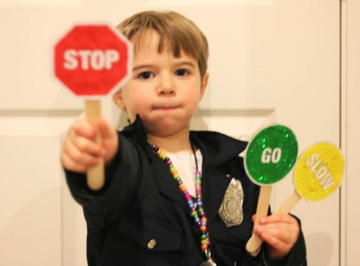
Express Yourself
Materials needed: Facial features cut out of magazines, paper, glue stick
What to do: Cut out different noses, eyes, hair, and other features from old magazines, and give them to your child to glue on to a blank paper circle. Encourage your child to make funny creatures or silly faces. Talk to your child about the pieces and how to glue them down, but don't be too directive with it, ask a lot of 'wonder questions,' like "I wonder what would happen if you put the pieces down without the glue?' and 'I wonder why the glue is getting all over the table?' Childhood is about learning new facts and applying them to theories, so help them make theories."
Variations: Let your child rip up the pieces or colour on the collage with crayons after the glue has dried.
Skills learned: Creativity, language

Ball Pass  Materials needed: Cardboard tube or play tunnel, softball  What to do: With you and your child at opposite ends of the tunnel, take turns lifting each end to roll a softball back and forth.  Skills learned: Motor planning, understanding cause and effect, teamwork |  |  | 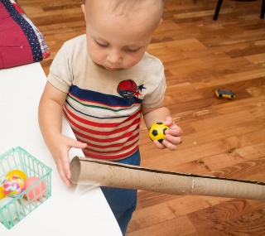
Draw Your Favourite Songs
Materials needed: Paper, crayons
What to do: As you sing one of your child's favourite songs, draw a simple picture of what is happening in the lyrics, then hand your child the paper to draw something else mentioned in the song.
Skills learned: Language skills, creativity, storytelling

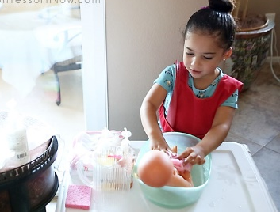 | 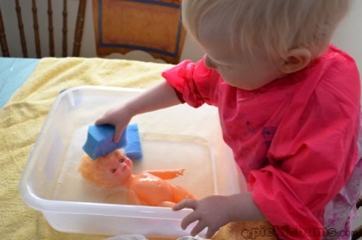 |  |  | 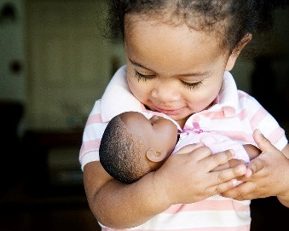
A Little Conversation
Materials needed: Doll or plush toy
What to do: Hand over the doll or toy, and encourage your child to hold, talk, dress, and take care of it. Talk to the doll the way you would talk to a child, and encourage your child to do the same.
Skills learned: Social, language and fine motor skills, creativity, and imagination.

