

Section 1 - Submitting a New Vacancy

- Log on to www.prospectsonline.co.uk

- Click the blue button entitled School login

- Select your school from the drop down list

- Enter your Email Address (this is usually the generic school office email address)

- Enter your Password - click Forgotten Password if you cannot gain access

- Once on the Homepage for your school – select Add New Vacancy

- Complete the necessary fields within the General Information tab
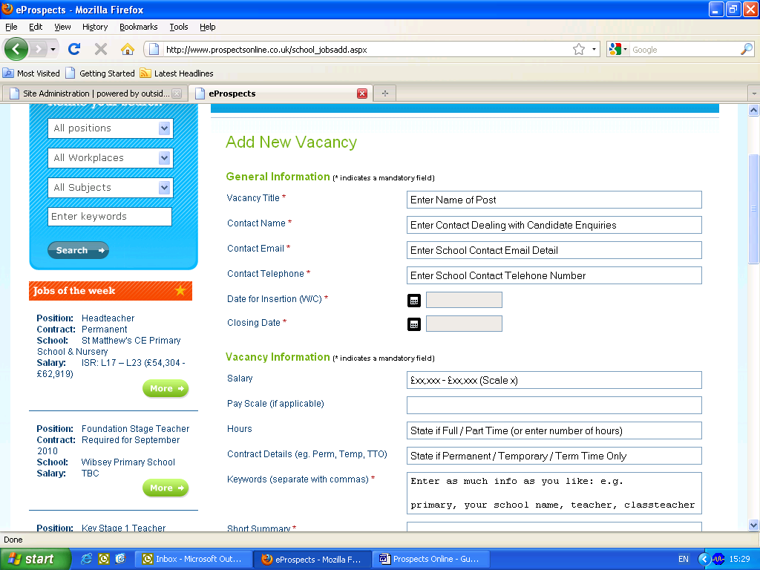

It is recommended that the Closing Date is 2 weeks following the Friday of the insertion date to leave enough turnaround time for applicants to apply

- Complete the necessary fields within the Vacancy Information tab:
  - You can copy and paste information into each field or you can type directly into the box(es)

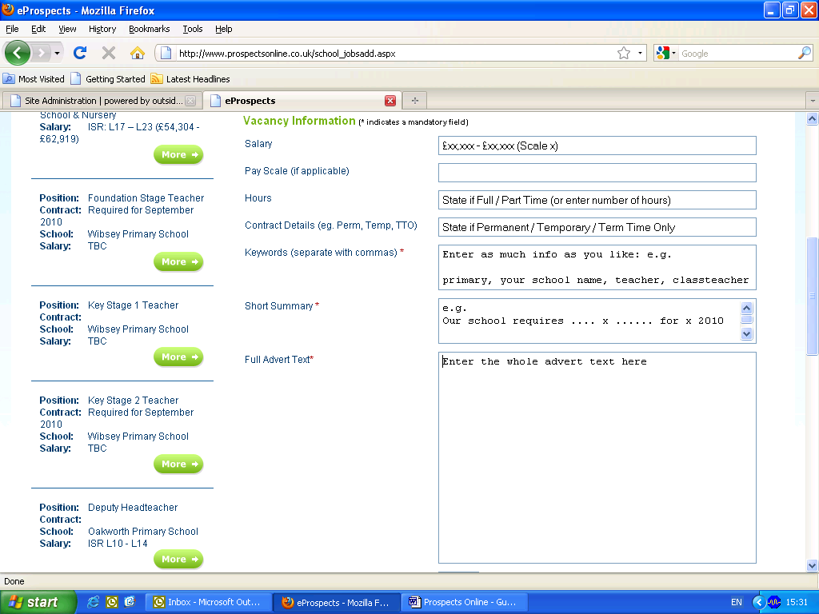

Expanding your audience, widening your prospects, reducing your workload

www.prospectsonline.co.uk

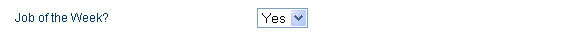

  - By selecting YES to ‘Job of the Week?’ ensures your vacancy gets maximum coverage by appearing on each page on the website until the closing date has passed. This option does incur a small charge.

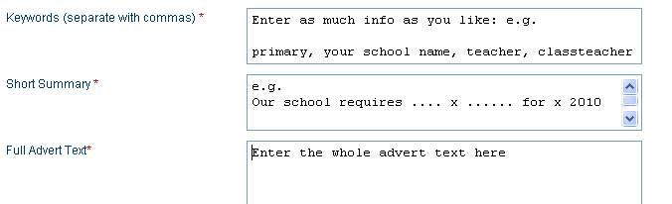

  - Keywords: words job searchers may use when looking for vacancies. Use words that would direct them to your advert.
  - Short Summary: should be used to introduce your vacancy to interest potential candidates into reading the rest of the advertisement.
  - Full Advert Text: should include detailed information relating to the role (i.e. a section introducing the school, section on what the post involves, information about visits, safeguarding etc

- Complete the necessary fields within the Additional Media Required tab:

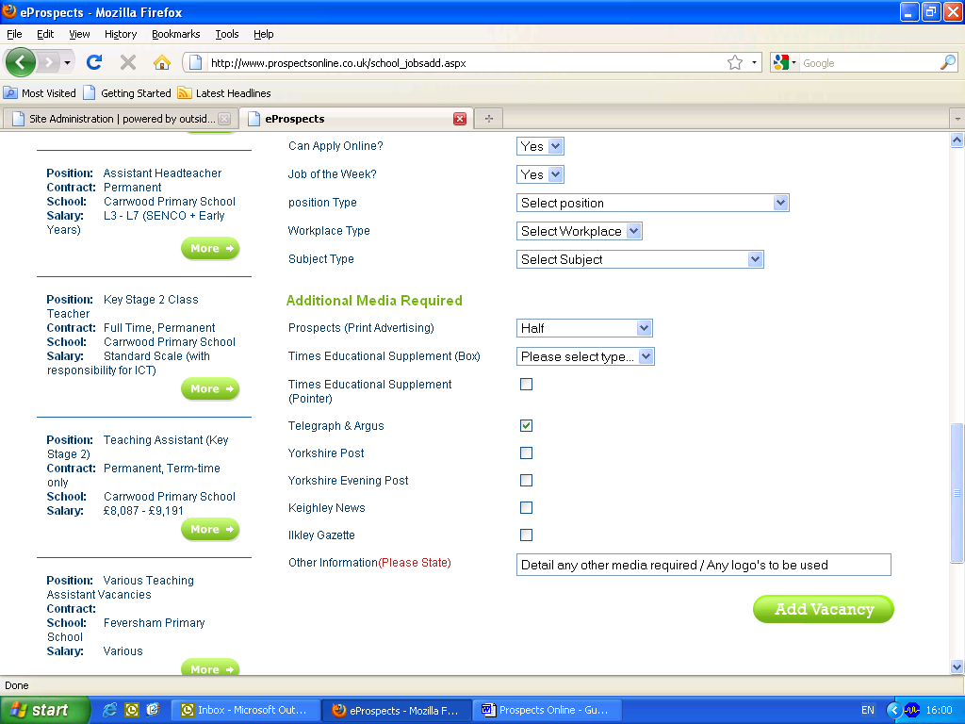

  - Indicate where you wish for the advert to be placed by using the drop down menu’s and tick boxes as desired.

  - Select Add Vacancy once completed

- You will receive a message box to confirm your vacancy has been submitted successfully and an email once the Recruitment & Advertising Team have changed the vacancy from Pending to Live

- Send your application pack to education.advertising@educationbradford.com so that this can be made available to candidates to download when viewing your advert.

- If your school does not use the standard application form (eg you need to use a specific church application form) please let the team know in your email, and attach the relevant form so that this can also be made available for candidates.
Expanding your audience, widening your prospects, reducing your workload

www.prospectsonline.co.uk

Section 2: Completed Online Applications

Preparation
- Ensure you have emailed the relevant documentation to education.advertising@educationbradford.com prior to the first appearance of your advertisement

- Ensure you make a diary note of your closing date in order to retrieve your completed applications

Retrieval
- Once your closing date has passed - log on to www.prospectsonline.co.uk (as per Section 1)

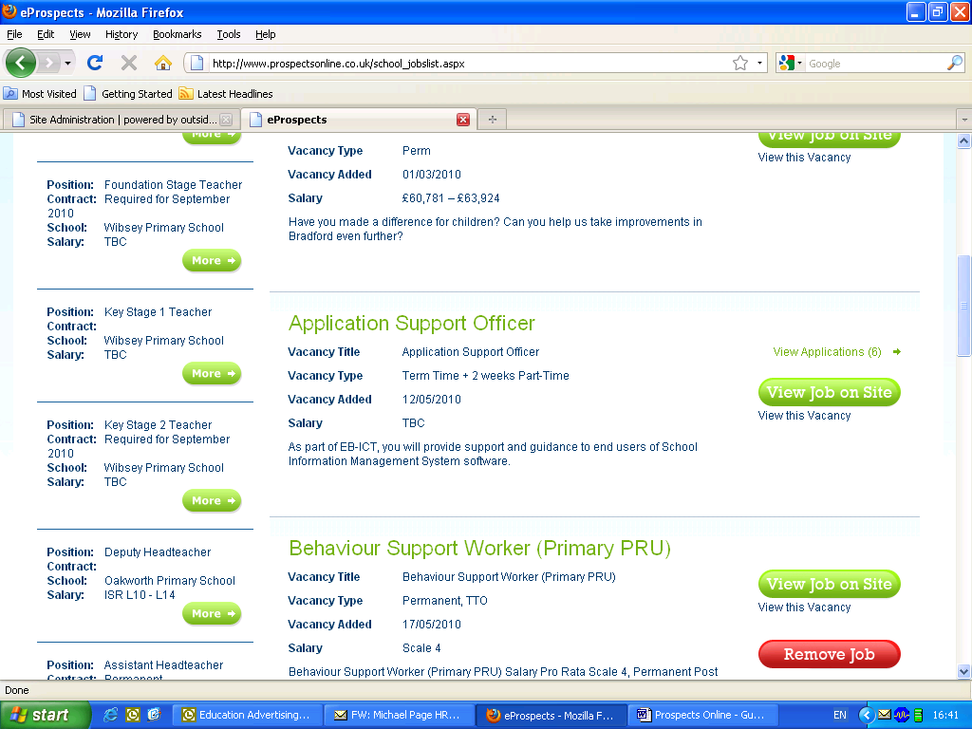
- Select ‘View All School’s Vacancies’

- Locate the desired vacancy and select ‘View Applications’

- Once the list of candidates has loaded, select ‘View Application’ to review each one
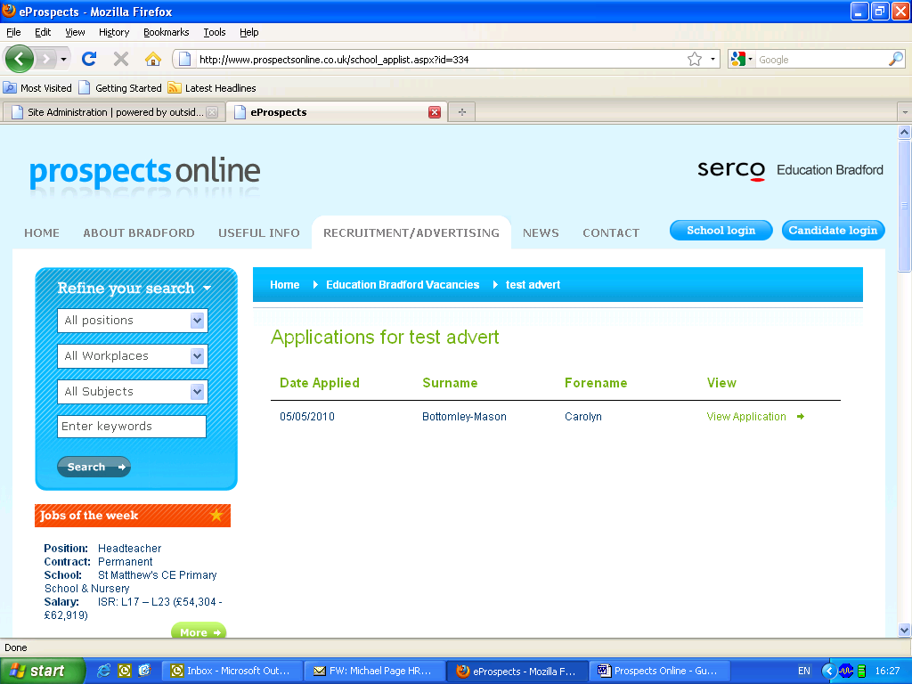
Bloggs
Joe
Smith
Sarah
Hussain
Amjad

  - Once the list of candidates has loaded, select ‘View Application’ to review each one

  - This will open the completed application form up in another window and enable you to review and/or print each application


Recruitment & Advertising Service – Tel: 01274 385992 / 3
Expanding your audience, widening your prospects, reducing your workload

www.prospectsonline.co.uk

