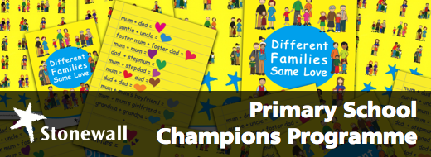

This course is available for Primary schools in Bradford 06/03/17

Venue: Cow and Calf conference suite Hangingstone Rd, Ilkley LS29 8BT

Delivered by James Robinson (NPQH)

Lead for Equality and diversity, Inclusion and Restorative practice Kirklees PRS

The Primary School Champions programme by Stonewall. your school will receive the following:
- Resources. You will receive an extensive pack of Stonewall’s acclaimed age appropriate “Different Families” primary school resources – so that your teachers and pupils are able to take advantage of our state-of-the-art learning aids. The resources you will receive will include training DVDs, education guides, posters, stickers and more.
- Discounted access to training and continuing professional development opportunities. Our training is undertaken by Stonewall's experienced practitioners who have trained thousands of staff in schools. Your staff will also be given discounted access to Stonewall events, conferences and training seminars.
- Benchmarking.We will equip you with the tools to evaluate your school’s current policies and practices with legal requirements and national best practice, so that you can create an action plan enabling your school to become a leader in the field.
- School Champions logo. Raising awareness of the good work you’re undertaking among your parents and community is important – so as to increase buy-in and engagement. That’s why Stonewall grants its School Champions exclusive use of the School Champions logo for internal and external communications.
- Stonewall schools helpline. You will have access to Stonewall's schools helpline throughout the year. Our expert education staff will provide tailored and responsive assistance.
- £200 plus VAT,
- To book a place on this course visit Stonewall.co.uk or
- Contact: james.robinson@pupilreferral.uk
- Tel : 07498717045

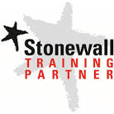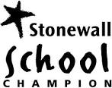

Primary School Overview
Primary school children come from a variety of backgrounds and families. Celebrating and acknowledging different families is crucial to make all children feel welcome and enable them to learn how to value those who are different.
Children prosper academically and developmentally in classrooms where they feel welcome and safe. Unfortunately, hurtful language is very commonplace in primary schools. Seven in ten of primary school teachers report hearing the word "gay" being used as an insult or to mean that something is rubbish.
This sort of homophobic language can affect any students perceived as different including boys who apply themselves academically, girls who behave like boys and kids with gay parents.
Through Primary School Champions, Stonewall partners with primary schools to help them celebrate different families and address homophobic language in the classroom.

Why should my primary school join?
- You will be prepared for your Ofsted inspections. Stonewall's expertise in advising primary schools how to navigate their legal obligations is second to none. Ofsted's framework requires its inspectors to investigate what primary schools are doing to celebrate different families and to address homophobic bullying. At the same time, schools are required under the Equality Act to actively tackle homophobia and protect those who might experience it. Because Stonewall has worked with Ofsted and other government agencies to create these legal requirements, we are perfectly placed to help your school meet them.
- You will help your pupils reach their potential. Pupils who hear homophobic language and abuse are more likely to struggle academically, become truant and suffer emotional and learning difficulties. By challenging such behaviour as it surfaces in a straightforward manner, you will give all your pupils the opportunity to reach their potential as healthy, driven and safe children. What's more, pupils who see their families and lives reflected in their learning are much more likely to feel included in school and as a result perform better.
- You will empower your staff. All teachers want what is best for their students and more often than not they're aware of the problem that homophobic language presents to their classrooms. But many simply feel ill-equipped to deal sensitively and effectively with homophobic language. By making the most of Stonewall's experience and expertise, you can empower your staff to tackle these issues with confidence.
- You will create a happy, welcoming learning environment. All primary schools aspire to creating for their pupils a safe place where they feel welcomed and happy. By working with Stonewall, you can help to safeguard such a positive learning environment by promoting a celebration of difference and empathy towards people from different family backgrounds.
To book a place on this course please visit www.stonewall.org.uk
- Contact : james.robinson@pupilreferral.uk Tel : 07498717045

