Prevent
Champions
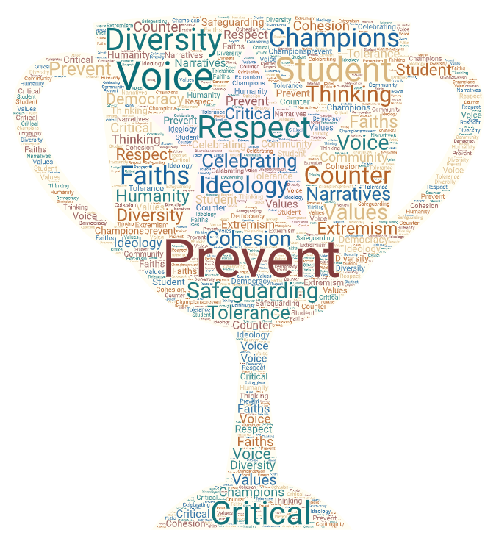

Our Prevent Champion schools agree to:

- Complete the Prevent self- assessment tool, a quick and easy tool to ensure Prevent matters are embedded into school policy, curriculum and with staff and pupils.

- Have a member of staff trained to deliver ‘Introduction to Prevent’ to all staff members and who will attend and cascade other Prevent related related training.

- Embed British values, SMSC needs, critical thinking and opportunities to discuss controversial issues within the school, both in curriculum and extra curricula activities and initiatives.

- Assess Channel referrals according to the ‘notice, check share’ model and contact the Prevent team if further guidance is needed.

Do you have students able to deliver Prevent awareness training to their peers?
If so please apply for Prevent Champions +.

In return you will receive:

- The Prevent Champion’s logo, to demonstrate your school’s commitment to the Prevent duty.

- Access to FREE staff training sessions on Prevent related issues.

- Access to FREE resources to help your school meet the Prevent Duty.

- Opportunities for your school to engage FREE speakers and projects to support Prevent work in schools.

- A regular Prevent update to keep you up to date with threat and risk in the area, especially in relation to young people.

Prevent Champions +
- Training as Prevent peer educators for selected pupils.

Training

Introduction to Prevent
An opportunity to be trained in Prevent so that you can cascade to all staff and governors, as and when necessary.

Holding difficult conversations with young people
The aim of the session is to equip practitioners with confidence and a means of answering difficult questions through a series of structured educational resources.

Cultural competency
Find out about the different communities and cultures within Bradford schools, their backgrounds and beliefs.

Presentations for young people
Training in how to deliver presentations on contemporary issues including
-the dangers of fake news and conspiracy theories
-risks associate with online gaming
-online risks and being media savvy

Prevent referrals
Training in how the referral process works, what makes a good referral, what to do if something doesn’t make the threshold.

The rise of domestic extremism
Who are the Far/ Extreme Right and why are they are such a risk to our young people?

Daesh and Al Qaida-
Who are they, what are their methods and why they are such a danger to our young people?

Israeli- Palestinian conflict
A simplified version for those who want to understand what is going on and why our young people may be interested in it.

Details of how to book will be sent out with the termly Prevent Education Newsletter. All workshops are free.

If you are interested in becoming a Prevent Champion or Prevent Champion + school please contact:
Geraldine Cooper
Prevent Education Officer (Acting)
geraldine.cooper@bradford.gov.uk

