People

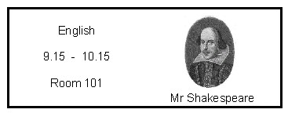

Why use photos of people
- Change is always difficult for the students on the autism spectrum and it is important that they know not only what is happening but who will be with them.
- Some students can struggle to remember faces and names even when people are familiar to them. They may need visual prompts to help them remember who is who in their class.

How to use
- Some classes will have different teachers on different days, supply and PPA cover for instance as well as different support staff for different sessions. Use photos to explain who the student will be carrying out an activity with.
- A timetable which includes photos of staff can help to reduce anxiety when a number of different adults are involved in working with the student.
- Visitors or unfamiliar people can be a source of anxiety for students with autism. Using photos to prepare them can reduce this anxiety.

Where next?
- Photos of people will also form an important part of transition programmes and social stories.

