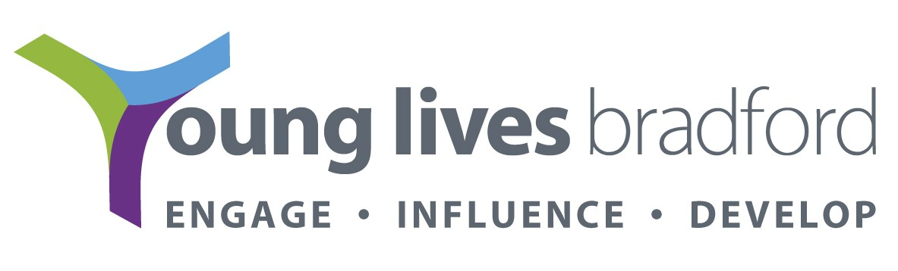

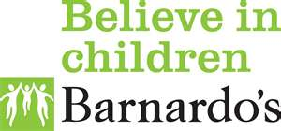

BRADFORD’S YOUTH CONTRACT

A total of £1.7m over the next three years has been received by Bradford for the Youth Contract. This funding is to support young people age 16 or 17 that are NEET and ‘reluctant to participate’ and move them in to a sustained place in education, employment and training as part of the City Deal from Leeds City Region.

The Youth Contract is intended to make a significant difference for vulnerable young people who are not participating so that they fulfill their full potential rather than continue to experience worklessness, poor health and social and economic exclusion.

There are 3 main objectives to the Youth Contract;

Objective 1 – This main objective of the programme – support 16 ad 17 year olds who are not in EET and at risk of long term disengagement. Support will be provided that results in them moving into education, training or employment with training and sustaining this outcome

Objective 2 – Increase the young people’s experience and qualifications so that they have the opportunity to continue in education and successfully find work, reducing the proportion that become unemployed in adult life

Objective 3 – Test methods of local delivery, encouraging innovation and evaluating the effectiveness of new models in order to develop best practice.

The Bradford Youth Contract offers tailored support from a ‘key worker service’ to help them move into education, apprenticeship or job with training. There will be a focus on multi agency working, with a wider remit to identify young people who have not yet demonstrated serious problematic behaviour but are in danger of doing so through identifying those that drop out quickly and ensure an appropriate support package is put in place
Bradford’s approach is to divide the funding into 3 Lots – Lots 1 and 2 is a new contract that we have commissioned jointly between Barnardos and Prospects and Lot 3 is a grant devolved to a voluntary and community sector organisation to act as broker agent.

Lot 1 - Vulnerable Groups (302 (2×151) young people in total) – maximum Eligible young people are those who have one or more of the following characteristics;
Young parents or young parents to be
Young offenders
Young people leaving a pupil referral unit
Young people who are homeless or have insecure housing

Lot 2 - NEET hot spots (410 (2×205) young people in total) Hot spots are identified as;
Central Keighley (Central, East and West Wards)
Eccleshill and locale
Little Horton

Lot 3 - (Not part of a competitive tender process) - Devolved Community Budget known as the ‘Young Futures Fund’.

The aim of the Young Futures Fund is to support Objective 3 of the overall Devolved Youth Contract - to test methods of local delivery encouraging innovation and evaluating the effectiveness of new models in order to develop best practice.

Each project has a particular community focus which is either geographical or community of interest. The projects support 16 and 17 year old NEET young people who are reluctant to participate or hard to engage (same as the core offer) with the aim of working with them to gain sufficient skills and confidence to enter and sustain their engagement in moving into accredited programmes. Each project is planned in such a way that young people have been involved in its design and development. It is expected that each project will support a minimum of 6 young people to move into positive destinations (education, employment or training). Due to each projects innovative approach to what they are delivering, it is expected that the projects will have a focus on ‘charting the young person’s journey’. Findings and methodologies will be shared amongst the other projects and young people in 2 ‘story telling’ events in March and August.

- Joint Activities and Motor Education Services (Peer Mentoring Support)
A support model where former NEET young people provide the support and mentorship of others supervised by experienced staff

- Bradford Youth Development Partnership (Flexible Intensive support for pre engagement issues)
Flexible, personalised support using a range of one to one and groups sessions involving literacy, numeracy, coping strategies and young person design activities

- Brathay (Social Enterprise Approach)
Support to turn their business ideas into reality, developing personal skills and confidence along the way.

- Bradford Community Broadcasting (personalised support through community radio reporting)
Using community media as the innovative context and catalyst for change, BCB will support NEET young people to becomes community reporters where there will be a focus on developing appropriate communication, confidence, and employability skills

- Bangladeshi Youth Organisation (Professional and Business Mentoring)
Supporting young people who are NEET in the inner city wards by offering mentoring from business and other professionals from the local community

- Woodside Community Neighbourhood Group (Sport/Health & Environmental activity based support)
Using strands of sports, health and environment the project will emphasise peer to peer work to support and motivate young people to get involved in their communities to make a difference

Bradford Youth Contract Core Offer
- Bradford Youth Contract is an entitlement of targeted support for NEET 16 and 17 year olds
- Targeted multi agency support
- Contracted deliverables that compliment partner input/offer not duplicate
- Additional capacity to existing services
- Share information

Youth Contract Key Worker Role
- Specifically support 16 and 17 year old NEETs
- Targeted work including assertive outreach
- Take on the role of Lead Professional
- Develop a Personal Progression Plan
- Co ordinate integrated multi agency support
- Enable parents and carers to positively engage on the process
- Access to an ‘Intervention Fund’
- Support the young person to engage/re engage in EET for a minimum of 26
- Weeks

Support Available
- Help to get to appointments
- Broker other support services
- Mentoring support
- Confidence building
- Motivation
- Job search
- Financial support

Referral Pathways
Positive Outcomes are defined as;
- Full time education or training funded by the YPLA/EFA
- Participation on an apprenticeship or a job with accredited training
- Equivalent to 280 guided learning hours per year (around 1 day per week)
- Participation in P/T education, including re engagement provision funded by the YPLA/EFA (young people will be participating in at least 7 hours of directed learning per week)

Sustained Positive Outcomes are defined as;
- Sustained participation for at least 5 months out of the 6 months in F/T education or training leading to an accredited qualification
- Sustained participation for at least 5 months our of 6 months in an apprenticeship
- Participation for at least 5 months out of the 6 months in F/T employment with P/T training equivalent (around 1 day per week)

Referrals to Bradford’s Youth Contract Core Offer
In order to assist Prospects and Barnardos in allocating the right key worker for the young person they require a referral form to be completed. This confirms that the young person fulfils the eligibility criteria. A phone call to either Prospects or Barnardos is required to say you are intending to refer a young person. If this can be done prior to the completion of a referral form it may assist you in whether or not the young person is suitable. Through a joint referral hub meeting between Prospects and Barnardos, a youth contract key worker can be allocated

Referring agencies are not expected to have completed a CAF.

Joy Robson Joy Robson
Barnardo's
Email: Joy.robson@barnardos.org.uk
Telephone: 01274 545186
Mobile: 07824561530

Liz Hemsley
Prospects
Email: liz.hemsley@prospects.co.uk
Telephone: Tel: 01274 377800
Like us on facebook

