Whole School Mental Health and
Emotional Wellbeing
Audit tool
for
Mental Health Champions Plus (MHC+) Schools

Version 2: November 2022

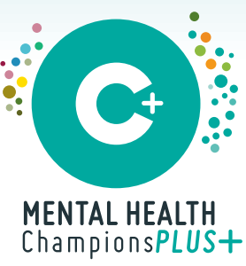

Originally produced by Bradford MHC Team (Nov 2020)
based on a document written by Kerry Clarke (Public Health), Tracey Williams (Educational Psychology, Brighton & Hove) and Dr. Pooky Knightsmith (Charlie Waller Memorial Trust)

Introduction

The emotional, mental health and wellbeing of Children and Young People (CYP) is as important as their physical health and wellbeing. Over recent years it has been recognised that changes need to be implemented to mental health services for CYP to identify CYP’s needs early and enable them to access timely, appropriate mental health services that support them to build resilience.

Mental health problems in CYP can result in – and can in turn be affected by – lower educational attainment, poor physical health, poor social relationships, school exclusion and limited future employment prospects as well as behaviours such as smoking, using drugs and drinking alcohol. Schools have an important role to play in helping to mediate the interaction between all of these different factors, in order to ensure that outcomes for all pupils are as positive as possible.

The Mental Health Champions (MHC) and Mental Health Champions Plus (MHC+) approaches aims to develop skills and knowledge in schools and to work with schools and key partners to help CYP to be resilient and mentally healthy. This audit is intended to help educational settings identify ways in which they can improve mental health/emotional wellbeing provision across school.

Improvements in provision as a result of action planning and implementation will also help to demonstrate the impact that the MHC+ project is having, and will therefore help to justify the continued commissioning of the projects.

Key principles

The audit is based on eight key principles for emotional, mental health and wellbeing as recognised by Public Health England:
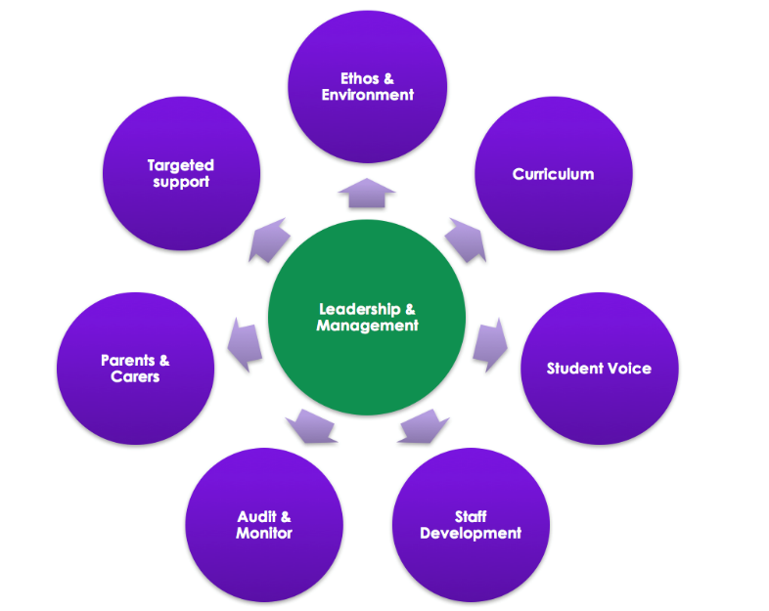

1. Leadership & Management:
We aim that every school in Bradford will have leadership and management that support efforts to promote emotional, mental health and wellbeing.

2. Ethos & Environment
We aim that every school in Bradford will have an ethos and environment that promotes respect and values diversity

3. Curriculum, teaching & learning
We aim that every school in Bradford will have curriculum, teaching and learning for CYP that promotes resilience and support social and emotional learning.

4. Student (CYP) Voice
We aim that every school in Bradford will enable student voice to influence decisions.

5. Staff Development
We aim that every school in Bradford will have staff development to support their own wellbeing and that of CYP

6. Audit & Monitor
We aim that every school in Bradford will identify need and monitor impact of interventions.

7. Parents & Carers
We aim that every school in Bradford will develop positive relationships with parents and carers

8. Targeted support
We aim that every school in Bradford is able to identify CYP at risk or with mental health/emotional wellbeing issues, and gain consent to access the appropriate emotional wellbeing and mental health intervention suitable to their needs.

How the audit works

The audit tool is comprised of 3 phases; an initial self-evaluation, an action planning and implementation phase, then a review of the initial evaluation in light of changes made.

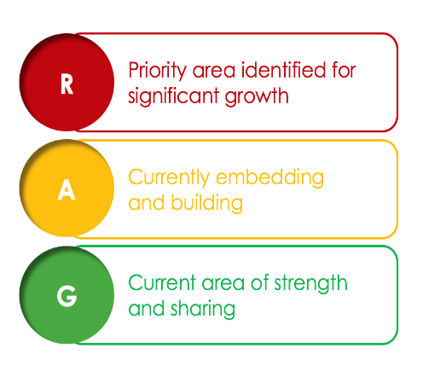
Phase One: School Self-Evaluation:
The process will begin with the school completing the self-evaluation.

FROM AUTUMN 2022: Schools will choose ONE of the Key Principles to focus on for the year, and will RAG rate (see Figure 2) themselves for each statement within this.
It is likely that all schools will have elements of red, amber and green within this. If practice within an area is felt to be all green, then you probably need to choose a different Key Principle to focus on instead!

You may want to complete the whole document (i.e. all eight sections) to help you decide which area to focus on this year, but this is not compulsory. Or, if you already have a good idea of what you’d like to work on (e.g. if you were in the first cohort of MHC+ schools and completed the whole audit last year, or if you already know that a particular area of practice needs revisiting) then just complete the section you want to focus on.
Whichever way you decide to do it, remember to date each RAG rating so that it’s clear when it refers to.

Phase two: developing an action plan
The Action Plan will be simple document showing the actions that you agree to carry out as a result of the self-assessment. It will be developed with your link EP from the MHC+ team during the first 1:1 session. You will probably already have a clear idea of some actions you want to take, but you can also use the 1:1 session to discuss other possible ways forward and clarify your thoughts.
Your link EP will send you a copy of your Action Plan after the 1:1 session so that you can refer to it throughout the year and link it to other documents within school as appropriate (e.g. your School Improvement Plan). The Action Plan will also form the basis of discussion at future 1:1 sessions.

Phase three: Review
Schools will repeat the RAG ratings at the end of the year. If action planning and implementation has been successful, at least some ratings will be improved. Assuming you’ve made progress with your identified area this year, you’ll move onto a different section next year.

Who should complete the self-assessment?

The MHC should work with colleagues to ensure that it reflects a fair assessment of practice across school. There is no set rule for who else should be involved, or how many people this should be, but we advise that at least one member of SLT contributes if possible, as many of the statements examine what is in place (and by extension, what would ideally be in place) at a “whole school” level.

Gathering information from others who hold relevant positions (e.g. PSHCE coordinator? Nurture Lead? Parent representative?), as well as some pupil and parent voice (e.g. through School Council? PTA? Parent Governor?) would also help to ensure that the audit is as comprehensive and thorough as possible, but we realise that this may not be feasible or practical within the time available.

Self-evaluation

Name of school
Date of initial evaluation
Staff members completing initial evaluation (names and roles)

1. Leadership & Management:

How is the school providing visible senior leadership for emotional, mental health and wellbeing (MHEWB)? | Red | Amber | Green
1.1 Your setting has a named member of staff from SLT with overall responsibility for MHEWB
1.2 The school/setting has a named Governor for SEMH
1.3 Named lead for school has regular communication with is signed up to Bradford’s Mental Health Champion project
1.4 All staff know how and when to report child/young person MHEWB concerns to MHC or appropriate member of SLT (or designated lead)
1.5 MHEWB is included in improvement plans, policies, systems and activities.
1.6 (and 5.7) The MHC is given adequate release time to attend MHC sessions (first half term) and MHC+ sessions (second half term), and to commit to whole-school development work
1.7 SLT prioritise the development of (and maintenance of) a whole school approach to MHEWB
1.8 There are clear information-sharing pathways with other relevant professionals, enabling joint planning and response

2. Ethos & Environment

How does the school or college’s culture promote respect and value diversity? | Red | Amber | Green
2.1 MHEWB considerations are strongly embedded into the school ethos, both for adults and CYP
2.2 Healthy, positive relationships are established/maintained between adults and CYP
2.3 Healthy, positive, professional relationships are established/maintained between adults, including with parents and families
2.4 School is felt to be regarded as a safe, kind and welcoming place, both within school and within the community
2.5 Specific and planned opportunities to develop empathy, respect and interpersonal skills are provided (e.g. social skills interventions, assemblies, trips, opportunities to learn about other cultures)
2.6 Information about ways to find support is visible and easily accessible to all, including parents/other family members
2.7 The school/setting has ongoing, visible anti-stigma work
2.8 Emotions and mental health are talked about openly and freely
2.9 The behaviour/inclusion/relational policy has at least as much emphasis on how positive, healthy relationships are developed and maintained within school as it does on how challenging behaviour is responded to

3. Curriculum, teaching & learning

What focus is given within the curriculum to social and emotional learning and promoting personal resilience, and how is learning assessed? | Red | Amber | Green
3.1 Opportunities exist to develop and promote social and emotional skills (e.g. through PSHE lessons, targeted interventions, work with individuals, extra-curricular activities)
3.2 Mental health/emotional wellbeing lessons are practical and relevant for pupils and encourage them to adopt emotionally healthy habits.
3.3 CYP are taught about mental health and stigma
3.4 PSHE curriculum is clearly outlined on school website
3.5 Key staff have been trained in how to teach difficult topics safely and sensitively
3.6 Sources of support are signposted in lessons where relevant
3.7 CYP are taught how to keep themselves as safe as possible (e.g. through age-appropriate and good quality sex/relationships education and drugs/alcohol education, as well as online safety, swimming lessons etc)
3.8 CYP are supported to be as resilient as possible

4. Student (CYP) Voice

How does the school or college ensure all CYP have the opportunity to express their views and influence decisions? | Red | Amber | Green
4.1 CYP have the opportunity to be involved in planning and decision making around MHEWB provision, irrespective of their ability or needs
4.2 CYP are encouraged to be confident and respectful in expressing their views
4.3 CYP feedback is regularly gathered and analysed to monitor the effectiveness of emotional wellbeing support, and to identify improvements.
4.4 There is a School Council (or similar) which feeds into decisions made by SLT
4.5 CYP feel that school is a safe, kind and welcoming place
4.6 CYP feel that their MHEWB needs are met within school

5. Staff Development

Key question: How are staff supported in relation to their own health and wellbeing and to be able to support CYP’s wellbeing? | Red | Amber | Green
5.1 Staff feel a sense of belonging at the school and feel valued and supported.
5.2 Staff wellbeing is recognised as fundamental to whole school health (e.g. this is prioritised in policy and practice; the HT’s performance management includes reference to whole staff wellbeing)
5.3 Staff in key roles relating to MHEWB are suitably trained and engage in regular supervision/reflective practice that is different to line-management CPD (e.g. attending MHC/MHC+ sessions, reading, CPD opportunities, shadowing opportunities)
5.4 Staff across school engage with training and CPD opportunities relating to MHEWB
5.5 Information signposting to sources of support for staff are well displayed/regularly communicated (e.g. via feedback from MHC Core meetings, staff wellbeing display board)
5.6 Staff have a safe and or quiet space they can access when needed, away from students and parents.
5.7 (and 1.6) The MHC is given adequate release time to attend MHC sessions (first half term) and MHC+ sessions (second half term), and to commit to whole-school development work
5.8 All staff are trained in MHEWB approaches/interventions that may be applied across the whole-school (e.g. Emotion Coaching, Restorative Practice) so that messages are consistent and cohesive

6. Audit & Monitor

How does the school or college assess the needs of CYP and the impact of interventions to improve wellbeing? | Red | Amber | Green
6.1 Decisions made at a policy/planning level in school reflect local/regional data about mental health where necessary (e.g. post-pandemic recovery, rates of parental mental ill-health)
6.2 School level data that indicates emotional wellbeing is gathered and analysed
6.3 MHEWB data is used to identify strengths and areas for improvement
6.4 MHEWB interventions, training and packages are reputable and fit for purpose (e.g. evidence-based and/or endorsed by reputable organisations)
6.5 Clear outcomes are set when introducing MHEWB resources and interventions
6.6 Impact of MHEWB interventions and packages is monitored (e.g. through the collection of qualitative and quantitative data), with appropriate actions being taken in response to this

7. Parents & Carers

How does the school or college work in partnership with parents and carers to promote emotional, mental health and wellbeing? | Red | Amber | Green
7.1 Parents/carers are provided with accessible information about emotional wellbeing policies, procedures, and how to access services
7.2 Parents/carers are offered opportunities to participate in events at school that deepen their understanding of how the school promotes emotional wellbeing (e.g. through coffee mornings, newsletters, workshops)
7.3 The school identifies ways in which it can support and work with parents/carers to promote MHEWB (e.g. signposting, referral to appropriate outside agencies, organising peer support)
7.4 Parents are informed about the MHC parent workshops
7.5 Staff are able to identify families who might benefit from MHC parental events, and are proactive in signposting.
7.6 School staff identify and overcome barriers to parental engagement as far as possible (e.g. language barriers, access, motivation)

8. Targeted support

How does the school or college ensure timely and effective identification of CYP who would benefit from targeted support and ensure appropriate referral to support services? | Red | Amber | Green
8.1 School staff are aware of and understand risk factors for mental health difficulties.
8.2 All school staff are aware of, and can recognise, basic warning signs that a student might need MHEWB support and know how to report any concerns.
8.3 There is effective communication with external agencies to understand how the school can support a child/young person.
8.4 School staff are aware of which members of staff can refer CYP to external agencies.
8.5 Relevant staff know how to make referrals and enquiries to a wide range of outside agencies for MHEWB support
8.6 CYP know who they can talk to if they have concerns about themselves or a friend, and what will happen if they raise a concern (e.g. confidentiality, safeguarding boundaries)
8.7 CYP are taught to be “critical consumers” of online content and can name reputable sources or types of support for MHEWB issues (e.g. local and national helplines/websites, Kooth, YoungMinds, BEAT)
8.8 All staff have at least a basic training in how to respond appropriately to specific events such as self-harm, suicidal ideation, panic attacks, substance misuse, CSE, FGM and so on
8.9 MHEWB support is planned and available at times of specific vulnerability (e.g. lead up to exams, transition, following critical incident at school/local/high profile)

Next steps: Action Plan

Please make a note below of any initial thoughts about your priorities for development, based on the findings of your audit (don’t feel like you have to fill all the boxes – you may add to this in future years – it is just a space to jot any initial thoughts). You will discuss these further in your first 1:1 session with a member of the MHC+ team later this term.

Date  (term/yr) | Goal - what would you like to achieve or work on? | Initial thoughts (e.g. ideas of how to work towards identified goal / further things to find out / potential barriers etc)

