What is Tolerance?

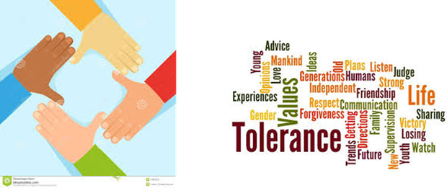
Tolerance is when you are patient and show kindness or love towards another person by helping them no matter how long it takes.
www.youtube.com/watch?v=M4Ijr3ClZN0

Discussion/Points
• The lambs were wrong to shun Lambert
• The mother sheep welcomed Lambert with an open mind/heart
• Everyone has a right to belong, even if they are different
• Everyone has different strengths and abilities

Tolerance is shown in many ways
•Accepting that all people have differences
•Being polite at all times – even when someone/thing has made you angry
•Sharing the things that you really like
•Being patient
•Respecting other peoples ideas that are different to yours
•Respecting others’ religious and cultural beliefs

Can you show Tolerance?
•Your teachers will be looking for examples of tolerance through out this week.
•Next week’s assembly will be rewarding those who have demonstrated tolerance.
•Will it be you?

Love and Respect

.
Some of the children in Nurture Group made a video about love and respect to show in an assembly.

- Home
- About Us
- News
- Key Information
- Parents
- Pupils
- Community
- Children's Centre
- P.E and School Sport
- Inclusion and SEND

