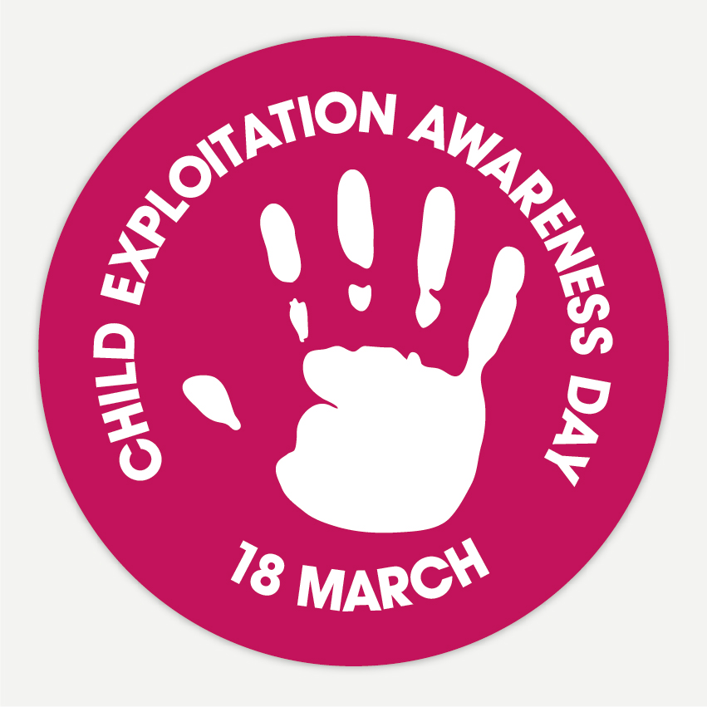

National Child Exploitation Awareness Day
18th March 2021
Safeguarding is everyone's business
Our aim is to raise awareness of exploitation and get as many people talking about it and ‘Spotting the Signs’ and to start some vital conversations. The awareness-raising day can be simply the day or you may wish to hold a week-long focus through your organisational channels.
It may be difficult for parents and carers and frontline professionals to differentiate between ordinary teenage behaviour and the risk of or involvement in exploitation but there are some signs that may signify that children or young people are being groomed for exploitation or actually being exploited.

ON MARCH 18, WE WANT THE WORLD TO UNITE AGAINST CHILD EXPLOITATION.
HELP US RAISE AWARENESS #CEADay21

We believe that if we can make more people aware, not only through our National
Awareness Day, but all year round through the Say Something if You See Something
campaign, that we can improve the chances of young people being heard. Together, we
can work to inform, educate and prevent child abuse within the UK

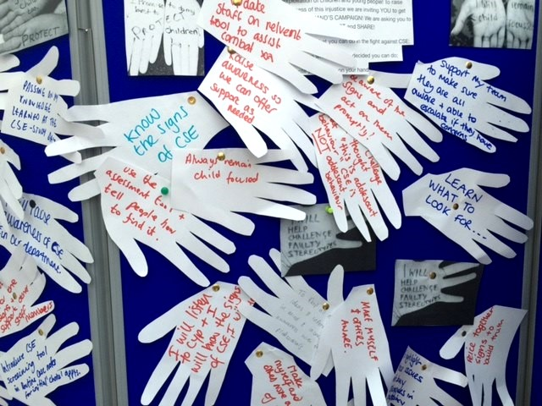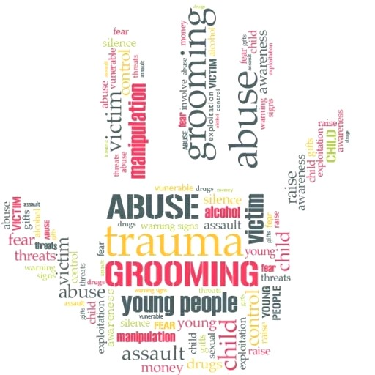

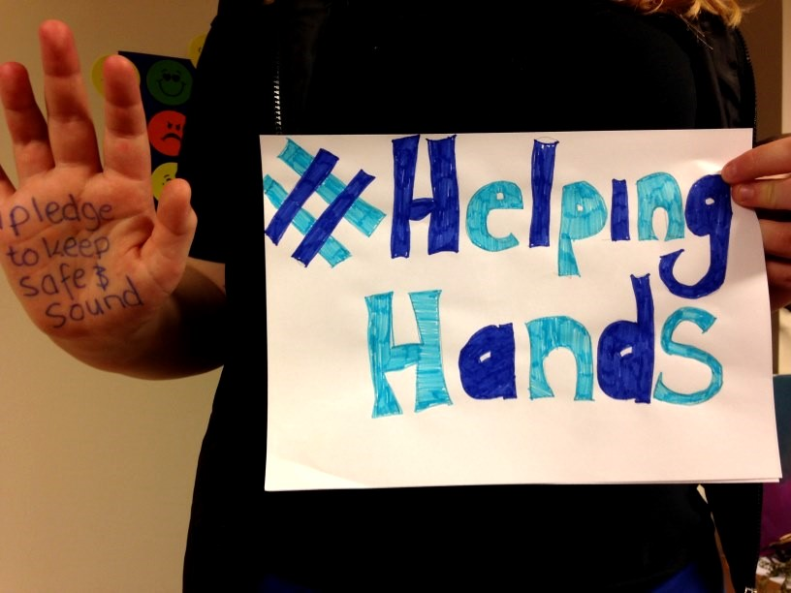

WRITE AND SHARE A PLEDGE
Write a personal pledge on your hands to show support for our Helping Hands campaign. Post your photo on social media with the hashtag #HelpingHands and #CEADay21 to help us raise awareness of CSE and wider exploitation.

DISPLAY OUR CAMPAIGN
… and help to raise awareness of Child Exploitation by displaying the banners and posters included – designed to encourage participation in the National CE Awareness Day – together we can raise awareness and deter child exploitation.

YOU CAN HELP TO GIVE VICTIMS A VOICE.

SHOW YOUR SUPPORT ON SOCIAL MEDIA USE #HELPINGHANDS AND #CEADAY21.

