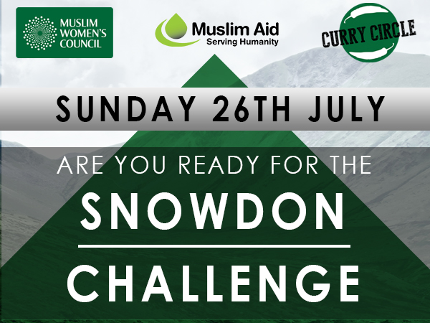
SNOWDON 2015 Climber’s info pack

Thank you for registering to take part in our Snowdon Challenge this year. This is brought to you by the Muslim Women’s Council in partnership with Muslim Aid, as an amazing opportunity to help our Curry Circle initiative. The Curry Circle feeds Bradford’s most disadvantaged people every week. Your £150 fundraising target will help feed 100 people (the target for under 18’s is £50). The more you raise, the more people you will be feeding.
So get ready to help deliver change in your community, and have some fun along the way whilst climbing Mount Snowdon with new and existing friends.
But before all that, below is some information that is going to be important to your challenge, so make sure to have a read and let’s get fundraising!
Some fundraising ideas
Collection Boxes
Collection boxes are a really simple way to support your fundraising efforts. Just create a collection box, and leave it in a prominent place, maybe the canteen at work or at the reception, or even just give it a shake in front of your friends and ask them to cough up!
Get Sponsored
Getting sponsored is one of the easiest ways to fundraise. Ask your friends, family and colleagues to support your challenge with a pledge, then ask them to complete the sponsor form and hand over the money!

Social Networking sites
This one sounds pretty obvious right? But it can prove so effective! Make sure to use your social media networks to remind everyone about your challenge. The response can sometimes be very surprising.
Have a BBQ
This one sounds too easy to be true, right? But we’re serious, invite some friends and family over for a BBQ, have some fun, some food and let everyone know about your fundraising challenge. They’re sure to support your amazing challenge after they’ve had a hearty BBQ and a chance to hear your plans.
Put up a notice at your place of worship, college, workplace
The best way to get people to donate to your project is to get the word out there as much as possible. A simple poster can let everyone know about your challenge, and gives you a great way to increase support for your challenge.
Donate During Ramadan
How much do you normally spend a day or week on lunch/dinner/take-aways? If you’re fasting, the money that you are saving during Ramadan could be donated towards your Snowdon Challenge!
All your amazing ideas
One of the greatest ways to fundraise is to be as creative as you can. At the end of the day, you will be the one undertaking the challenge, and you’re the best person to go out there and fundraise for the project. So whatever ideas come to mind, if you’re confident in its fundraising potential, go for it!
Equipment required
It is of paramount importance that you have the necessary clothing for the challenge for your safety and to enjoy the trek. The weather can be very unpredictable as you climb higher. Please ensure that you have the following:
Compulsory Items
✓ Appropriate footwear (preferably hiking boots)
✓ Waterproof jacket and waterproof trousers
✓ A rucksack – to carry food, water and extra warm clothing
✓ Pair of gloves
✓ Extra pairs of socks (never underestimate the power of dry socks!)
✓ Emergency rations (a couple of muesli or chocolate bars and a bottle of water)
**Please remember without these items you will not be allowed to trek

Recommended
• A scarf
• Warm hat
• Spare layers of clothing (It can get really cold up there!)
• Trekking poles
• Camera
• Sun-screen/glasses
• Whilst on trek: Ideally 3 layers should be worn; a t-shirt, followed by a fleece, thermal top, or a ‘hoodie’ underneath your waterproof jacket
• Thermos flask for a nice cuppa

Footwear
For the Snowdon Trek, boots are preferable; although shoes with thick soles will do and you should ideally do most of your training in the footwear you will wear for the climb (especially if it is new in order to avoid painful blisters). However, there is no need to spend a fortune if you are buying them for Snowdon alone. Outdoor shops, such as Millets and Sports Direct, stock perfectly adequate boots for around £15-£30 and many retailers will help ensure a perfect fit, which is obviously important. When purchasing your footwear, wear one thin and one thick pair of socks, which is the ideal combination for the hike and will prevent you from buying shoes that are too small.

Feet first!
There are some common foot problems which are very easy to treat and avoid:
• To avoid blisters keep your feet dry and wear socks made with fibres which draw moisture away from your skin – steer clear of pure cotton. Don’t lace your shoes too tightly or too loosely. The irritation from the pinching and rubbing may cause blisters.
• Aching arches are usually caused by pounding when you walk. Make sure you touch the ground with your heel first and push off with your toes.
• Blackened toenails are caused by the big toe hitting the front of your shoe. Keep your toenails neatly trimmed. Make sure that if one of your feet is slightly larger than the other, as most are, that your boots fit the larger one.

The fundraising bit
Please use the Sponsor form (on the separate attachment) to collect your money.
Any online donations can be done via www.currycirclebradford.co.uk and then click on the donate button

IMPORTANT! PLEASE FILL IN THE CONSENT FORM ON THE NEXT ATTACHMENT AND EMAIL/HAND IN BEFORE 25th JULY, ALONG WITH YOUR SPONSOR FORM AND ALL MONEY RAISED.
All cash collected can be left at Muslim Women’s Council offices.
All cheques to be made out to Muslim Women’s Council.
Our postal address is:
Muslim Women’s Council
Carlisle Business Centre
Lister Suite, 60 Carlisle Road
Bradford, BD8 8BD

Any questions? Please call our office on 01274 223230 or email us at directorsoffice@muslimwomenscouncil.org.uk

Good luck with all your fundraising and we look forward to meeting you at the walk!

