Our ref:  Your ref: | Department of  Children’s Services  – Aiming High for Children  Music & Arts Service  Fairfax Learning & Development Centre,  Flockton Road, Bradford, BD4 7RY  Tel: 01274 434 970  Fax: 01274 408 335  Email: schoolsmusicandarts@bradford.gov.uk
The Headteacher/
Music Co-ordinator or Head of Music
ALL BRADFORD MDC SCHOOLS
31 January 2018

Dear Headteacher/Music Co-ordinator or Head of Music

MUSIC RETURN – ACADEMIC YEAR 2017-2018

Annually we are asked to collate information across the Bradford MDC to return to the Arts Council, all information is then fed through to the DfE in order that a more accurate picture can be formed of music across the country.

We hope you will be able to support this information gathering exercise by providing information about pupils receiving musical opportunities in your school. Please find attached the data form which I would be grateful if you would complete as fully as possible.

Please note any ensembles/groups which you have booked directly with the Music & Arts Service do not need including as we already hold this information.

Would you also complete the pupil level information, if known, for your pupils including those who play but may not be in one of your ensembles.

Please also note that the information is required for the academic year 2017-18.

In the unlikely event it is a “nil” return for your school please indicate this also on the form.

Please complete the data collection required NO LATER THAN FRIDAY, 16 MARCH for inclusion in the 2017-18 data collection for Bradford MDC.

MUSIC AUDIT

As part of our continued commitment to support music in schools we hope to visit all schools each year to ensure the correct musical support can be offered.

Yours sincerely,
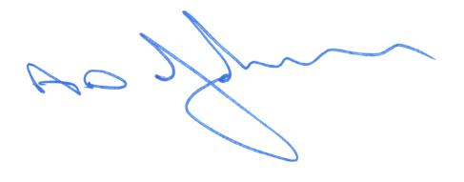
Tony Johnson
Head of Music & Arts Service

