Our ref:  Your ref: | Department of  Children’s Services  – Aiming High for Children  Music & Arts Service  Fairfax Learning & Development Centre,  Flockton Road, Bradford, BD4 7RY  Tel: 01274 434 970  Fax: 01274 408 335  Email: schoolsmusicandarts@bradford.gov.uk
The Headteacher/
Art Co-ordinator and Bursar
ALL BRADFORD MDC SCHOOLS

25 March 2019

Dear Headteacher/Art Co-ordinator/Bursar

ACADEMIC YEAR 2019-20 – ART PACKAGES BUY BACK

If you wish to renew or book a new art provision for 2019-20 then please complete the booking form attached.

The following documents can also be found on http://bso.bradford.gov.uk/Schools/CMSPage.aspx?mid=2164

- Art Provision Information (also attached)

- Art Provision booking form (also attached)

- Pupil Premium information

Please return this form by Friday 3 May 2019.

Yours sincerely

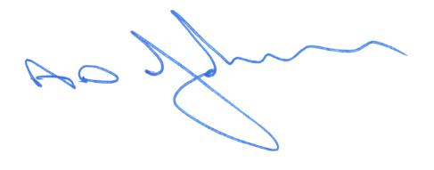

Tony Johnson
Head of Music & Arts Service

Enc

Bradford Council is fully committed to compliance with the requirements of the General Data Protection Regulation and the Data Protection Act 2018. “To learn more about how we use your information, go to www.bradford.gov.uk/privacy-notice and the Music & Arts Service Privacy Policy go to https://www.bradfordmusiconline.co.uk/site/changes-to-data-protection-legislation-25-may-2018/

