Our ref:  Your ref: | Department of  Children’s Services  – Aiming High for Children  Music & Arts Service  Fairfax Learning & Development Centre,  Flockton Road, Bradford, BD4 7RY  Tel: 01274 434 970  Fax: 01274 408 335  Email: schoolsmusicandarts@bradford.gov.uk
The Headteacher/
Art Co-ordinator and Bursar
ALL BRADFORD MDC SCHOOLS

8 February 2018

Dear Headteacher/Art Co-ordinator/Bursar

ACADEMIC YEAR 2018-19 – ART PACKAGES BUY BACK

If you wish to renew or book a new art provision for 2018-19 then please complete the booking form attached.

The following documents can also be found on http://bso.bradford.gov.uk/Schools/CMSPage.aspx?mid=2164

- Art Provision Information (also attached)

- Art Provision booking form (also attached)

- Pupil Premium information

Please return this form by Friday 16 March 2018.

Yours sincerely

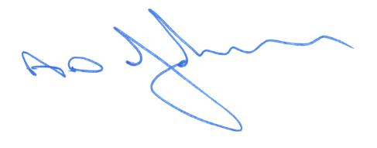

Tony Johnson
Head of Music & Arts Service

Enc

