
Meet the MNHES Team
Hannah Whittaker
Service Manager

‘I have been teaching in Bradford for over 20 years and enjoy reading, watching TV and needlecraft’


Claire Wright
Business Support Manager
‘I have worked in education since 2007 and have enjoyed developing my career and taking on new challenges along the way! Outside of work, I enjoy keeping active through strength training and spending time socialising with my family and friends’
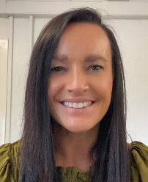
Melanie Lambert-Crookes
Attendance Support Officer
‘I am Melanie and I have been working in Education for 18 years, I love to support families and students. In my spare time I like to keep fit and travel’

Raheem Ahmed
Receptionist/Administrator
‘Hi my name is Raheem, and I enjoy playing or watching football quite often, I'm a new face at MNHES and really enjoying my time here so far’

Primary Team

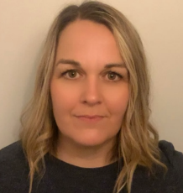

Melissa Sellers
Assistant Head - Primary Phase Lead

‘I have worked across Primary, specialist and alternative provisions in Bradford. I enjoy spending time with family, walking and visiting new places’
Asia Aslam-Armitage
Primary Teacher
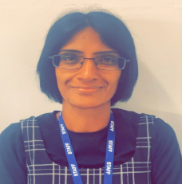

‘I have been a Primary teacher for 23 years and have worked at MNHES since 2016. In my spare time, I enjoy walking, going to the cinema and spending lots of time with my friends and family’


Helen Fox
Primary Teacher

‘I have been a primary teacher for over 30 years within the Bradford area. I have worked at MNHES since 2015. I love teaching and you will always see me with a smile on my face! I also enjoy films, exploring different places and solving puzzles’

KS3 Team
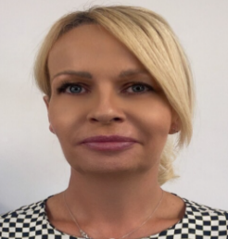
Emma-Jayne Best
KS3 Team Leader

‘I have been a teacher in both Primary and Secondary Schools for 29 years! Currently KS3 Team Leader at MNHES. I love anything sparkly and my favourite thing to do is clothes shopping and buying new make-up items. My motto is Live, Laugh and Love!’



Claire Broad
KS3 Teacher

‘I am Claire and I have been working in Education in Bradford for 17 years, both primary and secondary. I love travelling to new places and enjoy reading psychological thrillers’



Malachy Mallon
KS3 Teacher

‘I have been working at MNHES for 8 years and currently teach Maths to students in Key Stage 3. Outside of work, I enjoy climbing and going to the theatre/cinema’

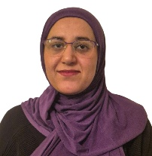

Mazish Ahmed
KS3 Teacher

‘I have been teaching Science across Bradford for over 15 years and am passionate about inspiring young people to explore and understand the world around them. Biology is
my particular favourite because life is everywhere, outside the classroom I love exploring the coast and discovering the amazing plants and animals that share our world’



Raminder Chawla
Learning Mentor
‘I have followed my passion and worked in Education sector for last 19 years, as a TA, Cover supervisor, HLTA, Teacher, SEND Officer, in different primary and secondary schools across Bradford and Leeds; and currently as a Learning mentor at MNHES, Shipley. My hobbies and interests are listening to music, cooking, and knitting’



Sophia Kadir
Learning Mentor
‘I have worked in education for 14 years and I have always been passionate about helping young people achieve their best. I am a total foodie and love trying new restaurants and cafes’

KS4 Team



Robert Holladay
KS4 Team Leader

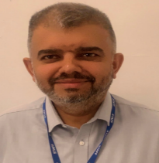
‘This is my fifth year at MNHES and I like all sports especially football’

Asaf Hussain
KS4 Teacher


‘I have been teaching since 1995. Love to travel. I have worked in London, Suffolk and Yorkshire’
Gabrielle Murray
KS4 Teacher
‘I have been a teacher for 26 years who loves to walk in the hills’


Michelle Guinan
KS4 Teacher
‘I’ve been teaching for 27 years—spending two decades in secondary mainstream schools and seven years at MNHES (previous known as TRACKS). Now working part-time, I dedicate my free time to exploring the outdoors on my boat and in my caravan’


Nicholas Box
KS4 Teacher
‘I have been in teaching for over 30 years, working most recently at Immanuel College. I initially trained as a PE teacher but for the last 12 years I have been teaching Maths. I enjoy gravel/mountain biking followed by a nice cake and coffee’


Rebecca Cesar de Sa
KS4 Teacher

‘I have worked at MNHES for over 10 years. I particularly enjoy teaching PE, I am very sporty and my main hobby is running. I once ran 113 miles for charity!
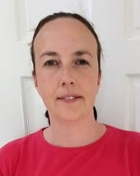
Martina Deery
KS4 Teacher

‘I have I have been teaching at MNHES for 5 years. I spend my free time with horses and my dog Lily’


Simon Wells
KS4 Teacher

‘I have been teaching in Bradford since qualifying in 2000 as a geography teacher. Now loving teaching English. I run my sons open age football team on a Sunday and have a keen interest in Geocaching’

Welfare Team


Waqass Khalid
Welfare Officer

‘I have been working in the education sector for the past 11 years spanning from special needs education to mainstream and medical needs settings. I enjoy time outdoors in nature, walking and the gym’



Charlotte Gill
Education Engagement Worker

‘I have been working in education for 10 years. I enjoy reading, cooking, listening to music, spending time with my family. I also really like dogs and cows’



Happy Rashid
Education Engagement Worker

‘Hi, my name is Happy and I have been working as an educator for 10 years. My hobbies are traveling and eating chocolates’



Humiyrah Hussain
Education Engagement Worker

‘I have been working at MNHES for 4 years. I enjoy playing football, cooking and doing my makeup’



Eugene Benjamin
Specialist Well-being and Therapeutic Support Practitioner

‘I'm the wellbeing practitioner at Medical Needs and I've now been working in education for 3 years. I like working in education as each day is different, and everyone involved is always learning. For fun, I enjoy watching movies at the cinema’
Hospital Team


Sarfraz Nawaz
Teacher in Charge

‘My name is Sarfraz I am an experienced science educator who has spent the last 19 years inspiring students across the Bradford district. Driven by a natural love for problem-solving, I specialise in turning complex scientific concepts into engaging, hands-on challenges for students. I have a passion for fostering critical thinking both inside and outside the classroom. When am not designing interactive experiments or helping students crack tough equations, I enjoy sharpening my mind by masterfully solving the Rubik’s Cube’

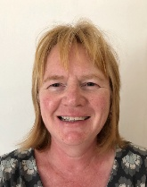

Janet Vekaria
Learning Support Assistant

‘My name is Jan. I worked as a teacher in mainstream primary and nursery schools for 31 years before taking up a supporting role at the hospital school 8 years ago. I love singing in a choir, walking and learning languages’

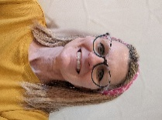

Kathleen Astin
Learning Support Assistant

‘Before joining MNHES in 2018, I worked in Public Service as a Police Officer. I enjoy reading and singing in a choir’

