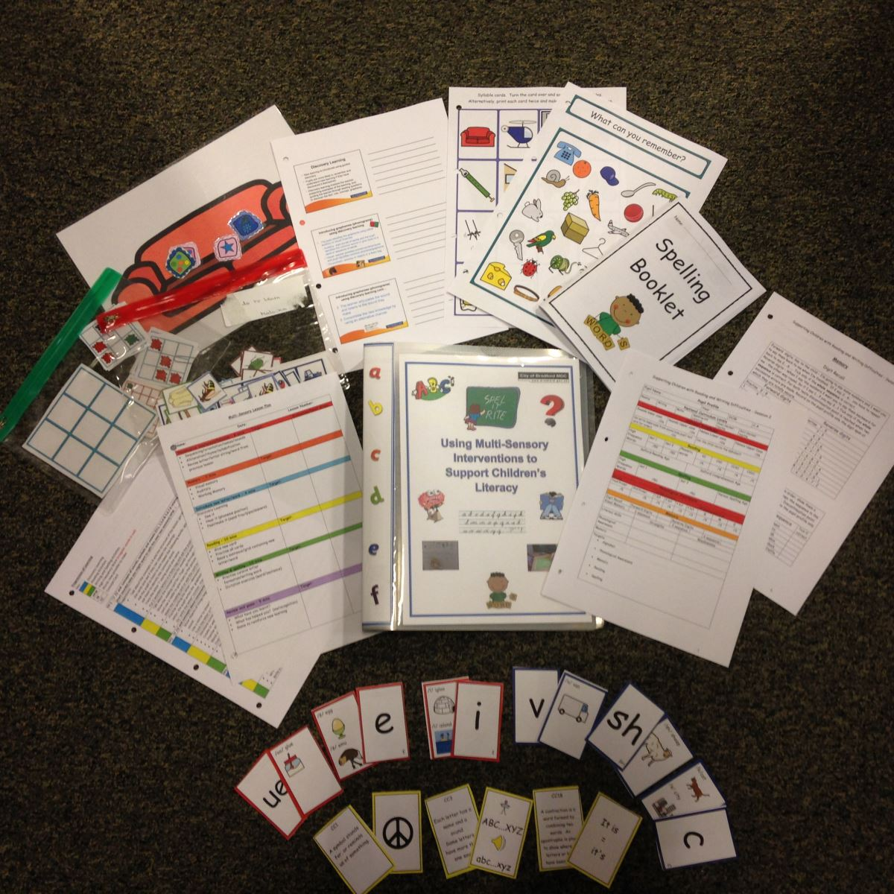

Using a Multi-Sensory Approach to Support Literacy Difficulties

We will be running the very successful Multi-Sensory Literacy course again in the Autumn, Spring and Summer terms 2017-2018. The course is accredited at level 2 and 3 by the CERTA (Open College Network). It is aimed at HLTAs or experienced TAs with a GCSE or equivalent in English. It teaches how to deliver a cumulative multi-sensory intervention and provides a comprehensive set of resources.

The course includes eight taught sessions, each three hours long, plus a final session to collate portfolios Details of the session are below:

- Covers the nature of literacy difficulties and provides an understanding of dyslexia.
- Shows learners how to use informal assessments to create a profile of a pupil’s strengths and weaknesses and set targets for learning.
- Introduces multi-sensory learning, provides a structure to deliver a cumulative multi-sensory learning programme and covers the use of the Alphabet Arc activities.
- Examines the phonological awareness components of the programme and the concepts of phonological awareness.
- Teaches the learners how to carry out the reading elements of the programme and how to introduce the literacy concepts.
- Teaches learners how to carry out the spelling and writing activities and explores games that can be used with the programme.
- Provides an overview of the whole lesson and looks at how to teach handwriting and the importance of motor skills.
- This is a feedback session which ends with the learners doing group presentations about the cumulative multi-sensory lesson sharing tips for delivery.

Each session involves a combination of taught materials, practical activities and videos with lots of opportunities for discussion and feedback. Learners will be required to have a pupil to work with . They will have five portfolio task to complete. In addition to attending the course TAs will need an afternoon each week to work with their pupil and complete their portfolio tasks.

The cost is of the full 9 week course is £400. This includes all the resources and teaching sessions and a full day overview for SENCOs.

TO BOOK - Please see below the link to our full courses booklet and application form:
Bradford Schools Online –CPD & Courses – Support services courses

https://bso.bradford.gov.uk/Schools/CMSPage.aspx?mid=3448.

Please read some of our feedback on overleaf
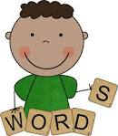

Our feedback!

I love the way the course is cumulative and fills the gaps in learning/literacy"

“I have enjoyed all aspects of the course and found our group activities particularly beneficial"

"I have learnt so much on this course and every aspect has helped me to deliver a lesson suited to the personal needs of my pupil"

"I really enjoyed the course and found it gave me a clear understanding of Multi-Sensory Learning"

"Excellent, enjoyed the balance of theory, then putting into practice during one-to-one lessons. Great balance.'

"It will have a great impact in school"

“ I have learnt a whole host of valuable skills which I believe will make a huge difference to the children I support”
“Extremely useful to extend my skills in my current role”
“An excellent step-by-step cumulative approach”
“Very good, gave a clear and good understanding of the problems that dyslexic children can have. It also gave good, comprehensive ways to help children with dyslexia and other literacy issues with reading and writing skills”
Well-structured course with very knowledgeable tutors. Course work was relevant to our jobs and will be of great benefit to children who are struggling with literacy. Extremely useful, very relevant. Highly recommended!”
“Very useful!! I am keen to apply my new found knowledge and skills with several pupils within year 6. The structured lesson approach to multi-sensory learning has allowed me to discover and address varying misconceptions and knowledge gaps with my pupil”
“I now have a more in depth knowledge of Dyslexia and the challenges that children with Dyslexia face in education and learning. As a result, I feel I have a better understanding of how to support, develop and encourage children with literacy learning difficulties”

