Using schedules

Autism

Spectrum

Team

First...Then
- ‘First’ and ‘Then’ boards are a simple means of beginning to help
structure transition from one activity to the next.
- They provide the child with information about what they will be doing and what that it will be followed by.
- The child should have a highly motivating activity second as it will encourage them to complete the first one.
- They can be a useful tool to use if the child is unsure about what to do or reluctant to engage with what the adult is requesting. You may have to start by using objects of reference to convey meaning to the child. Match the object to the symbols or pictures to support the child in understanding what the symbols represent.

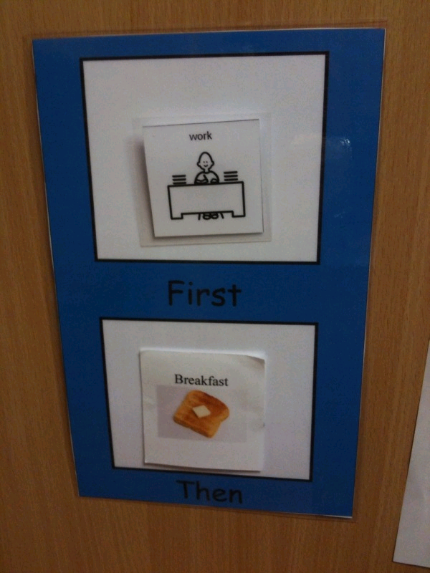
- In the ‘First’ box choose the activity you wish the child to complete and then choose an activity which will reward the child in the ‘Then’ box. Initially these might be photos or actual objects, leading on to symbols/ pictures to represent them, dependent upon the child’s level of understanding
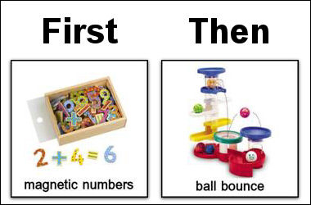

Visual timetables
- Pictorial/ Symbol timetables are used with pupils to help provide structure to represent each of the sessions/ activities the child will be taking part in. They are useful for children who have an understanding of ‘First/Then’ schedules and are ready to follow a longer sequence of activities. The child must also understand that the symbols represent activities.
- For some children photograph timetables may be appropriate. Ensure the photographs you use match the activity/ session the child will be in. For example, do not use a photo of a blue plate for snack if the child will ultimately be using a yellow plate during snack time.
- Attach each item (photo/symbol) onto the schedule board with Velcro in the order it will be occurring through the day.
- Encourage the child to take the symbol from the timetable and take it to the area they will be working in. Large symbols can be placed in the different areas of provision so that the child can ‘dock’ their symbol as they complete the activity.
- Once each activity has been completed, the symbol is then taken off the timetable and placed in the finished box/envelope. Posting symbols in the finished box is important;
- to enable the child to develop a conceptual understanding of when an activity is finished,
- to know what activities have been completed
- and what is left to do.
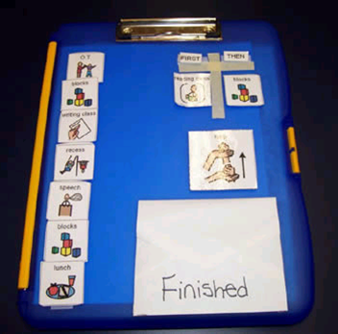
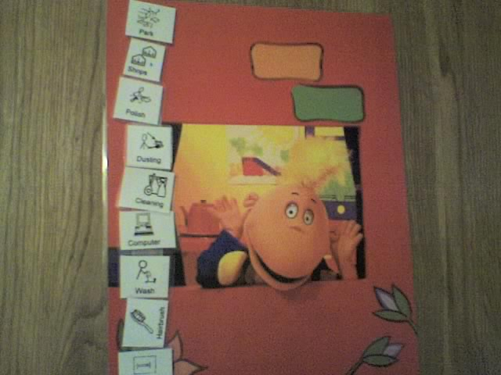

Fixed timetable on classroom cupboard Portable timetable on clip board

Symbols can be attached to wallets or clip boards so that they can move around with the child as they move from activity to activity or around school. Symbols can be stored in the wallet.
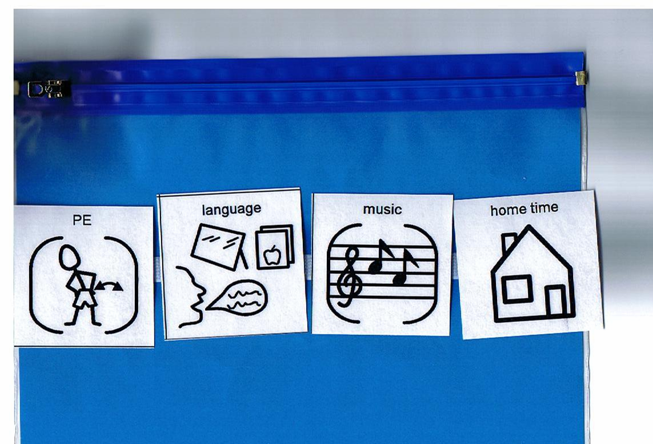

- Visual timetables are an important tool for children on the autism spectrum and not something staff should feel they have to ‘ween the child off’. They have the potential to increase the independence of the child and have a variety of different uses throughout life, particularly for reducing anxiety around unexpected changes to routine.
- The next step would be to move on to using a smaller version or class timetable.

