Bradford District Care Trust
Health Trainer Service
Hillside Bridge
4 Butler Street West
Bradford
BD3 0BS

Tel: 01274 777527
health.trainers@bdct.nhs.uk
www.bdct.nhs.uk
7 July 2014

To Whom It May Concern,

I am writing to inform you that the next training course to train people to become Health Trainers will commence in September 2014.

We are keen to recruit people with experience of working or living in the outer estate areas of Bradford and Keighley – and also people from the Roma, Central and East European, Gypsy & Traveller and Bangladeshi communities. The languages we are specifically looking for people to speak from within the Roma, Central and East European and Bangladeshi communities are Slovakian, Polish and Sylheti in addition to English.

Please see enclosed posters that advertise the training course and information sessions about the training courses. I would be grateful if you would display them within your organisation.

Application packs can be requested by e-mailing healthtrainers@bdct.nhs.uk. Please pass on this information to anyone interested in applying. Please note the deadline for receipt of completed application forms is 3pm, 15 August 2014 – so please display the poster until this date .

If you require any further information please do not hesitate to contact us.

Kind regards,

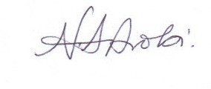

Nurjahan Ali Arobi
Health Trainer Service Manager

Enclosures

