Stoma

 Physical Needs Team

What is a stoma?
- A stoma, also known as an ‘ostomy’, is a surgically created opening in the gastrointestinal or urinary tract created to divert the flow of faeces or urine.

What are the different types of Stomas and stoma bags?
There are three different types of stomas:
- Colostomy (Colon): the output from a colostomy often resembles a traditional stool and commonly functions between 1 and 3 times a day.
- lleostomy (small intestine) is more active than a colostomy and functions between 3 and 6 times a day and the output being looser.
- Urostomy (bladder) the urostomy bag has a bung or tap at the bottom to allow urine to be drained into the toilet at regular intervals.
- There are 5 main types of stoma bags.
- The type of stoma determines which bag is used as well as what the individual feels most comfortable wearing and most confident changing.

Is the stoma bag emptied or changed?
- Most people with an ileostomy use drainable stoma bags that are emptied down the toilet. This is emptied when they are less than half full – usually around 4 to 6 times a day and the bag is changed every 1 to 3 days.
- How often a colostomy bag needs to be changed depends on which type of bag is used. Closed bags may need changing 1 to 3 times a day. There are also drainable bags that need to be replaced every 2 or 3 days.

Disposing of used stoma bags
- They should be disposed of in accordance with school policy.
Can the CYP empty and change their own stoma bag?
- It is important to encourage the CYP’s confidence in self-care with the view of eventual transfer of responsibility from caregivers to the CYP.
Where to store equipment?
- Supplies should be stored in a locked cupboard within the hygiene suite/toileting room to preserve confidentiality and ensure equipment is not tampered with by others using the room.

Where do I get supplies from?
- Parents will take all the supplies into the setting.

Stoma

Emergency kit
- The emergency kit will need to be taken into setting daily.

Risk Assessment
- A risk assessment will be needed and will be written by a health care professional or with parents and the SENCO.

Care Plan:
- A care plan is written by the school nurse or the community/ outreach nurse.
- Equipment needed includes: gloves, apron, gauze/dry wipes, adhesive removal spray, new stoma bag, scissors, cream, disposal sack.

School Trips
- Ensure there is a trained member of staff to accompany the CYP.
- Ensure the correct amount of equipment for the duration of the trip.

Educational implications:
- Stomas can bleed easily when rubbed or bumped.
- Contact sports are not advised but for those who do take part in them will need a guard to protect their stoma.
- They can participate in normal activities including PE and non-contact sports.
- The stoma bag/pouch is worm while swimming, wearing larger swimsuits or a t-shirt can help cover up the pouch.

Who delivers staff training?
- The paediatric urology specialist nurse who works within a team of specialist nurses.
- It is crucial that two or three staff members are trained to perform this procedure in the event of staff absence, sickness cover.
- If the setting is unable to provide a carer at short notice i.e. due to illness parents/carers maybe asked to step in.
- It is the responsibility of the educational setting to contact health for further training for additional staff or when training updates are due.

School trips/ Outings/ Residentials
- Ensure there is a trained member of staff to accompany the CYP.
- Timing of stoma care should fit into the school day as far as possible in order to minimise any disruption to lessons.

Stoma

Useful contacts:
Children’s Bowel Nurse Specialist Leeds 01133 926757
Community Nursing Team Bradford: 01274 365051
Children’s Outreach Team Airedale: 01535 293720

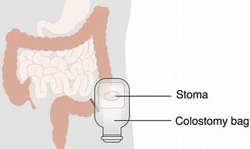
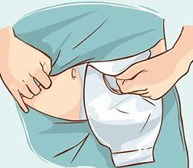

Children’s books about Stoma
- It is important to educate peers about stomas as the attitude of others can impact on how the individual feels.
- Sam’s Stoma by Jessica Manning
- Wearing a Colostomy Bag (Human Body Helpers) by Harriet Brundle
- t’s Okay! : I Have a Stoma by William M Bauer

Useful websites:
Young ostomates - Colostomy UK

https://www.colostomyuk.org/information/young-ostomates/

This leaflet gives general information. For advice and support contact the relevant health professional.

Physical Needs Team

