Guide for school SENDCOs:
Pathway for Gross Motor Difficulties Support
(please give the parent/carer a copy of the ‘Guide for Parents/Carers’)
Understanding Gross Motor Difficulties
Gross motor difficulties involve challenges with movements that use large muscle groups, affecting abilities such as sitting, crawling, walking, running, and jumping. Gross motor difficulties can impact on activities that use fine motor skills such as handwriting; this is because to be successful in a fine motor skill, the gross motor skills must be able to provide and sustain a stable, supportive base from which to operate, for example, a good sitting posture. Early identification and intervention are crucial for effective support.
Please refer to the flow chart below for a summary of the ‘Pathway for Gross Motor Difficulties Support’, followed by a colour coded detailed information box for each stage of the journey. (There is a separate pathway for children who are within the Airedale Health Authority; contact us for details sensoryandphysicalneeds@bradford.gov.uk .)

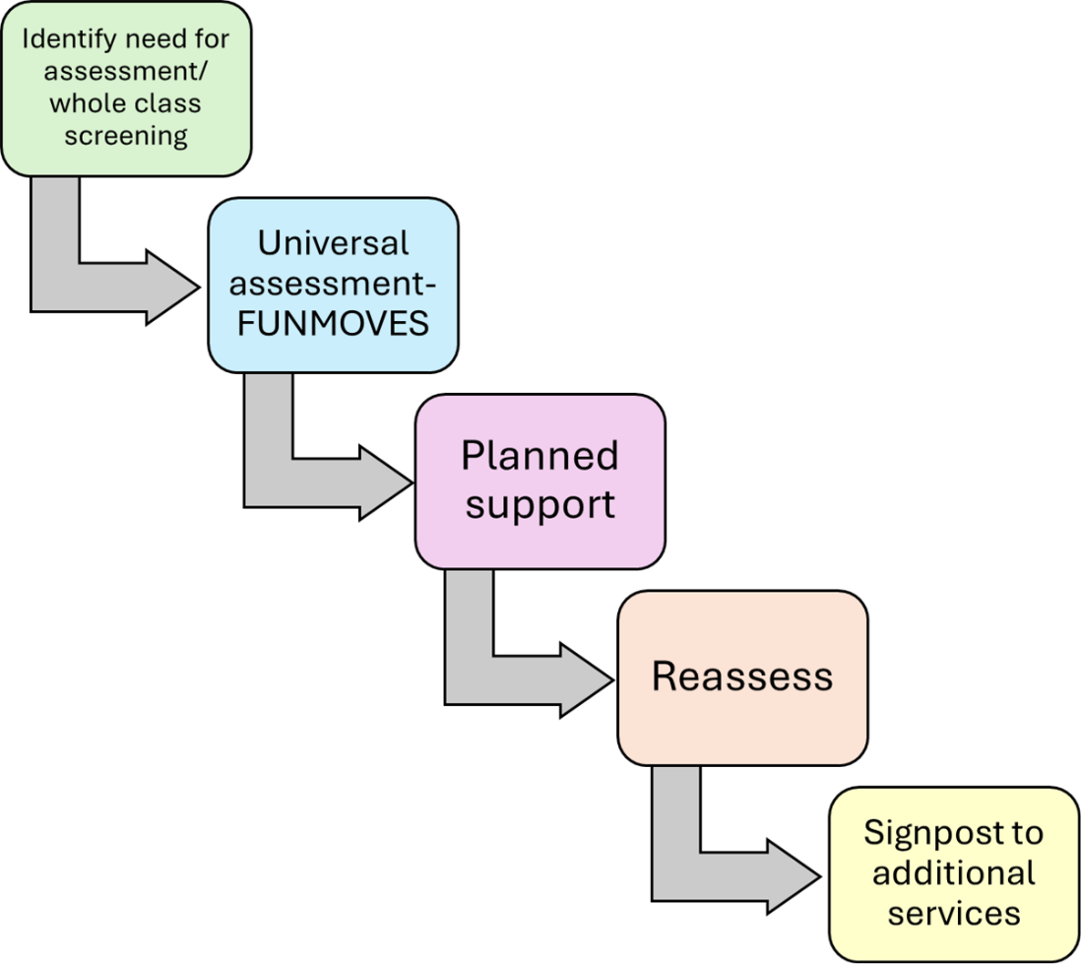

Identify need for assessment/whole class screening
1. Common signs to watch for in pupils:
- Delayed milestones (e.g., not sitting up, crawling, or walking at expected ages)
- Unusual movements or posture
- Difficulty with balance and coordination
- Frequent tripping or falling
- Trouble with tasks like climbing stairs
Does the child have more difficulty than his/her peers in any of the following activities?
Running Jumping Hopping Throwing Catching Balancing on one foot (Taken from FunMoves)
Have a look at the Abilities page on the Pathways website – recommended by the Physiotherapists in Bradford: https://pathways.org/all-ages/abilities/
This will give you an idea whether the child is requiring further assessment and support.

2. Speak to parents about the child’s strengths and areas of concern. Discuss whether parents have noticed any difficulties in the above skills or daily activities such as: dressing, going up and down stairs, navigating round objects, walking on uneven ground.
Collect any relevant information from home about the pupil's difficulties

3. Professional Development for Staff
Organise training sessions for teachers and staff on recognising and supporting gross motor difficulties, for example, pdNet Level 1 Training, which is a free resource:
https://pdnet.org.uk/pdnet-level-1-training/

Universal assessment - FUNMOVES
FUNMOVES is an assessment and guidance tool recommended by Bradford physiotherapists, designed to improve gross motor skills in children.
It involves a series of fun and engaging activities that help develop coordination, balance, and overall motor skills.
Please click on the link below for information on the FUNMOVES gross motor needs screening tool:
FUNMOVES Flyer

Planned Support
Classroom Strategies:
Implement strategies to support the pupil’s gross motor skills, such as providing opportunities for movement breaks and incorporating physical activities into lessons.
Allow extra time for tasks requiring gross motor skills.
Provide alternative methods for demonstrating learning (e.g., using technology for tasks that are challenging physically).

Environmental Modifications:
Ensure the classroom environment is conducive to learning, with accessible materials and tools.
Arrange seating and classroom layout to minimise distractions and support the pupil’s needs.

Implementing FUNMOVES following assessment:
- See contact details on the FUNMOVES Flyer (link above) to learn more about the FUNMOVES program and receive training.
- Incorporate FUNMOVES activities into the school day, either as part of PE lessons or in short, regular sessions.
Pass on the information below to parents/carers so that they can incorporate activities at home: Changing everyday routines to improve fundamental movement skills

Educational Assessments
If gross motor difficulties impact the pupil’s learning, you can refer into the Physical Needs Team Hub sessions. Click on the link below to access the Physical Needs Team page on Bradford Schools Online. Here you can find a link to our 30minute Hub sessions as we can help suggest classroom strategies and technology to help alongside FUNMOVES activities.
https://bso.bradford.gov.uk/content/special-educational-needs-and-disabilities/0-25-specialist-teaching-and-support-service-stass/sensory-and-physical-needs-service/physical-and-medical-team

Reassess
Monitor progress through observations and feedback from teachers and parents.
Adjust the FUNMOVES activities based on the pupil’s development and needs.

Signposting to additional services
If little or no progress has been made from following FUNMOVES intervention, speak to parents about asking the GP to consider referring for Physiotherapy involvement

Useful Resources and Support in Bradford and Airedale
Bradford District Care NHS Foundation Trust:
Offers services such as physiotherapy and occupational therapy for children.
Contact: Bradford District Care NHS Foundation Trust

Specialist Teaching and Support Service (StaSS):
The Physical Needs Team sit within this service and provide assessment and recommendations to SENDCo’s for CYP whose physical needs are impacting on their access to the curriculum. By clicking on the link below, you can find links to the Physical Needs Team Hub sessions and Referral form:
https://bso.bradford.gov.uk/content/special-educational-needs-and-disabilities/0-25-specialist-teaching-and-support-service-stass/sensory-and-physical-needs-service/physical-and-medical-team

