Oxygen


Physical Needs Team

CYP may require oxygen in an educational setting for a variety of reasons.
The main types of oxygen tanks used in settings:
- Compressed oxygen.
- Oxygen concentrator.
Oxygen Cylinders
- There are several different types of static and portable cylinders that look similar but deliver a range of flow rates.
- A ‘regulator’ is sometimes attached to a cylinder which enables lower oxygen flow rates to be delivered.
- Carry bags are available for portable cylinders.
- If a CYP is carrying their own portable cylinder a trolley can be provided by the supplier.
Oxygen concentrator
- Is a machine operated by electricity.
- Needs to be plugged into the main wall socket when being used - adaptors/ extension leads must not be used as they may reduce the power supply to the concentrator.
- It draws air from the room atmosphere, through the inlet, passing a filter that removes dust– The air is compressed before it passes through a chamber removing nitrogen but allowing the oxygen to pass through.
- Filters must be in place and totally dry before operating the unit.
- Oxygen is collected in a product tank where it is concentrated to a high purity before being pumped down the tubing at the prescribed flow rate.
- When concentrators are used, the setting must be supplied with an alternate source of oxygen, such as a spare oxygen cylinder.
- Ventilation parts must be unobstructed by any items which may impede ventilation.
- For safety reasons the concentrator should be switched off when not in use.

Oxygen

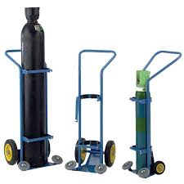
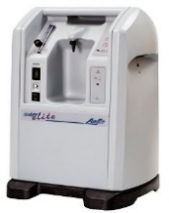
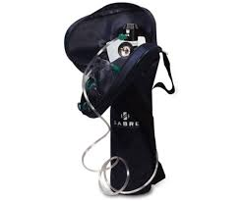

The oxygen provider will:
- Deliver oxygen as required and install oxygen equipment.
- Advise on the safest place for storage.
- Provide user guides for all oxygen equipment.
- Provide an emergency backup cylinder (if using an oxygen concentrator).
- Provide required consumables e.g. nasal cannula, oxygen tubing, face masks.
- Provide a carry bag for portable oxygen cylinders.
- Service the equipment at regular interval.
- Complete a risk assessment every six months.

Emergency Cylinders
- Emergency cylinders are provided in case of a power cut or machine failure.
- They need to be located where they can be easily accessible.

Staff Training
- Before a CYP can be administrated oxygen, relevant staff need to have completed training in the safe use of oxygen.
- If the CYP is known to the Community Nursing team/Outreach nursing team contact them to arrange training. Otherwise the school nurse or parents can deliver the training.

Oxygen

Health Care Plan
- Is written by clinical staff/school nurse in partnership with parents and the SENCO.
- Will identify medical conditions and what actions to follow to ensure the CYP can be safely supported.
- Will need to outline the emergency protocol.
- Staff working with the CYP must be familiar with the health care plan.
- Will need to be regularly reviewed at least annually or earlier if the CYP’s needs change
Who prescribes the oxygen?
- The CYP’s consultant. Nurses can amend this e.g. if the amount of oxygen needs to be increased.

Risk Assessment
- The oxygen provider will visit the setting ahead of the CYP starting in the setting and perform a field-based risk assessment before delivering oxygen equipment.

Swimming:
- Contact the health care provider to arrange extra tubing and nasal prongs.
- Inform staff at the swimming pool ahead of swimming.
- Inspect the nasal prongs after swimming to check if water is inside and replace if needed.
School trips/ Outings/ Residentials
- Ensure there is the correct amount of oxygen for the duration of the trip.
- Ensure there is a trained member of staff to accompany the CYP.
- Contact transport ahead of the trip to check what amount of oxygen they are permitted to carry and to ensure there is space to carry the oxygen.
- Alternate transportation may be required.
- The vehicle window will need to be kept partially open when oxygen equipment is in use.

Oxygen

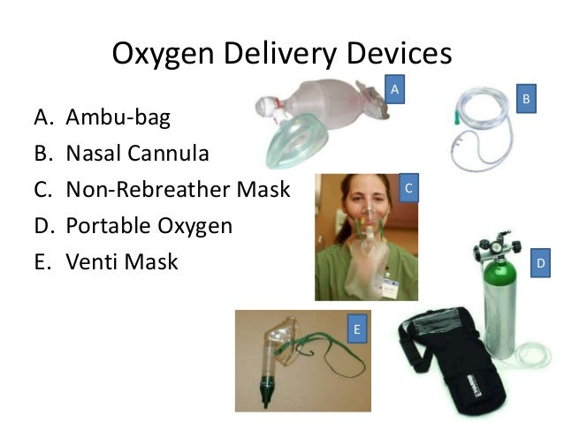

Relevant people to notify when oxygen is on site
- The educational setting needs to inform their insurance.
- Fire Rescue Service: the presence and location of the oxygen cylinder storage areas.
- Electricity company: if using a concentrator- to be made aware of the CYP if the power supply is ever interrupted.
- Building manager (fire safety).

Safety:
- As oxygen is prescribed it is subject to medicine management protocol as well as safety precautions.

- Place statutory hazard notices in areas where oxygen is stored, including the classrooms.

- Ensure all relevant safety information is communicated to staff.

- Concentrators should be used in an open space near a plug and at least 1.5 meters away from a heat source and 3m away from naked flames e.g. Bunsen burner, candles, gas cooker.

Oxygen

- Oxygen cylinders can easily fall and be knocked over. They need to be stored appropriately and securely e.g. locked container with adequate ventilation and out of direct sunlight.

- Ensure the positioning of equipment does not cause a trip hazard.

- Be aware of where the tubing is at all times e.g. ensure it does not become tangled, kinked or become trapped or crushed under furniture as this can stop/ reduce the oxygen flow.

- Keep it away from feet when walking to prevent it becoming a trip hazard.

- The length of the tubing should only be altered by the supplier.

Statutory documents:
‘Supporting pupils at school with medical conditions’.
https://www.gov.uk/government/publications/supporting-pupils-at-school-with-medical-conditions--3

Useful contacts:
Community nursing team Bradford: 01274 365051
Children’s Outreach Team Airedale: 01535 293720

This leaflet gives general information. For advice and support contact the relevant health professional.

Physical Needs Team

