Fine and Gross motor skills for handwriting: School Guide
Handwriting is a complex ‘whole body’ activity which requires:
- Fine and gross motor skill development
- Correct postural positioning
- Being able to use both sides of the body at the same time.
- Being able to reach across the middle of the body with their writing arm eg. Can draw a horizontal line across a page without having to switch hands in the middle or start a sentence at the margin and continue to the very end of the line.
- Correct seating
- Strength and stability trunk, neck, shoulder and hips.

Most children begin to develop all these skills throughout their early years and enable them to:
- Sit upright at a table,
- form letters correctly and efficiently,
- place them on a line,
- Size their letters appropriately and consistently
- Write from left to right, starting at the beginning of the line and finishing at the end.
- Use the correct amount of pressure
- Write fluently

Here are a few tips and ideas to help your child develop some of the fine and gross motor skills they need in order to be a happy and functional writer.
Let’s start by looking at the hand and some fine motor skills
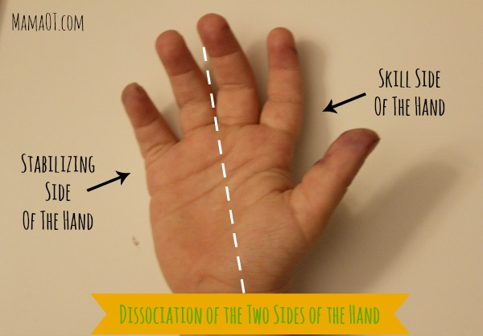

Your child should be able to hold a small object under their ring and little fingers (stabilizing side of their hand) and use their thumb and other fingers (skill side) to pick up another bead or small object.

Fine motor skills activities you can do to develop both sides of the hand:

- Clicking fingers
- Hold a pen with the stabilizing side and taking the lid off with the skills side.
- Holding an object with the stabilizing side and twirling a pencil (like a baton) with the skill side.
- Holding an object with the stabilizing side and rolling and pencil with the skill side.
- Picking up small objects eg buttons, beads, small lego bricks and holding them in the same hand whilst picking up more. Then post into a slot. Make it into a game and see how many they can hold.
- Flicking paper ball with each finger at a target.
- Pop a sheet of bubble wrap.

Fine motor skills to help develop pencil grip - The skill side of the hand
- Your child also needs to develop strength and flexibility in the skill side of their hand in order to be able to hold a pencil, efficiently and effectively. This will ideally be in a dynamic tripod grip.
The importance of a good grip is to eliminate pain and strain.
However,
If your child is holding their pencil in a different way and it is not affecting their handwriting development, then there is no need to change anything as long as it is a functional grasp. Inefficient, non- functional grasps should be avoided as although children may be able to produce handwriting at primary school, they often will struggle with pain or stamina issues at secondary school when they need to write longer amounts.
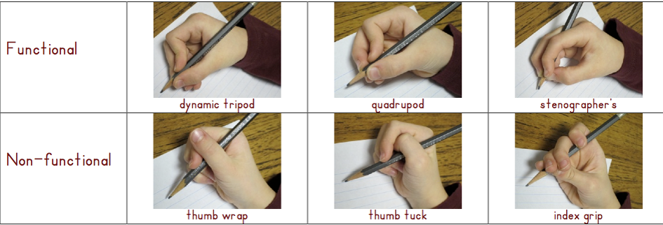
Fine motor skills activities you can do to develop the skill side of the hand:
- Build a tower with clothes pegs - using only the ends of thumb and forefinger (not the side)
- Peg socks onto a washing line - using only the ends of thumb and forefinger (not the side)
- Pick small objects up - using thumb and forefinger and place them into a container.
- Threading small beads onto a lace.
- Pick a line of coins up from the table using only your finger tips and post them into a money box using 1 hand only.
- Doing and undoing nuts and bolts
Gross motor skills
In order for your child to be able to sit upright at a table for any length of time, they need to have developed strength and stability in their:
- Trunk
- Neck
- Shoulders
- Hips

Here are some ideas for activities you can do to help your child build gross motor strength:
Trunk Stability:
- Press ups against the wall
- Superman position – lay on tummy with arms outstretched in front and legs straight and lifted off the floor
- Tug of war
- 2 Handed Bat game – 2 children lay out flat on their tummy’s facing each other with their arms outstretched in front of them holding a bat (or a book) in both hands – bat a ball to and from each other.
- Puppy dog walking - both hands placed on the floor, knees bent – walk around like a dog.

Neck Stability:
- Balance a beanbag or beanie toy on head and walk around. You could create an obstacle course to increase difficulty
- Lying down on your back on the floor leaning back on elbows. Hold for as long as possible and keep extending the time
- 2 Handed Bat game – 2 children lay out flat on their tummy facing each other with their arms outstretched in front of them holding a bat in both hands – bat a ball to and from each other.

Shoulder stability:
- Activities using dance streamers or ribbons
- Keeping large balloon in the air above the head.
- Pouring water from one container to another
- Drawing shapes in the air using whole arm movements
- Twirling a skipping rope.
- Animal Walks – bunny hops, puppy dog walking, crab walking

Hip stability:
- Walk heel to toe along a course.
- Crab grab – scatter soft toys around the floor - scoot around the floor in a crab position, collect the toys by sitting down and using their feet to pick them up. Once the toy has been picked up with feet they can then hold it with their hands and scoot back to a collecting point.
- Tight rope walker – walk along a straight line or skipping rope placed on the floor.
- Bridges – lie on the floor on their back. Form an arch by placing feet flat on the floor and lifting up knees and hips – roll a ball through the arch.
Dexteria Jn App for Apple and Android has been designed by Occupational Therapists to help develop some of these fine motor skills. Please see our advice sheets for apps.

Now that you have read through this sheet - take a look at the Fine Motor Skills Videos on our power point showing a child carrying out fine motor skills practice!

