Gastrostomy

 Physical Needs Team
What is a gastrostomy?
- A gastrostomy is a surgical opening through the skin of the abdomen to the stomach.
- A feeding device e.g. a PEG tube (Percutaneous Endoscopic Gastrostomy) is put into this opening so that a special liquid feed containing nutrients can be delivered directly into the stomach bypassing the mouth and throat.

When Might a CYP need a Gastrostomy ?
- when unable to take enough food/fluid via their mouth due to unsafe swallow.
- when having feeding problems with nasogastric tubes.
- many families find a gastrostomy tube more acceptable than a nasogastric tube because it can be hidden under clothing.

Who will deliver staff Training?
- Ahead of the CYP starting in a setting, staff awareness training will need to be delivered.
- If feeds are needed during the day further training is delivered by the Abbott nurse who can be contacted through the community/outreach nursing team.
- There are three main types of feeding devices that are inserted into the gastrostomy opening and although the principles of caring for them are broadly similar, staff will receive specific advice for the type as part of the training.
- It is the responsibility of the educational setting to contact health for further training for additional staff or when training updates are due.

What are the different types of Gastrostomy feeds?
- There are three ‘regimes’ for gastrostomy feeding:
- Bolus (intermittent) – a specific amount of feed given in one go, usually over 20 minutes.
- Continuous – a continuous feed is given slowly over a number of hours using a pump.
- A combination of the two e.g. bolus fields during the day and a continuous overnight feed.
- For pupil who are mobile the feeding pump is carried around in a rug sack.

Gastrostomy

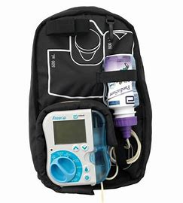

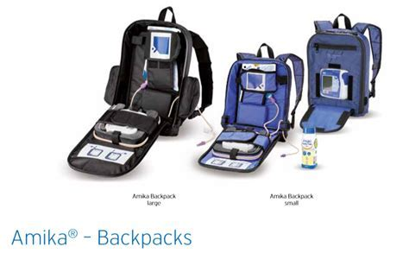

What can we put down the gastrostomy tube?
- a special milk feed which contains all the nutrients and calories needed.
- Some CYP may be able to continue to eat regular food by mouth using the gastrostomy to top up their feeds.
- Liquid medicine can also be given by the gastrostomy.

Is there an Emergency care Kit
- The emergency care kit will need to be taken into the setting daily and accompanied with the CYP at all times.

What are the Educational Implications?
- For physical sports activities ensure the tube is taped securely so it does not get pulled or tugged.
- It is advised to avoid contact sports, due to the risk of the device becoming dislodged or damaged.
- Swimming needs to be avoided until the stoma has fully healed, which is usually four weeks after placement of the gastrostomy.
- Contact the named community/outreach nurse for further advice.

Will the setting need a Care plan?
- A care plan is needed and will be written by either the school nurse or the community/outreach nurse.

Where do I get my supplies from?
- Parents will take all the supplies into the setting.

Gastrostomy

Can the CYP go swimming?
- once the gastrostomy site has healed, usually about six weeks after the operation, the CYP child will be able to go swimming
- It is advisable to keep the tube tucked away in the costume, a dressing is not necessary when swimming.
- After swimming the area around the tube will need to be cleaned with warm water and dried.

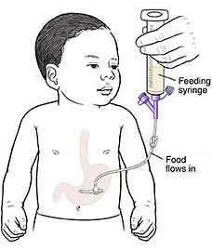

Children’s books about Gastrostomy
- It is important to educate peers about a Gastrostomy as the attitude of others can impact on how the individual feels.
- My belly has two buttons: A Tubie Story by Meikele Lee
- The abilities in me: Tube Feeding by Gemma Keir
- My Gastrostomy Tube by Kimberly Gastineau
- Two Belly Buttons: A True Story About Tube Feeding and Acceptance by Valerie Lynn Rasanen

Contact numbers:
Community Nursing Team Bradford: 01274 365051
Children’s Outreach Team Airedale: 01535 293720
Abbot nurse: 01274 365051
https://www.gov.uk/government/publications/supporting-pupils-at-school-with-medical-conditions--3

This leaflet gives general information. For advice or support contact the community nursing team.

Physical Needs Team

