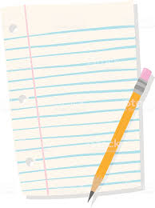
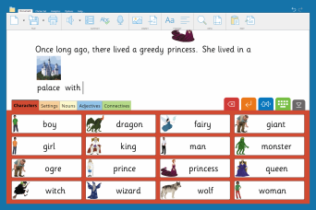
? Clicker

Clicker is a fun, assistive software tool that can be used to support children with their writing skills. It will even read back what has been written so you can hear whether it is correct or needs a second look!
Clicker is for all children at Primary age. It helps children get their ideas down without worrying about handwriting and can be a way for reluctant writers to write longer pieces of work more easily. Clicker enables children to feel success with writing more easily which then leads to increased motivation!


Some children are reluctant writers because the physical act of handwriting is difficult. It may be tiring or cause their hand to ache or is simply not physically possible.
For other children, reluctance to write may be due to the high cognitive demand– trying to concentrate on forming letters at the same time as thinking about sentence structure, spelling, punctuation and grammar, composition and effect!
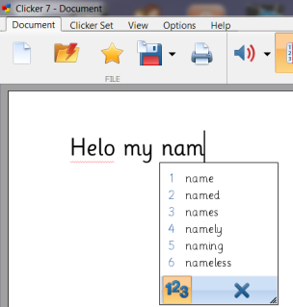
Whilst typing, Clicker can provide a level of support that is right for an individual child.

Choosing which features to switch on and off you can reduce or increase the number of challenges for each child. For example, using auto capitalisation, spelling support and predictive text will allow a child to focus more on the composition of their writing whilst the programme models the correct use of grammar and spelling.
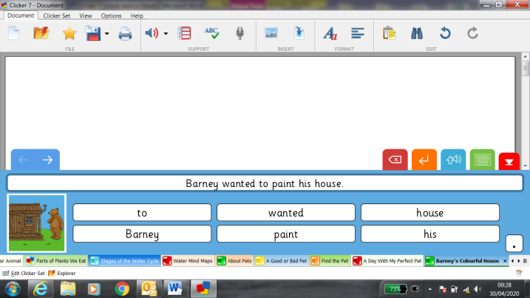
Free, downloadable LearningGrids provide fun and colourful resources readily available for children both beginning to write and those of all ages and abilities. These can be used to assist children to record their learning in a wide range of subjects and topics – see examples below.
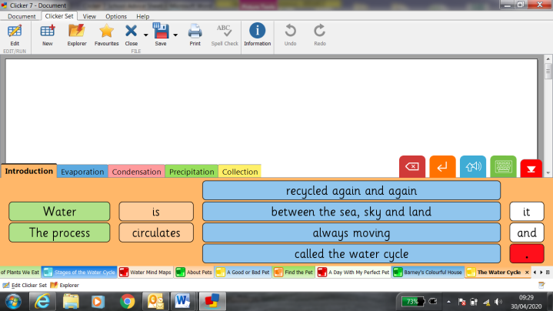

Clicker Board can be used to create a mind map of ideas, phrases, pictures and text.
Once planning for writing has been done, with a click you can create a word bank or picture bank to support the write up- saving repetition and increased workload that can come with plans, first drafts and final drafts!
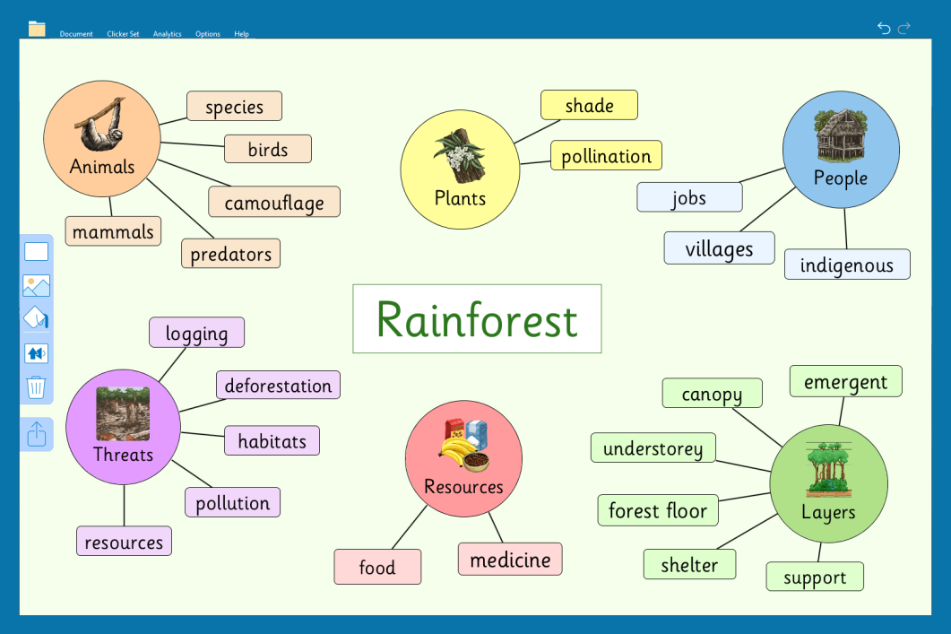

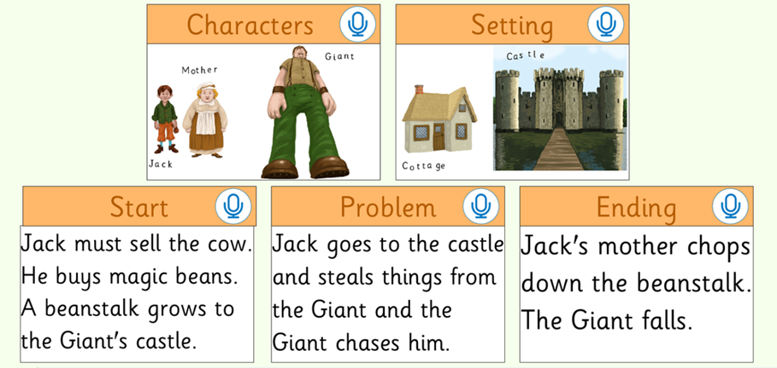

To see an introductory video of Clicker click on the link below:

https://www.cricksoft.com/uk/clicker

Join the Clicker Community Group on Facebook https://www.facebook.com/groups/Clicker.Software/

Getting started

How to:

- Get writing- use it as a word processer like Microsoft word for example, but with added support.

- Click on the Clicker Icon on your desktop
- The Quick Start Screen will come up
- Click on Start writing

- Download the free resources - LearningGrids
In addition to writing grids, LearningGrids also provides information books & stories and many other activities.

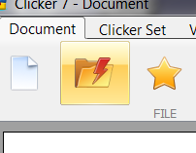
- From the Quick Start screen which you can get back anytime by clicking on the explorer tab

- Click on the Files tab (see picture below).
- This will bring up the LearningGrids symbol; click on it to access the free resources.
You must be connected to the internet at this point to access them.
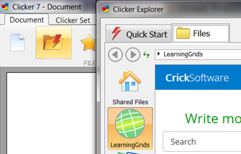

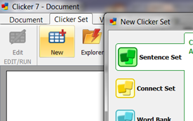

- If you like, you can make your own Clicker resources too – go to the Clicker Set tab and click New.

