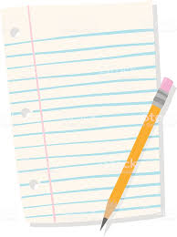
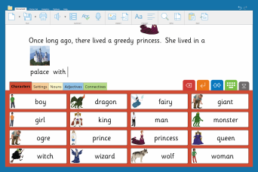
? Clicker

Clicker is a fun, accessible computer programme that can be used to support children with their writing skills. It will even read back what you have written so you can hear whether it is correct or needs a second look!
Clicker is for all children at Primary age. It helps children get their ideas down without worrying about handwriting and can be a way for reluctant writers to write longer pieces of work more easily. Clicker lets children be successful with writing which gives them more motivation!
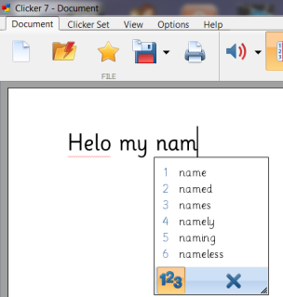
Writing can be difficult - Clicker can help your child make sentences that make sense, find the right words and improve their writing without having to concentrate on their handwriting.

Whilst typing, Clicker can provide a level of support that is right for your child. It has:
- Predictive text
- Spelling support
- Grammar support
- Word banks
Simply turn on the features your child needs!

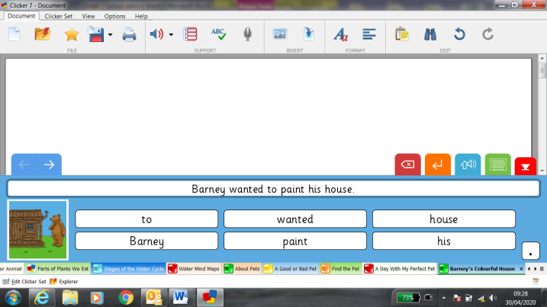
There are ready-made LearningGrids to help your child write:

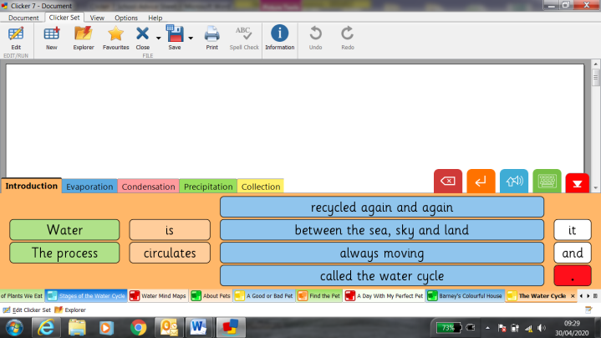

Clicker Board can be used to organise ideas, phrases, pictures and text.
Once planning has finished, with a click, a word bank or picture bank can be created to support the writing.
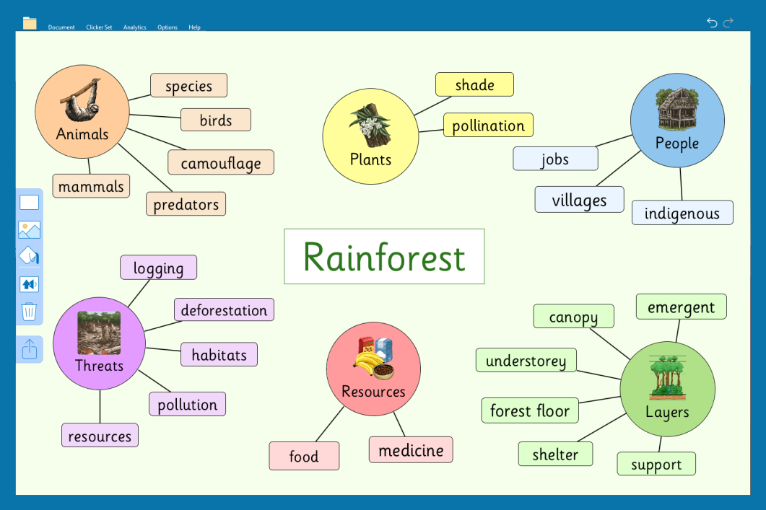

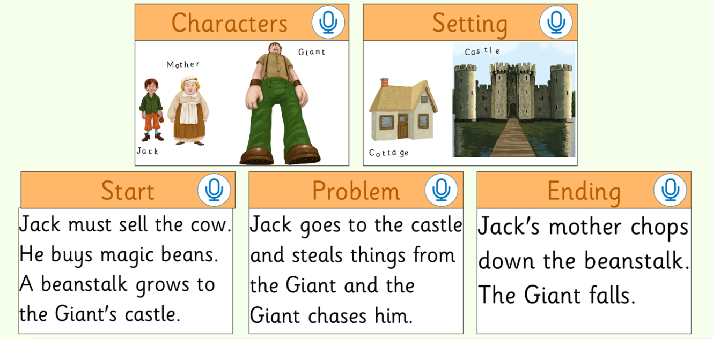

Instead of writing, your child can record their voice to record their work

