
Physical Friendly Setting Award
For Bradford settings supporting learners with a physical disability.
Introduction

Over the last three years, the Physical Needs Team have been working alongside Bradford settings from Early Years through to Secondary, supporting them in reaching a standard of support for CYP with Physical Needs that results in the award of Physical Friendly Setting.

Whether your setting has many learners with Physical Needs or just a few, the journey toward becoming a Physical Friendly Setting can give you and your staff the confidence and knowledge necessary, to meet their needs.
We are looking forward to working with more schools so feel free to register your interest with us - read on to find out how straightforward the whole process is…
Our sendco said: ‘Staff feedback forms enabled us to develop our message to staff around PD, focusing on finding solutions to any barriers to learning.’

Keeping it simple

pdnet, a partner organisation within the Whole School SEND Consortium, is a national network that provides support, resources and training for professionals who work towards meeting the unique needs of learners with physical disability at every phase of their learning (Early Years, Schools, Post 16). The Physical Needs Team have been working with and supported by pdnet for many years.
pdnet Membership is free and is achieved by registering on www.pdnet.org.uk.
We advise you register with pdnet so that you can use pdnet ‘Self Evaluation Tool’ to audit what you are doing well and create an action plan of areas to develop further. You can then use the pdnet ‘Standards’ as a benchmark in working towards achieving the Physical Friendly Setting Award.
You will also have access to the:
· Effective Practice Hub which holds a wealth of useful resources, written by professionals across the physical disability sector, which include: advice leaflets, risk assessment examples, top tips, checklists, templates and many more.
· pdnet forum where you can ask questions and receive advice and recommendations from other professionals
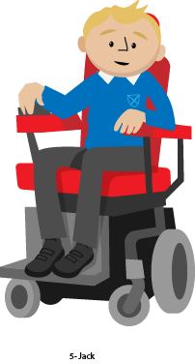
· pdnet Level 1 training free training modules with a downloadable certificate on completion.

Our sendco said: ‘It highlighted the need to have a staff member trained as a Manual handling Trainer’.
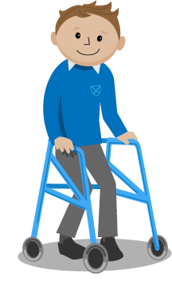
Our sendco said: ‘It gave our link governor a better understanding of PD’.

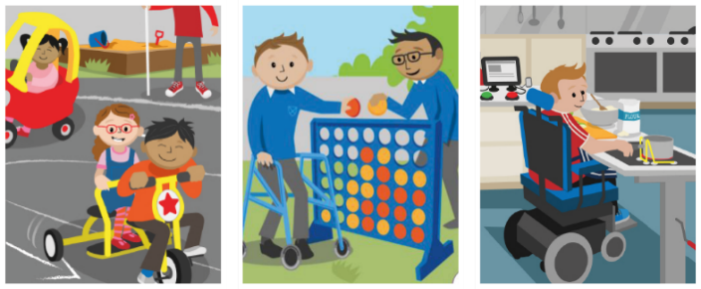
L1 Online Training
Early Years
Schools
Post-16
‘Raising Awareness of Physical Disability’ to develop awareness and understanding of physical disability, the impact it can have on learning and the steps that can be taken to overcome this. Great for all staff working alongside CYP with physical needs.

Physical Friendly Setting Award
The Process
Email SensoryAndPhysicalNeeds@bradford.gov.uk to express your interest. Register as a pdnet member. Get to know the pdnet Standards. Bring together your self-evaluation team. All staff complete free pdnet level 1 online training.
We can support you to use the Self Evaluation Tool. Click on the Physical Needs Team BSO webpage using the link below. There you will find a document ‘How to use the pdnet Self Evaluation Tool ‘: https://bso.bradford.gov.uk/content/special-educational-needs-and-disabilities/0-25-specialist-teaching-and-support-service-stass/sensory-and-physical-needs-service/physical-and-medical-team
If needed, we can support with meetings in person or on TEAMS, in the sharing of ideas for evidence and by discussing how you might work through the action plan. We can also put you in touch with other sendcos who have completed the process, for further support.
Collect information
Collate existing setting documents and information. Collect feedback from relevant stakeholders including staff, parents, children, professionals (use the editable forms that can be customized by adding your setting’s logo as well as templates for covering letters).
Evaluate provision
Compare your setting’s existing provision to the pdnet Standards. Discuss your findings with your team.
Take action
Plan actions arising from your self-evaluation. Disseminate your findings and action plan. Set review dates.

Evaluation visit : Following completion of the action plan contact the Physical Needs team to arrange an evaluation visit. Following a successful evaluation process your setting will be awarded the Physical Friendly Setting.
Our sendco said: ‘Staff feedback forms enabled us to develop our message to staff around PD, focusing on finding solutions to any barriers to learning.’

